DEVELOPMENT OF A LEARNING MANAGEMENT SYSTEM FOR
ARELLANO UNIVERSITY – JAS CAMPUS

A Thesis Project
Presented to the
College of Information Technology Education
Arellano University – Jose Abad Santos Campus

In Partial Fulfillment of the Requirement for the
Bachelor of Science in Computer Science

By

HUBILLA, ERROL JAMES
MENDOZA, ERIKA PAULA
CARILLANES, MICO ANGELO
TOLENTINO, JULIUS ROBERT T.

DR. LEONARD L. ALEJANDRO
Technical Adviser

March 2026

DEDICATION
This thesis is humbly dedicated to the Almighty God, whose divine guidance, infinite wisdom, and abundant blessings bestowed upon us the strength, perseverance, and resilience necessary to accomplish this academic endeavor.
We likewise dedicate this work to our beloved families, whose unwavering love, patience, and steadfast support have sustained us throughout our academic journey. Their sacrifices, encouragement, and enduring belief in our capabilities have served as a profound source of inspiration and motivation.
Our deepest gratitude is also extended to our esteemed professors, mentors, and adviser, particularly Dr. Leonard L. Alejandro, whose invaluable guidance, scholarly expertise, and constructive insights significantly enriched the quality and completion of this research.
Furthermore, this study is dedicated to Arellano University – Jose Abad Santos Campus and to future researchers in the field. It is our earnest hope that this work, specifically the proposed Learning Management System with Integrated AI Academic Assistant, will contribute meaningfully to the enhancement of academic processes and serve as a valuable reference for subsequent studies and innovations in the field of educational technology.

EXECUTIVE SUMMARY
Title: DEVELOPMENT OF A LEARNING MANAGEMENT SYSTEM FOR ARELLANO UNIVERSITY – JAS CAMPUS
Developers: HUBILLA, ERROL JAMES
MENDOZA, ERIKA PAULA
CARILLANES, MICO ANGELO
TOLENTINO, JULIUS ROBERT T.
Class Adviser: Dr. Leonard L. Alejandro
Technical Adviser: Dr. Leonard L. Alejandro
Copyright Year: 2026
Summary: This thesis centers on the design, development, and evaluation of a comprehensive, role-based Learning Management System (LMS) with an integrated AI Academic Assistant tailored specifically for Arellano University – Jose Abad Santos Campus (AU-JAS LMS). Built upon a modern cloud-native architecture utilizing React.js, TypeScript, Tailwind CSS, and Material UI on the client side and Supabase PostgreSQL with Row-Level Security (RLS) and Edge Functions on the server side, the platform unifies institutional governance, curriculum design, student enrollment, classroom pedagogy, automated grading, and conversational AI assistance within a single responsive web environment.
The primary objective of this study is to resolve operational bottlenecks, usability barriers, and fragmented academic workflows experienced by administrators, academic deans, registrars, faculty members, and students. The system introduces five dedicated role portals featuring guided multi-step configuration wizards for Academic Year and Grading Period setup, degree program curriculum mapping with automated prerequisite validation, conflict-checked section scheduling and faculty loading, individual and bulk CSV student enrollment, an 8-tab Faculty Section Studio with a 4-tier Assessment Builder and Rubric Studio, and an anti-tamper Dual-Key Grade Release pipeline gated by mandatory student faculty evaluations.
Through a systematic development and two-phase testing process guided by the Waterfall Software Development Life Cycle (SDLC), the researchers verified functional completeness across desktop and mobile viewports and evaluated the system with 30 respondents comprising students, faculty, administrative staff, and IT professionals using the ISO/IEC 25010 Software Quality Model. The evaluation yielded composite mean scores ranging from 4.77 to 4.93 across Functional Suitability, Performance Efficiency, Compatibility, Usability, Reliability, Security, Maintainability, and Portability, consistently achieving an "Excellent" verbal interpretation.
Overall, this study demonstrates that a purpose-built, institutionally aligned Learning Management System enhanced with role-aware AI assistance and automated academic workflows significantly reduces administrative workload, enforces data integrity through database-level security and forensic audit trails, and elevates the teaching and learning experience at Arellano University – Jose Abad Santos Campus.

TABLE OF CONTENTS
Pages
TITLE PAGE i
APPROVAL SHEET ii
DEDICATION iii
EXECUTIVE SUMMARY iv
TABLE OF CONTENTS v
CHAPTER 1: INTRODUCTION 1
1.1 Introduction 1
1.2 Purpose and Focus 2
1.3 Research Questions 2
CHAPTER 2: REVIEW OF RELATED LITERATURES/SYSTEMS AND STUDIES 2
2.1 Local Literatures 2
2.2 Foreign Literatures 3
2.3 Local Studies 4
2.4 Foreign Studies 4
CHAPTER 3: METHODOLOGY 5
3.1 Requirements Analysis 5
3.1.1 Software Development Life Cycle 5
3.1.2 Conceptual Diagram 5
3.1.3 Flow of Existing System 6
3.1.3.1 Flow Chart of the Existing System 6
3.1.3.2 Data Flow Diagram of the Existing System 7
3.1.4. Flow of Proposed System 8
3.1.4.1 Flow Diagram of the Proposed System 8
3.1.4.2 Level 1 Flow of Proposed System 8
3.2 Requirements Documentation 9
3.2.1 Research Methods 9
3.2.2 Analysis Methods 9
3.2.3 Scope 10
3.3 Technical Background 10
3.3.1 Product Description 10
3.3.2 Economic Use of the Product 11
3.3.3 User Requirements 11
3.3.4 System Requirements 11
3.3.5 Setting and Participants 12
3.4 Development and Testing 12
3.5 Description of the Prototype 13
3.6 Implementation Plan 24
3.7 Implementation Results 24
CHAPTER 4: SUMMARY, CONCLUSION AND RECOMMENDATIONS 25
4.1.A Results 25
4.1.B Testing Project Results 25
4.1.C Final Evaluation Outcome (User Review) 27
4.2 Conclusions 28
4.3 Recommendation 29
CHAPTER 5: ACKNOWLEDGEMENT 29
6. REFERENCES 30

LIST OF APPENDICES 32
A. Certificate of Implementation 33
B. Sample Input/Output/Report 34
C. Presentation of Findings 36
D. Evaluation Tool/Test Documents 38
E. Certificate of Initial and Final Testing 41
F. Gantt Chart of Development Schedule 43
G. User's Manual 44

LIST OF TABLES
Table 1. Technical and Functional Comparison 25
Table 2. System Module and Viewport Verification Results 26
Table 3. Composite Mean 27

LIST OF FIGURES
Figure 1. SDLC - Waterfall Model 5
Figure 2. Input-Process-Output-Benefits (IPOB) Diagram 6
Figure 3. Flowchart of the Existing System (Learning Management System) 6
Figure 4. Data Flow Diagram of the Existing System (Level 0) 7
Figure 5. Flowchart of the Proposed Learning Management System 8
Figure 6. Data Flow Diagram of the Proposed Learning Management System (Level 1) 8
Figure 7. User Login 13
Figure 8. Admin Dashboard 13
Figure 9. User Profile 14
Figure 10. User Management (Admin) 14
Figure 11. Profile Approval (Admin) 15
Figure 12. Academic Years Configuration Wizard 15
Figure 13. Department Management 16
Figure 14. Announcements and Events 16
Figure 15. Faculty Evaluation Management 17
Figure 16. Audit Log (Admin) 17
Figure 17. System Settings 18
Figure 18. Registrar Dashboard 18
Figure 19. Enrollment Management (Registrar) 19
Figure 20. Profile Verification (Registrar) 19
Figure 21. Registrar Logs 20
Figure 22. Grade Release and Submission Verification 20
Figure 23. Dean Dashboard 20
Figure 24. Section Management (Dean) 21
Figure 25. Faculty Loading (Dean) 21
Figure 26. Program Management (Dean) 21
Figure 27. Course Catalog Management (Dean) 22
Figure 28. Program Level Management (Dean) 22
Figure 29. Course Type Management (Dean) 22
Figure 30. Faculty Dashboard 23
Figure 31. Academic and Campus Calendar 23
Figure 32. My Sections and Course Module Studio 23
Figure 33. Create Assessment Builder 24
Figure 34. Account Activation and Student Onboarding 24

Development of Learning Management System for
Arellano University - JAS Campus
Errol James Hubilla
Arellano University
errolhub@gmail.com
Erika Paula Mendoza
Arellano University
erikapaulamendoza2003@gmail.com

Mico Angelo Carillanes
Arellano University
mico.carillanes.stem@gmail.com
Julius Robert T. Tolentino
Arellano University
Juliustolentino.diamond@gmail.com

OVERVIEW
This study presents the design, development, and evaluation of an enhanced, role-based Learning Management System (LMS) with an integrated AI Academic Assistant for Arellano University – Jose Abad Santos Campus (AU-JAS LMS). The proposed system addresses operational bottlenecks, interface complexity, manual grading dependencies, and fragmented academic workflows experienced by institutional stakeholders [1]. Built on a modern web architecture utilizing React.js, TypeScript, Tailwind CSS, and Material UI on the frontend and Supabase PostgreSQL with Row-Level Security (RLS) and Edge Functions on the backend, the platform delivers a responsive, accessible, and secure digital learning environment across desktop and mobile devices.
The research details the system’s five-role governance architecture—spanning System Administrator, Academic Dean, University Registrar, Faculty Member, and Student—alongside its multi-step configuration wizards, curriculum mapping and prerequisite validation engine, automated periodic grade calculation and transmutation, dual-key grade release workflow, and context-aware conversational AI assistant powered by Google Gemini [2], [3]. Furthermore, it reviews related local and foreign literature and empirical studies on LMS adoption, learning analytics, usability frameworks, and intelligent educational services.
By streamlining account onboarding, academic calendar configuration, degree program and section scheduling, bulk CSV student enrollment, classroom assessment delivery, and transparent academic performance tracking, the developed system enhances institutional productivity while minimizing administrative overhead and technical barriers for school personnel, educators, and students at Arellano University – Jose Abad Santos Campus [1], [3].
Categories and Subject Descriptors
Information Systems → Information Systems Applications → Educational Information Systems → Learning Management Systems; Computing Methodologies → Artificial Intelligence → Conversational AI Assistants; Security and Privacy → Access Control → Role-Based and Row-Level Security
General Terms
Algorithms, Management, Performance, Design, Reliability, Experimentation, Security, Human Factors, Usability
Keywords
Learning Management System, E-Learning, Educational Technology, Blended Learning, Role-Based Access Control, Automated Grading, Prerequisite Validation, AI Academic Assistant, React, Supabase
CHAPTER 1: INTRODUCTION
Learning Management Systems (LMS) have become foundational infrastructure adopted by higher education institutions to deliver instructional materials, manage academic records, and evaluate student performance in modern blended and online learning environments [1]. The transition from traditional paper-based classroom administration to digital academic platforms has reshaped how universities distribute coursework, monitor attendance, administer assessments, and compute periodic grades. Consequently, an institutional LMS is no longer merely a supplementary instructional tool; it serves as an essential operational backbone that ensures academic continuity, data integrity, and accessibility for all stakeholders [2].
Despite the widespread availability of digital learning platforms, many institutions continue to encounter significant challenges related to interface complexity, fragmented administrative workflows, manual grade transmutation errors, and insufficient role-specific tooling for academic deans and university registrars [3]. When an LMS lacks streamlined workflows for curriculum mapping, prerequisite validation, schedule conflict detection, and automated grade computation, faculty members and administrative personnel experience increased cognitive load and operational delays, often prompting educators to resort to disconnected third-party tools.
This research targets the academic community of Arellano University – Jose Abad Santos Campus, including System Administrators, Academic Deans, University Registrars, Faculty Members, and Students. The proposed system addresses existing limitations by delivering a unified, responsive, and role-governed Learning Management System integrated with a context-aware AI Academic Assistant that simplifies academic administration, automates grading and enrollment pipelines, and enhances user satisfaction.
1.1 Introduction
A Learning Management System (LMS) is an integrated software application designed to plan, deliver, track, and evaluate educational courses and institutional academic processes within a structured digital environment. A well-engineered LMS facilitates organized instructional delivery, real-time attendance and assessment monitoring, and data-driven performance analytics that continuously improve pedagogical outcomes for both faculty and students [1].
Recent empirical studies highlight the rapid expansion of e-learning platforms in higher education, noting that well-structured digital environments effectively satisfy students’ instructional material and assessment requirements [2]. However, excessive navigational complexity and disconnected administrative modules frequently cause faculty members and staff to hesitate in utilizing an LMS to its full capacity, diminishing its overall effectiveness in blended learning settings [3]. Furthermore, the absence of built-in contextual guidance and role-aligned onboarding mechanisms hinders rapid user acceptance among newly registered students and educators.
To address these factors affecting LMS adoption and operational efficiency in higher education, this study develops a customized Learning Management System specifically engineered for Arellano University – Jose Abad Santos Campus (AU-JAS LMS). The developed platform unifies the complete academic lifecycle—from school year configuration and curriculum blueprint mapping to batch student enrollment, multi-tier classroom assessments, automated periodic grade transmutation, mandatory faculty evaluations, and official registrar grade release—within a single web application.
Without an integrated and user-centered system, institutions face recurring operational issues: disorganized learning experiences for students, heavy administrative workloads for teachers managing coursework and calculating periodic grades, delays in verifying student credentials and releasing official grade reports, scheduling collisions across rooms and faculty loads, and limited real-time support for users navigating academic requirements. By embedding multi-step guided wizards, strict role-based security, and a conversational AI Academic Assistant, the AU-JAS LMS directly resolves these institutional challenges.
1.2 Purpose and Focus
The primary purpose of this project is to design, develop, and implement an enhanced, user-friendly Learning Management System with an integrated AI Academic Assistant for Arellano University – Jose Abad Santos Campus. The system focuses on providing a cohesive, role-based platform for five distinct institutional user groups—System Administrators, Academic Deans, University Registrars, Faculty Members, and Students—streamlining both classroom instruction and academic governance through intuitive navigation, guided wizards, and automated computation engines.
By aligning the platform directly with the institutional policies and academic workflows of AU-JAS Campus, the system encourages faculty members and staff to rely on a single unified platform rather than fragmented external tools. Educators benefit from automated weighted grade calculation, rubric-assisted scoring, and structured module publishing; students gain transparent access to learning materials, interactive assessments, curriculum progress checklists, GWA analytics, and 24/7 AI academic guidance; and school administrators, deans, and registrars obtain real-time institutional insights, conflict-free section schedules, and immutable audit logs.
1.3 Research Questions
1.3.1 General Objective
The general objective of this study is to design and develop an integrated, role-based Learning Management System with a context-aware AI Academic Assistant for Arellano University – Jose Abad Santos Campus that improves user experience, automates academic and grading workflows, enforces institutional data integrity, and minimizes operational errors across desktop and mobile devices.
1.3.2 Specific Objectives
- To implement an automated email onboarding invitation pipeline via Supabase Auth containing a secure activation link that directs newly registered users to mandatory password setup and account activation.
- To enforce strict Role-Based Access Control (RBAC) and PostgreSQL Row-Level Security (RLS) across five institutional portals—System Administrator, Academic Dean, University Registrar, Faculty, and Student—supported by two-tier profile verification queues and forensic JSON audit logs.
- To provide a guided multi-step Academic Year and Term Configuration Wizard enabling administrators to configure academic calendars, grading periods (Prelim, Midterm, Semi-Final, Finals), 100% component weight budgets, special grade rules (INC, DRP, FA), institutional transmutation tables, and version history rollback.
- To equip Academic Deans with comprehensive curriculum and logistics management tools, including degree program catalogs, curriculum mapping with prerequisite chains, course blueprints with lecture/laboratory multipliers, section scheduling with automated room and faculty conflict detection, and faculty workload monitoring.
- To enable the University Registrar to verify student profiles, manage program shifting, and execute both individual and batch bulk CSV student enrollments with automated prerequisite validation and year-level progression tracking.
- To provide Faculty Members with an 8-tab Section Studio supporting syllabus and lesson publishing, lesson duplication across cohorts, daily attendance tracking, threaded discussions, rubric design, and a 4-tier Assessment Builder (Quiz, Exam, Activity, Project) with CSV question import.
- To implement an automated gradebook computation and anti-tamper Dual-Key Grade Release pipeline that calculates weighted periodic and final grades, locks submitted grade sheets for Registrar audit, and gates student report card visibility behind mandatory faculty evaluations.
- To deliver a mobile-first, WCAG-accessible user interface with zero horizontal overflow across desktop (1440x900) and mobile (390x844) viewports, complete with multi-audience announcements, an interactive campus calendar, printable Transcript of Records (TOR), and a What-If Grade Simulator.
- To integrate a context-aware AI Academic Assistant powered by Google Gemini via Supabase Edge Functions that provides role-specific operational guidance, study support, and instant query resolution for administrators, deans, registrars, faculty, and students.
CHAPTER 2: REVIEW OF RELATED LITERATURE AND STUDY/SYSTEMS
This chapter reviews recent scholarly literature, empirical studies, and deployed educational systems relevant to the design and development of the Learning Management System with an integrated AI Academic Assistant for Arellano University – Jose Abad Santos Campus. The review is organized into four distinct perspectives: local literature, focusing on educational frameworks and digital platform initiatives within the Philippine context; foreign literature, encompassing international theoretical models, learning analytics, and AI-enabled education; local studies and systems, highlighting empirical evaluations of LMS deployments across Philippine higher education institutions; and foreign studies and systems, presenting international validations of LMS acceptance, faculty perspectives, and institutional adoption.
Each referenced work is synthesized to highlight its core concepts, methodologies, and empirical findings, followed by an explanation of how these insights directly inform the architectural and pedagogical design of the present system. Most cited sources span the 2019–2025 period, ensuring that the study is grounded in contemporary advancements in web-based learning management, software quality standards, and intelligent academic support.
2.1 Local Literature
Sumalinog et al. [4], in their phenomenological investigation titled "Learning Management in Virtual Classroom: A Phenomenological Study," examine the dual realities of virtual classroom management in the Philippines. While digital platforms afford educators enhanced organization and resource accessibility, instructors remain challenged by issues of grading integrity, assessment security, and student engagement. The present AU-JAS LMS directly addresses these pain points by implementing a structured React.js and TypeScript frontend paired with an anti-tamper grading pipeline, timed assessment controls, randomized question ordering, and dual-key Registrar grade verification, transforming the platform into a secure and comprehensive academic management environment.
Mallillin et al. [5], in "A Framework in Online Learning Process: A Guide to Educational Teaching During COVID-19 Pandemic," establish a structural framework asserting that effective online learning is built upon three core pillars: institutional support, mode of instructional delivery, and alignment with school system processes. The architecture of the AU-JAS LMS operationalizes these three pillars by embedding role-aware AI support, structured module and assessment delivery, and end-to-end institutional workflows spanning the System Administrator, Academic Dean, Registrar, and Faculty portals.
Fabito et al. [6] investigate the determinants of LMS adoption and satisfaction in Philippine higher education using an extended Information System Success Model (ISSM). Their findings demonstrate that System Quality and Information Quality are the primary drivers of user satisfaction and continued platform utilization. The present study translates these findings into practice by combining a high-performance React.js, Vite, and Tailwind CSS user interface for superior system responsiveness with a relational Supabase PostgreSQL backend enforced by Row-Level Security (RLS) to guarantee the accuracy, consistency, and integrity of academic records.
Garcia [7] applies the Technology Acceptance Model (TAM) to evaluate Filipino college students’ acceptance of learning management systems, demonstrating that Perceived Ease of Use serves as a decisive antecedent to Perceived Usefulness and overall Adoption Intention. Guided by this principle, the AU-JAS LMS utilizes a clean, minimalist Material UI and Tailwind CSS layout with guided multi-step wizards and session draft auto-recovery. By minimizing cognitive load and navigational friction, the platform enables students and educators to immediately experience the practical usefulness of its automated grading, curriculum tracking, and schedule management logic.
Lucero et al. [8] assess the e-learning readiness of faculty members and students across government and private higher education institutions in the Philippines, identifying technical infrastructure, user training, and tool awareness as the three critical dimensions governing implementation success. The AU-JAS LMS bridges these readiness gaps by deploying a lightweight, cloud-hosted web application that runs smoothly on standard desktop and mobile browsers without specialized client hardware, while providing an embedded, role-aware AI Academic Assistant and contextual tooltips that reduce the need for extensive manual training.
2.2 Foreign Literature
Elmunsyah et al. [1], in "Understanding the Impact of a Learning Management System Using a Novel Modified DeLone and McLean Model," emphasize that traditional LMS platforms frequently encounter barriers related to rigid content delivery, technical complexity, and limited administrative flexibility. Evaluating system quality, service quality, and educational impact, their work demonstrates that overcoming usability and support barriers is essential to sustaining long-term user satisfaction. The present research applies these insights by integrating automated workflow wizards, real-time in-app notifications, and conversational AI support to elevate both system quality and service quality.
Pan et al. [9], in "A Systematic Review of Learning Analytics-Incorporated Instructional Interventions on Learning Management Systems," examine how embedded learning analytics influence teaching practices and student outcomes. Their review provides empirical evidence that real-time visual analytics—such as grade distribution tracking, early-warning risk indicators, and progress dashboards—significantly enhance student self-regulation and instructor intervention. Building upon this literature, the AU-JAS LMS incorporates an Achievement and Early Warning Radar for faculty alongside GWA trend analytics, a live 4-year Curriculum Checklist, and a What-If Grade Simulator for students.
Al-Fraihat et al. [10], in their empirical study "Evaluating E-Learning Systems Success: An Empirical Study," develop a multidimensional model measuring technical system quality, information quality, service quality, educational system quality, and perceived satisfaction. Their findings reveal that successful LMS deployment depends heavily on technical accessibility, responsive user support, and clear organization of instructional materials. The current study incorporates these dimensions by enforcing WCAG-aligned contrast and keyboard navigation, responsive mobile drawer ergonomics, and structured module roadmaps.
Kaya Keleş and Özel [11], in "A Review of Distance Learning and Learning Management Systems," explore the architectural and pedagogical dimensions of digital learning platforms, emphasizing that effective distance and blended learning relies not merely on software availability, but on user-centered workflows that connect administrators, instructors, and learners. The AU-JAS LMS reflects this holistic perspective by interconnecting administrative term governance, dean curriculum planning, registrar enrollment, and classroom instruction within a unified relational schema.
Da Silva et al. [12], in "A Literature Review on Intelligent Services Applied to Distance Learning," investigate the integration of artificial intelligence and conversational agents within LMS environments. Their findings conclude that intelligent services substantially improve platform responsiveness, reduce instructor support bottlenecks, and foster personalized student learning. Directly informed by this work, the AU-JAS LMS embeds a Google Gemini-powered AI Academic Assistant via Supabase Edge Functions that dynamically adapts its guidance and prompt suggestions to the active user’s institutional role and academic context.
2.3 Local Study/Systems
Punsalan et al. [13] conducted an empirical study titled "The Effectiveness of the Online Learning Management System in Delivering Engineering Education in Select Private Higher Education Institutions in Pampanga, Philippines." Their results indicate that while an LMS provides the necessary digital tools for quality instructional delivery, student motivation and interactive engagement features strongly moderate academic success. To foster sustained engagement and self-managed learning, the AU-JAS LMS provides interactive syllabus completion roadmaps, threaded section discussion boards, instant assessment score breakdowns, and real-time attendance monitoring.
Acala and Dimasacat [14] examine student perceptions regarding LMS utilization and its impact on communication skills among private school learners in Manila, highlighting the importance of structured communication channels between educators and students. In alignment with their findings, the AU-JAS LMS implements multi-audience targeted announcements, section-specific bulletin feeds, and threaded course discussions that keep communication organized and transparent.
Estimo and Destacamento [15], in "Evaluating Learning Management System and E-Learning Modules in Maritime Education," establish a four-dimensional evaluation model demonstrating that instructor and student satisfaction depend on functional completeness, accessibility, technical reliability, and cognitive presence. Their study validates the importance of backend reliability and role-specific functionality—principles that guided the AU-JAS LMS’s use of PostgreSQL relational constraints, automated prerequisite checks, and high-availability cloud deployment.
Inoncillo [16] investigated "Perceived Learning Management System Effectiveness, Teacher’s Self-Efficacy, and Work Engagement: Groundwork for an Upskilling Plan." The study demonstrates that simplifying complex administrative and grading tasks within an LMS directly strengthens teacher self-efficacy and work engagement. The AU-JAS LMS advances this goal by automating periodic grade calculations, transmutation table lookups, rubric scoring, and lesson duplication across cohorts, freeing faculty members from repetitive spreadsheet computations.
Navarro et al. [17] integrated Task-Technology Fit (TTF) and the Extended Technology Acceptance Model (TAM) to evaluate student satisfaction with LMS platforms at Philippine universities. Their findings prove that alignment between system capabilities and actual academic tasks is the strongest predictor of user satisfaction in post-pandemic blended education. The AU-JAS LMS achieves high Task-Technology Fit by mirroring the exact institutional lifecycle of Arellano University – JAS Campus.
2.4 Foreign Study/Systems
Sezer and Yilmaz [18], in "Learning Management System Acceptance Scale (LMSAS): A Validity and Reliability Study," establish a validated psychometric framework for assessing student and faculty acceptance, system usability, and perceived educational value in digital learning environments. The evaluation methodology of the present study draws upon these standardized quality assessment principles, combining quantitative Likert-scale evaluation with the ISO/IEC 25010 software quality framework.
Rabiman et al. [2], in their study "Design and Development E-Learning System by Learning Management System (LMS) in Vocational Education," evaluate the practical effectiveness of tailored LMS modules in supporting applied skill acquisition and structured coursework. Their findings confirm that a customized LMS aligned with institutional curricula significantly improves instructional quality, learner engagement, and academic performance.
Turnbull et al. [19], in "Learning Management Systems: An Overview," document the global evolution of LMS platforms as mission-critical university infrastructure, emphasizing the necessity of integrating administrative registration, course delivery, and assessment analytics. Finally, Miller [20], in "Understanding Faculty Perspectives on Using a Learning Management System," identifies technological and institutional barriers affecting faculty adoption, concluding that intuitive course authoring tools and responsive technical support are vital for sustained educator engagement—capabilities directly provided by the AU-JAS LMS’s multi-step wizards and AI Lesson Copilot.
CHAPTER 3: METHODOLOGY
3.1 Requirements Analysis
3.1.1 Software Development Life Cycle
This chapter presents the methodology utilized in the design, development, and evaluation of the Learning Management System for Arellano University – Jose Abad Santos Campus (AU-JAS LMS). It encompasses the requirements analysis, conceptual framework, operational flows of the existing and proposed systems, requirements documentation, technical background, development and testing processes, prototype description, implementation plan, and implementation results. The discussions are supported by architectural diagrams and system interface figures that illustrate logical workflows, data relationships, and multi-role user interactions.
In this study, the Waterfall Software Development Life Cycle (SDLC) Model was adopted to guide the researchers in developing the Learning Management System with Integrated AI Academic Assistant Support for Arellano University – JAS Campus. According to Sommerville [21], the Waterfall Model is a structured, plan-driven software engineering process in which distinct development phases—Requirement Analysis, System Design, Implementation, Testing, Deployment, and Maintenance—are planned and executed systematically. Because an institutional LMS governs formal academic records, curriculum prerequisites, grading formulas, and role-based security rules that are strictly defined by university policies, a structured phase-by-phase methodology ensured complete specification accuracy before database and application coding commenced.
During the Requirement Analysis and System Design phases, the researchers analyzed existing academic workflows at AU-JAS Campus, defined the five institutional role portals (Admin, Dean, Registrar, Faculty, and Student), and designed the PostgreSQL relational schema and user interface wireframes. In the Implementation and Testing phases, the React.js and TypeScript frontend, Supabase Row-Level Security (RLS) policies, automated gradebook and transmutation engines, and Google Gemini AI Edge Function were developed and verified through unit, end-to-end, and user acceptance testing prior to cloud deployment. The Waterfall development process is illustrated in Figure 1.
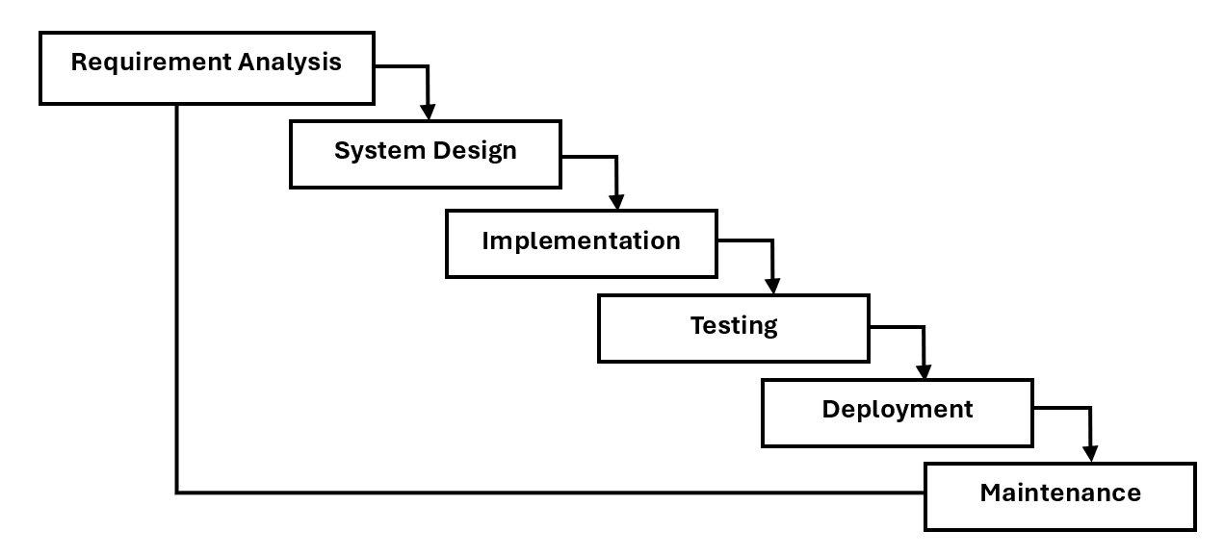
Figure 1. SDLC - Waterfall Model
3.1.2 Conceptual Diagram
The Conceptual Diagram presented in Figure 2 illustrates the overall Input-Process-Output-Benefits (IPOB) structure of the proposed Learning Management System for Arellano University – JAS Campus, detailing the input sources, the central processing system, the generated screen and hard copy outputs, and the resulting institutional benefits for all stakeholders.
Following the Waterfall Software Development Life Cycle, each component in the IPOB framework was mapped directly to institutional requirements. The system ingests structured academic, instructional, and user data from the five authorized campus roles across desktop and mobile devices, processes them through role-gated business logic and database security rules, and produces real-time interactive dashboards, automated grade computations, official academic reports, and AI-assisted guidance.
INPUT block. It is divided into three categories: Data, Users, and Devices. Data covers User Credentials and Account Information, Academic Year and Grading Criteria Configurations, Degree Programs, Courses, Curriculum Maps, and Section Schedules, Student Enrollment Records (Individual and Bulk CSV), Course Materials, Syllabi, Assessments, and Announcements, Attendance Logs and Assessment Submissions, and User Queries and AI Assistant Interactions. Users include the System Administrator, Academic Dean, University Registrar, Faculty Members/Professors, and Students. Devices include Personal Computers, Laptops, Tablets, and Smartphones.
PROCESS block. It refers to the proposed system, Development of a Learning Management System for Arellano University – JAS Campus, which executes role-based authentication, multi-step academic year and curriculum configuration, prerequisite-validated student enrollment, coursework and assessment delivery, automated periodic grade calculation and transmutation, dual-key Registrar grade release, and context-aware AI Academic Assistant processing.
OUTPUT block. It encompasses all generated results from the system, classified into Screen Outputs and Hard Copy Outputs. Screen Outputs include the Email Invitation and Password Activation Interface, Role-Based Dashboards and User Management Portals, Bulk Program Enrollment Confirmation Displays, Automated Gradebook Computation and Academic Performance Trackers, Course Module, Assessment Submission, and Announcement Feeds, and the Interactive Responsive AI Assistant Drawer. Hard Copy Outputs include Printable Official Transcript of Records (TOR), Printed Section Grade Sheets and Academic Performance Reports, and Master Lists of Enrolled Students per Program and Section.
BENEFITS block. It outlines five core benefits that stakeholders will gain from utilizing the system: (1) New users will experience a streamlined and secure onboarding process through automated email invitations and password setups; (2) Administrators, Deans, and Registrars will be able to govern user roles, map curricula, schedule conflict-free sections, and execute bulk program enrollments efficiently; (3) Faculty members will save time and eliminate manual grading errors through automated weighted grade calculations and transmutations from prelims to finals; (4) Students and professors will gain immediate visibility into academic performance tracking, curriculum completion, and course progress across mobile and desktop devices; and (5) School personnel and students will benefit from instant system guidance and academic query resolution provided by the integrated AI Academic Assistant.
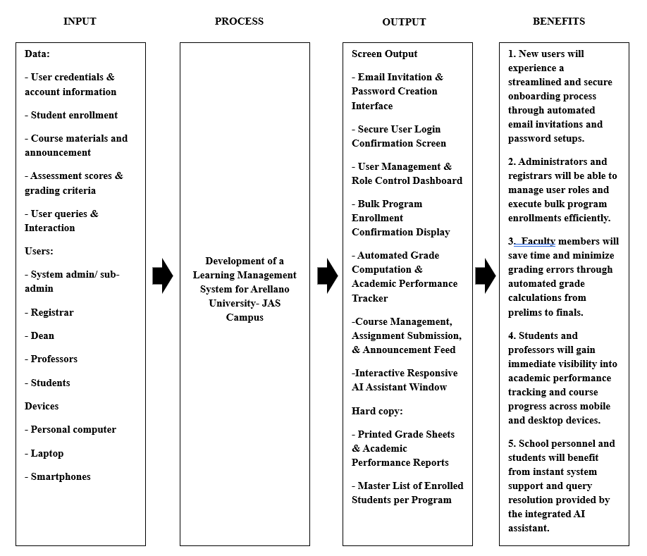
Figure 2. Input-Process-Output-Benefits (IPOB) Diagram
3.1.3 Flow of Existing System
3.1.3.1 Flowchart of the Existing System
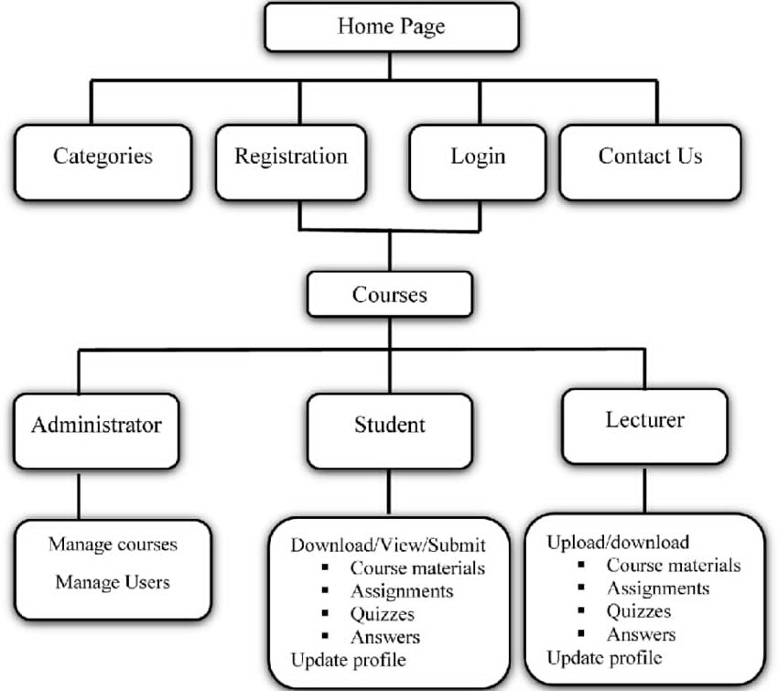
Figure 3. Flowchart of the Existing System (Learning Management System)
The existing system flow, as illustrated in Figure 3, represents the operational sequence of the conventional Learning Management System setup prior to the proposed enhancement. The workflow begins at the Home Page, where users navigate top-level links such as Categories, Registration, Login, and Contact Us. Upon completing registration or logging in, users are directed to a generic Courses directory that branches into three basic user roles: Administrator, Student, and Lecturer.
Within this traditional structure, the Administrator is restricted to basic course creation and user list maintenance, lacking dedicated multi-step wizards for school year setup, grading period weight allocation, transmutation scales, or forensic audit logging. Similarly, the Student and Lecturer roles are limited to basic file actions—uploading or downloading course materials, assignments, quizzes, and answer files, and updating basic profile fields.
Critically, the existing workflow lacks dedicated portals for the Academic Dean and the University Registrar. As a result, essential academic processes—such as degree program curriculum mapping, prerequisite enforcement, section scheduling, room and faculty conflict detection, bulk student enrollment, automated periodic grade transmutation, mandatory faculty evaluation gating, and official grade release—must be performed manually outside the platform, leading to data fragmentation, delayed grade reporting, and increased administrative workload.
3.1.3.2 Data Flow Diagram of the Existing System
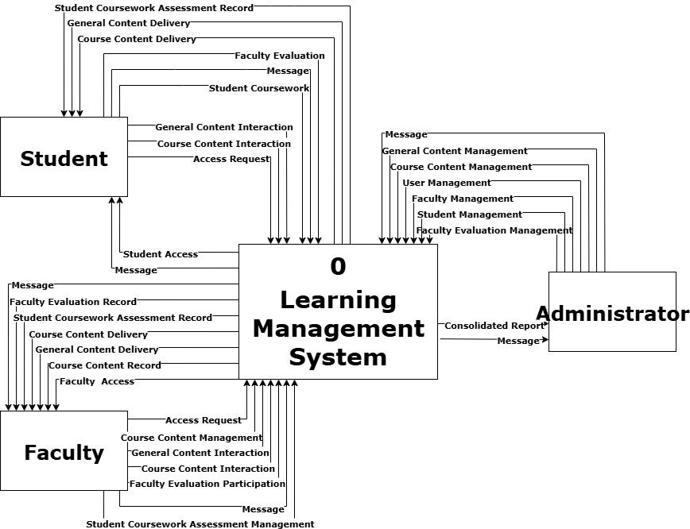
Figure 4. Data Flow Diagram of the Existing System (Level 0)
The Level 0 Data Flow Diagram (DFD) presented in Figure 4 illustrates the context-level interaction between external entities—Student, Faculty, and Administrator—and the central Learning Management System process. At this level, the LMS acts as a central intermediary that receives access requests, content uploads, coursework submissions, and evaluation inputs while returning content delivery feeds and consolidated summaries.
In this model, the Student entity submits access requests, general and course content interactions, coursework submissions, and faculty evaluation responses to the LMS, receiving course content delivery and assessment records in return. The Faculty entity provides course materials, manages coursework assessments, and participates in evaluations, while the Administrator oversees user management, general content, and faculty evaluation setups to generate consolidated reports.
While this context diagram captures basic classroom exchanges, it highlights the absence of specialized institutional entities—specifically the Academic Dean and the University Registrar—as well as the lack of automated prerequisite validation, dual-key grade release verification, and intelligent AI support services, which are addressed in the proposed system flow.
3.1.4 Flow of Proposed System
3.1.4.1 Flow Diagram of the Proposed System
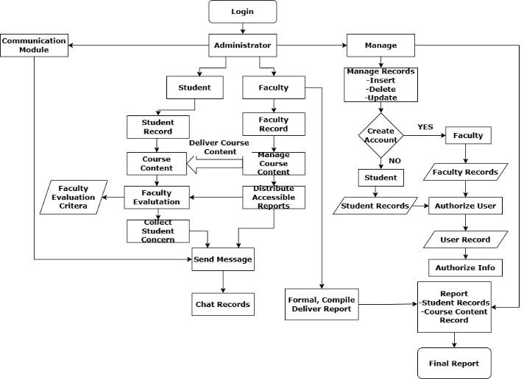
Figure 5. Flowchart of the Proposed Learning Management System
The Flow Diagram of the Proposed System shown in Figure 5 illustrates the enhanced, end-to-end operational sequence of the developed Learning Management System for Arellano University – JAS Campus. The process begins at the secure Login gateway, where authenticated users are dynamically routed by the Role-Based Access Control (RBAC) engine to their respective institutional workspaces—System Administrator, Academic Dean, University Registrar, Faculty, or Student—alongside the integrated Communication and AI Assistant module.
In the administrative and records management branch, the system governs account creation, automated email onboarding invitations, two-tier profile verification, academic calendar and grading schema configuration, degree curriculum mapping, section scheduling with conflict detection, and batch student enrollment. Every record insertion, update, or verification action is validated against PostgreSQL Row-Level Security (RLS) policies and recorded in immutable audit logs before updating the central User, Student, and Faculty repositories.
In the instructional and academic evaluation branch, Faculty members publish syllabus roadmaps and learning modules, administer 4-tier assessments (Quizzes, Exams, Activities, and Projects), track session attendance, and trigger automated weighted grade calculations. Students access learning modules, submit assessments, participate in threaded discussions, and complete mandatory end-of-term faculty evaluations. Once submitted by Faculty and verified by the Registrar through the Dual-Key Grade Release pipeline, official transmuted grades, Transcript of Records (TOR), and consolidated institutional reports are generated accurately and transparently.
3.1.4.2 Level 1 Flow of Proposed System
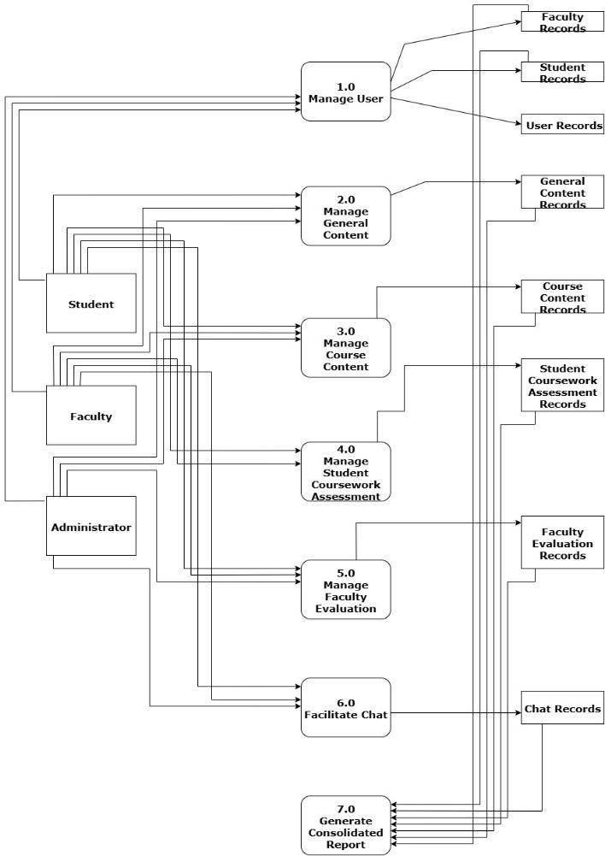
Figure 6. Data Flow Diagram of the Proposed Learning Management System (Level 1)
The Level 1 Data Flow Diagram shown in Figure 6 expands the context-level architecture by decomposing the proposed AU-JAS Learning Management System into seven interconnected core functional processes and their corresponding relational data stores in Supabase PostgreSQL.
Process 1.0 (Manage User) handles account provisioning, automated email invitation links, role assignment across Admin, Dean, Registrar, Faculty, and Student, and two-tier profile verification, reading and writing to the Faculty Records, Student Records, and User Records data stores. Process 2.0 (Manage General Content) governs institutional departments, academic years, grading periods, transmutation scales, targeted campus announcements, and calendar events, persisting data in General Content Records.
Process 3.0 (Manage Course Content) enables Academic Deans to define degree programs, curriculum maps, prerequisite rules, and section schedules, and empowers Faculty members to publish syllabi and instructional modules into Course Content Records. Process 4.0 (Manage Student Coursework Assessment) orchestrates the 4-tier Assessment Builder, rubric scoring, daily attendance logging, automated periodic grade calculation, and the anti-tamper Dual-Key Registrar Grade Release pipeline stored in Student Coursework Assessment Records.
Process 5.0 (Manage Faculty Evaluation) administers customizable Likert-scale evaluation instruments and enforces the dual-key gating rule requiring students to evaluate their instructors prior to viewing released term grades, storing responses in Faculty Evaluation Records. Process 6.0 (Facilitate Chat and AI Assistant) powers threaded course discussions and the context-aware Google Gemini AI Academic Assistant via Supabase Edge Functions, logging interactions in Chat Records. Finally, Process 7.0 (Generate Consolidated Report) aggregates verified records across all data stores to produce real-time KPI dashboards, curriculum audit checklists, GWA analytics, printable Transcripts of Records (TOR), and forensic audit logs.
3.2 Requirements Documentation
3.2.1 Research Methods
This study employed the Quantitative Research Method combined with a Descriptive Research Design to guide the requirements analysis, functional verification, and software quality evaluation of the Learning Management System for Arellano University – JAS Campus. Quantitative research focuses on the systematic collection and statistical analysis of measurable data through structured instruments and computational techniques (Creswell, 2014) [22].
The descriptive research design was utilized because it systematically characterizes the existing conditions, workflows, and user perceptions within a target institutional setting without manipulating variables (McCombes, 2019) [23]. In this study, the descriptive design enabled the researchers to document the concrete operational challenges encountered by administrators, deans, registrars, faculty members, and students at Arellano University – Jose Abad Santos Campus and to measure how effectively the developed LMS resolves those challenges.
This methodological approach was selected because evaluating an enterprise academic platform requires both objective functional verification metrics and standardized user quality ratings. As noted by Apuke (2017) [24], descriptive quantitative research utilizing structured survey questionnaires effectively determines the frequency, distribution, and composite mean agreement of respondents across standardized evaluation criteria, ensuring objectivity and statistical validity.
3.2.2 Analysis Methods
Interview
Structured and semi-structured interviews were conducted to gather detailed qualitative insights regarding stakeholders’ experiences with existing academic and classroom management workflows at Arellano University – JAS Campus. As Kvale (2007) [25] explains, interviews provide an effective mechanism for capturing in-depth user requirements, pain points, and institutional expectations. Faculty members, administrative staff, and students were interviewed to identify bottlenecks in course material distribution, manual grade computation, section scheduling, and student enrollment.
Observation
Direct observation was employed during both the system analysis and prototype testing phases to record user interactions, navigation patterns, and task completion times in real time. Creswell (2014) [22] notes that systematic observation enables researchers to evaluate system responsiveness and user adaptation under authentic usage conditions. The researchers observed participants executing multi-role workflows—including school year setup, curriculum mapping, bulk CSV enrollment, assessment taking, and AI Assistant querying—across both desktop and mobile viewports.
Survey/Questionnaire
Standardized survey questionnaires were distributed to 30 respondents to formally evaluate the developed AU-JAS Learning Management System [26]. Aligned with the ISO/IEC 25010 Software Quality Model [27], the evaluation instrument assessed the platform across eight core software quality characteristics: Functional Suitability, Performance Efficiency, Compatibility, Usability, Reliability, Security, Maintainability, and Portability. Responses were measured using a 5-point Likert scale and analyzed using frequency counts and weighted composite means to determine the overall acceptability and quality of the system.
3.2.3 Scope
The scope of the developed system encompasses a comprehensive, web-based Learning Management System with an integrated AI Academic Assistant for Arellano University – Jose Abad Santos Campus, governed by strict Role-Based Access Control (RBAC) and PostgreSQL Row-Level Security (RLS) across five institutional roles: System Administrator, Academic Dean, University Registrar, Faculty Member, and Student. For System Administrators, the scope includes automated user onboarding via Supabase Auth email invitations, bulk CSV user and department imports, staff profile verification with side-by-side diff inspection, a 3-step Department Management wizard, an enterprise Academic Year and Term Configuration Wizard with version history rollback, custom grading period and 100% component weight budgeting, special grade rules (INC, DRP, FA) with a dry-run sandbox, transmutation table management, faculty evaluation questionnaires, forensic JSON audit logs, and global system branding settings.
For Academic Deans, the scope covers college-level KPI dashboards, Program Level and Course Type CRUD, Degree Program Catalog and 4-year Curriculum Map construction, curriculum cloning across school years, course blueprints with lecture/laboratory unit multipliers, a 3-step Section Scheduling Wizard, a 3-step Faculty Load Assignment Wizard, and an automated Schedule Conflict and Room Collision Inspector. For the University Registrar, the system provides student profile verification and requirement auditing, academic program shifting and year-level overrides, individual student enrollment, batch bulk CSV enrollment with automated prerequisite validation, official section grade inspection and Dual-Key Grade Release with cryptographic timestamping, and dedicated Registrar audit logs.
For Faculty Members, the platform provides an 8-tab Section Studio comprising Syllabus and Interactive Module publishing, cross-cohort lesson duplication, a multi-criterion Rubrics Builder Studio, a 4-tier Assessment Builder (Quiz, Exam, Activity, Project) with CSV question import, threaded discussion moderation, daily attendance session tracking, holistic student performance modals, automated weighted gradebook computation and transmutation, and anti-tamper grade submission to the Registrar. For Students, the portal delivers personalized dashboards, weekly timetables, syllabus completion roadmaps, online assessment taking and file submission, attendance rate tracking, mandatory faculty evaluation gating, a live 4-year Curriculum Checklist, printable official Transcript of Records (TOR), GWA trend analytics, and a What-If Grade Simulator.
Across all five roles, the system provides a context-aware AI Academic Assistant powered by Google Gemini via Supabase Edge Functions, multi-audience targeted announcements, a universal interactive campus and section calendar, and full responsive parity across desktop (1440x900) and mobile (390x844) devices adhering to WCAG 2.1 accessibility standards.
Limitations: Because the AU-JAS LMS is a cloud-synchronized web application backed by Supabase PostgreSQL and Edge Functions, an active internet connection is required for authentication, real-time database transactions, and conversational AI Assistant queries. File attachments uploaded to course modules and assessment submissions are subject to configurable institutional file size and MIME-type restrictions defined in System Settings. Furthermore, the platform is scoped strictly to academic governance, curriculum management, enrollment, classroom instruction, and grading; it does not cover financial accounting, tuition fee cashiering, or human resource payroll processing.
3.3 Technical Background
3.3.1 Product Description
The proposed system is an enterprise-grade, web-based Learning Management System with an integrated AI Academic Assistant developed specifically for Arellano University – Jose Abad Santos Campus (AU-JAS LMS). It directly resolves the usability, scheduling, enrollment, and grading limitations of conventional LMS platforms by unifying five role-specific workspaces within a single responsive Single-Page Application (SPA).
For Students, the system provides a distraction-free learning portal where they can access syllabi and lecture modules, complete timed quizzes and exams, upload project deliverables, participate in class discussions, monitor their attendance and 4-year curriculum progress, simulate future GWA outcomes, print official Transcripts of Records, and consult a 24/7 AI Tutor for concept clarification and study guidance.
For Faculty Members, the system streamlines instructional delivery and assessment management through guided module and assessment wizards, reusable grading rubrics, bulk CSV question imports, one-click lesson duplication across sections, daily attendance wizards, and an automated gradebook that computes weighted periodic and final grades and transmutes scores automatically.
For the Academic Dean, the platform provides comprehensive control over the college’s academic catalog, enabling the creation of degree programs, multi-year curriculum maps with prerequisite chains, lecture and laboratory course blueprints, and class sections while automatically detecting room, instructor, and schedule collisions and monitoring faculty unit loads.
For the University Registrar, the system centralizes student credential verification, program shifting, individual and bulk CSV block enrollment with automated prerequisite enforcement, year-level promotion evaluation, and the final verification and official release of faculty-submitted section grade sheets.
For the System Administrator, the platform delivers complete institutional governance over user accounts, automated onboarding invitations, department structures, school year and term calendars, grading period weights, transmutation tables, evaluation instruments, system branding, and immutable forensic audit logs.
3.3.2 Economic Use of the Product
The AU-JAS LMS provides a highly cost-effective, sustainable digital solution for Arellano University – Jose Abad Santos Campus. Built using open-source frontend frameworks (React.js, TypeScript, Vite, Tailwind CSS, Material UI) and deployed on cloud-native serverless infrastructure (Vercel and Supabase), the system eliminates expensive per-seat proprietary LMS licensing fees and complex on-premise server maintenance.
Furthermore, by digitizing and automating course module distribution, assessment administration, periodic grade computation, faculty evaluations, bulk CSV enrollments, and Transcript of Records generation, the platform significantly reduces paper consumption, printing expenses, and administrative labor hours across all campus departments.
3.3.3 User Requirements
This section outlines the operational and qualification requirements for each of the five institutional user roles of the Learning Management System:
Students
• Must be officially registered as a student at Arellano University – Jose Abad Santos Campus.
• Must possess an active institutional or personal email address to receive the automated account activation link.
• Must have basic computer or smartphone literacy and familiarity with standard web browsers.
• Must have access to a desktop computer, laptop, tablet, or smartphone with internet connectivity.
Faculty Members / Professors
• Must be an authorized faculty member employed under Arellano University – Jose Abad Santos Campus and assigned to an academic department.
• Must have foundational proficiency in operating web browsers, uploading digital instructional documents, and managing classroom assessments.
• Must have access to a personal computer, laptop, or mobile device to manage sections, record attendance, and submit computed gradebooks.
Academic Deans
• Must hold an official appointment as an Academic Dean or Program Head at Arellano University – Jose Abad Santos Campus.
• Must be familiar with institutional curriculum policies, CHED program standards, course prerequisites, and faculty workload unit allocations.
• Must have an authorized Dean account scoped to their designated college or academic department.
University Registrars
• Must be an authorized personnel member of the Office of the University Registrar at Arellano University – Jose Abad Santos Campus.
• Must be knowledgeable in institutional enrollment procedures, student credential verification, prerequisite rules, and official grade release protocols.
System Administrators
• Must hold official IT and systems governance authorization from Arellano University – Jose Abad Santos Campus.
• Must be proficient in managing user roles, academic calendar configurations, grading schemas, audit logs, and technical support operations.
• Must maintain regular data exports, CSV backups, and security oversight of the institutional environment.
3.3.4 System Requirements
The technical, permission, hardware, and software requirements of the system are defined as follows:
• Role Permissions: Role-Based Access Perimeter: Students and Faculty have scoped access restricted strictly to their enrolled or assigned sections, preventing unauthorized modification of institutional settings or other users’ private records.
• Administrative Scoping: Departmental and Records Governance: Academic Deans manage curriculum catalogs, sections, and faculty loads within their assigned college, while Registrars govern student profile verification, enrollments, and official grade releases.
• System Administration: Superuser Governance: System Administrators have full control over user provisioning, department setup, academic year wizards, grading and transmutation rules, evaluation templates, system settings, and forensic audit trails.
• Client Hardware: Desktop or Laptop PC (Dual-core 1.6 GHz processor or higher, 4 GB RAM minimum) or Mobile Device/Smartphone (Android 10+ or iOS 14+ with at least 390px viewport width).
• Web Browser Compatibility: Any modern evergreen web browser supporting ES2022, CSS Grid, and Flexbox, including Google Chrome (v100+), Mozilla Firefox (v100+), Microsoft Edge (v100+), or Apple Safari (v15+).
• Network Connectivity: Broadband Wi-Fi, Ethernet, or 4G LTE / 5G mobile data connection (minimum 5 Mbps recommended for smooth rich-media loading and real-time AI Assistant streaming).
• Cloud Hosting Infrastructure: Vercel Edge Network for static SPA asset delivery and Supabase Cloud (PostgreSQL 15+, GoTrue Auth, Supabase Storage, and Deno Edge Runtime with Google Gemini API integration).
3.3.5 Setting and Participants
The testing and evaluation of the Learning Management System for Arellano University – Jose Abad Santos Campus were conducted within the academic environment of Arellano University – JAS Campus in Malabon/Manila, utilizing both computer laboratory workstations and personal mobile devices to reflect real-world blended learning conditions.
The participants of the study consisted of 30 respondents purposively selected from the campus community, comprising college students, faculty members, academic administrative personnel (Deans and Registrar staff), system administrators, and Information Technology experts. These respondents were selected because they represent the exact end-user roles of the platform and possess direct experience with institutional academic workflows.
During the evaluation sessions, participants interacted directly with the live deployed AU-JAS LMS across both desktop (1440x900) and mobile (390x844) viewports. Respondents executed role-specific tasks including account activation, school year configuration, curriculum mapping, section scheduling, bulk CSV student enrollment, module and assessment authoring, online quiz taking, automated grade computation and release, and querying the integrated AI Academic Assistant. Following hands-on testing, all 30 participants completed a structured evaluation questionnaire based on the ISO/IEC 25010 Software Quality Model.
The quantitative ratings gathered from the respondents were statistically processed using frequency counts and weighted composite means to determine the system’s compliance with international software quality standards across Functional Suitability, Performance Efficiency, Compatibility, Usability, Reliability, Security, Maintainability, and Portability.
3.4 Development and Testing
3.4.1 Development Process
The development of the Learning Management System for Arellano University – JAS Campus was executed using a modern, type-safe, full-stack web architecture. On the client side, the application was built using React 18.3 and TypeScript 5.9 with Vite 7.1 as the build bundler. The user interface was engineered using Tailwind CSS 4.2 and Material UI (MUI v7) for responsive layouts and accessible modal wizards, AG-Grid React for high-performance data tables with multi-column sorting and dynamic filtering, Zustand for reactive state management, React Hook Form for multi-step form validation, and Toast UI Editor for rich markdown content authoring.
On the backend and database layer, the system utilizes Supabase, powered by a PostgreSQL relational database enforcing strict Row-Level Security (RLS) policies, foreign-key cascade integrity, and stored database functions such as fn_evaluate_student_year_level for automated student year-level promotion. Authentication and automated onboarding email invitations are handled by Supabase Auth, file uploads are managed via Supabase Storage, and the context-aware AI Academic Assistant is powered by a serverless Supabase Edge Function (ai-assistant) integrating Google Gemini AI. Furthermore, custom engineering hooks—including useFormDraft for sessionStorage draft auto-recovery and useHasRealChanges for semantic change detection—were implemented across all multi-step wizards.
Following the Waterfall SDLC presented in Section 3.1.1, the development team first finalized the database schema and Figma UI prototypes before implementing the five role portals sequentially: (1) System Administrator governance and Academic Year wizards, (2) Academic Dean catalog, curriculum mapping, and conflict-checked section scheduling, (3) University Registrar student verification, bulk CSV enrollment, and grade release, (4) Faculty 8-tab Section Studio, 4-tier Assessment Builder, and automated Gradebook, and (5) Student learning portal, curriculum tracker, printable TOR, and mobile-first responsive drawers, culminating in production deployment on Vercel.
3.4.2 Testing Process
Testing of the AU-JAS Learning Management System was conducted in two rigorous stages—Initial Internal QA Testing and Final User Acceptance Evaluation—focusing on functional completeness, relational data integrity, security isolation, cross-viewport responsiveness, and usability.
Unit and Component Testing
Automated unit and component tests were executed using Vitest and React Testing Library to validate grade calculation formulas, transmutation table lookups, 100% component weight budget validators, special grade rule evaluators (INC, DRP, FA), and wizard step state transitions.
End-to-End CRUD and Workflow Verification
Using Playwright browser automation alongside manual verification across 53 comprehensive test probes, the researchers verified the full Create-Read-Update-Delete (CRUD) lifecycle of every entity—including Academic Years, Departments, Terms, Announcements, Campus Events, Program Levels, Course Types, Course Blueprints, Sections, Syllabi, 4-tier Assessments, Student Submissions, and Gradebook Releases—achieving a 100% pass rate with zero orphan database rows.
Role-Based Security and Broadcast Testing
PostgreSQL Row-Level Security (RLS) policies and UI RoleGate boundaries were tested across all five roles to confirm that unauthorized route access is blocked, section-scoped announcements and events are isolated strictly to enrolled cohorts, and submitted grade sheets are locked against post-submission tampering.
Cross-Device and Mobile Viewport Testing
The application was audited across Desktop (1440x900) and Mobile (390x844 iPhone) viewports. All dashboards, AG-Grid cards, multi-step wizards, and touch navigation drawers maintained 100% boundary compliance with zero horizontal overflow.
Usability and ISO/IEC 25010 User Evaluation
During final testing, 30 respondents from Arellano University – JAS Campus evaluated the live system and completed the ISO/IEC 25010 survey instrument, confirming high learnability, operability, and user satisfaction across all five institutional portals.
3.5 Description of the Prototype
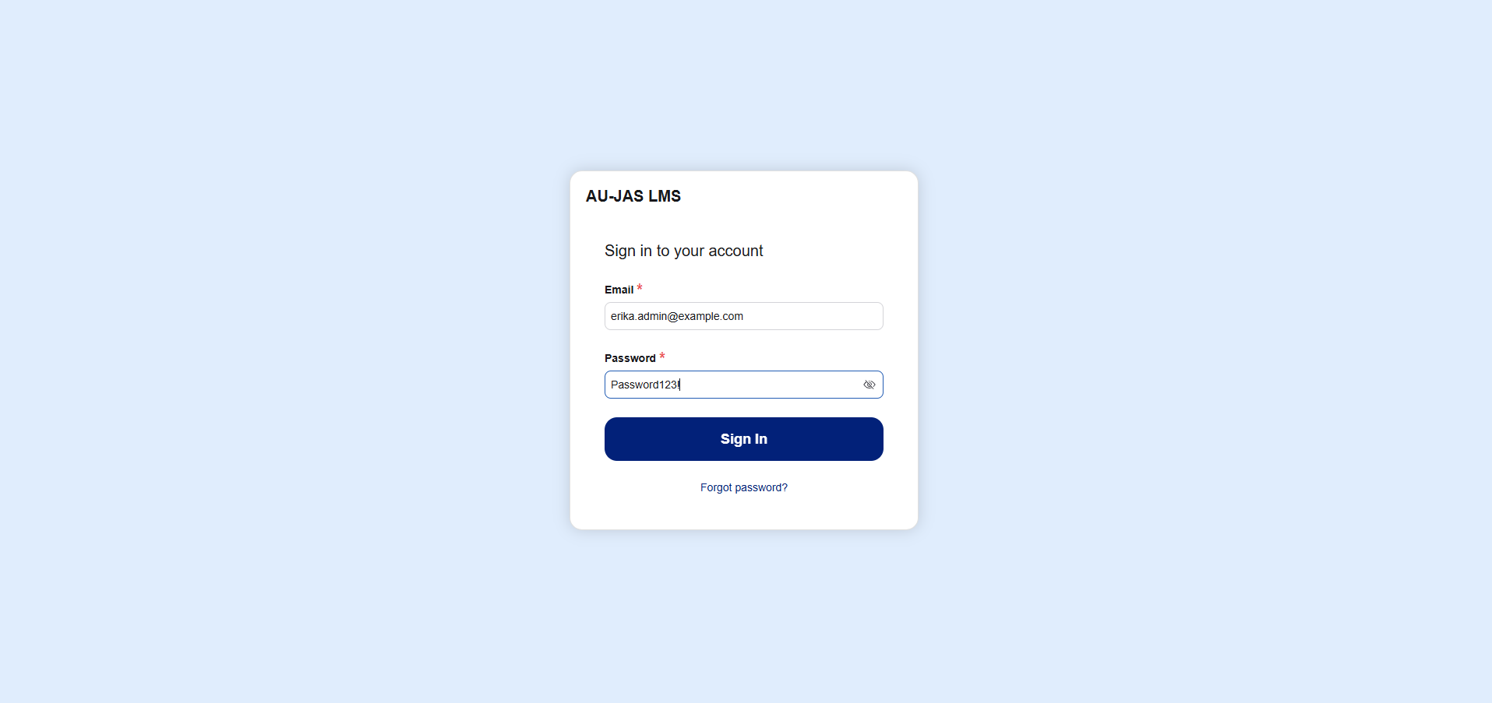
Figure 7. User Login
The User Login interface serves as the unified authentication gateway for all five institutional roles of the AU-JAS LMS. Users enter their registered email address and password to authenticate via Supabase Auth, after which the system’s RoleGate router automatically directs them to their respective role portal (Admin, Dean, Registrar, Faculty, or Student).
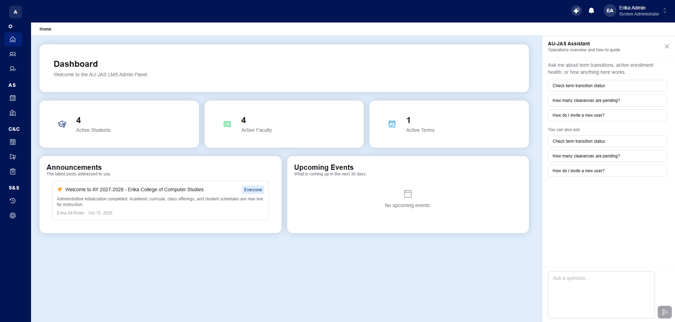
Figure 8. Admin Dashboard
Upon logging in, the System Administrator is directed to the Admin Dashboard, which displays real-time institutional KPI cards including Total Active Users, Active Students, Active Faculty, Departments, and the currently active Academic Year and Term. The dashboard also provides quick-action shortcuts, recent system announcements, upcoming campus events, and top-bar access to notifications and the context-aware AI Assistant.
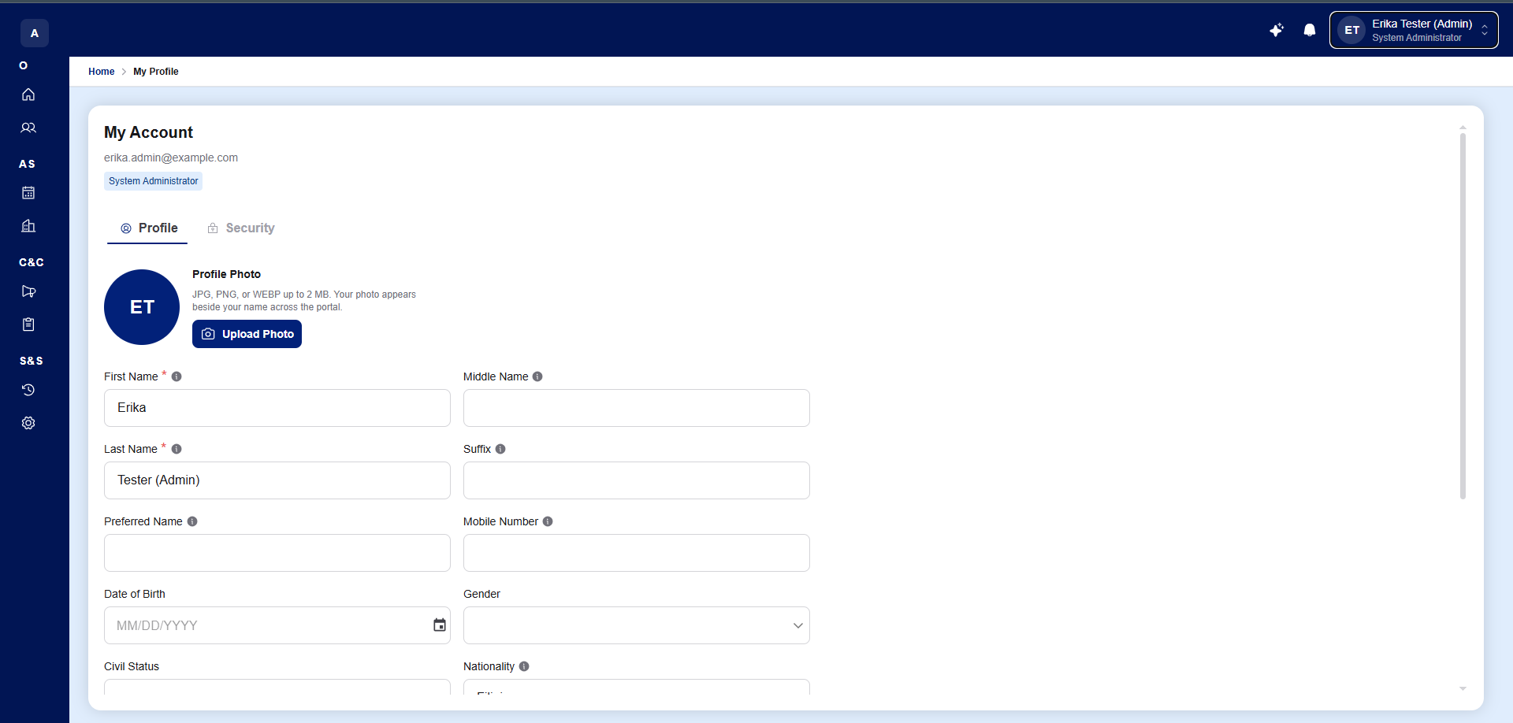
Figure 9. User Profile
The User Profile module provides a comprehensive view of the user’s account credentials and personal details. Through this interface, users can manage their profile photograph, contact number, birth date, gender, civil status, nationality, and residential address, as well as update their account password within the security settings panel.
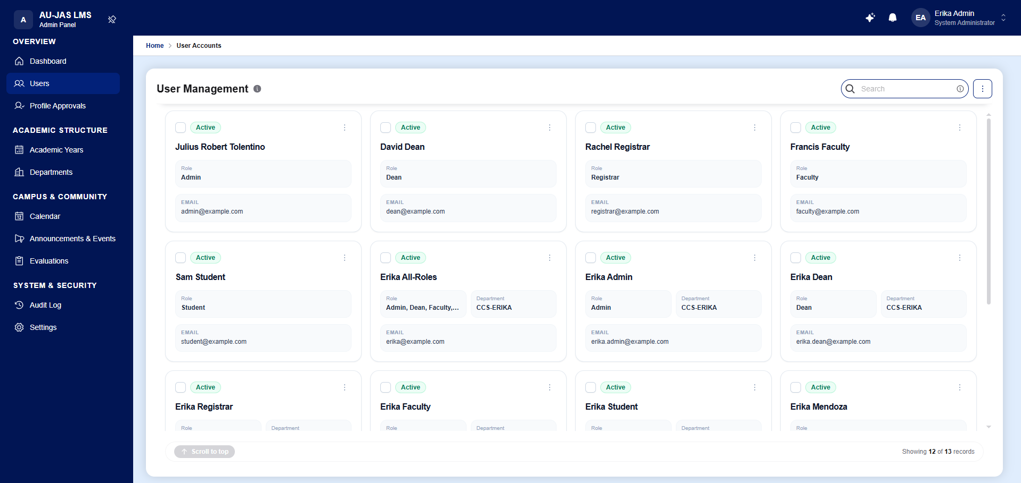
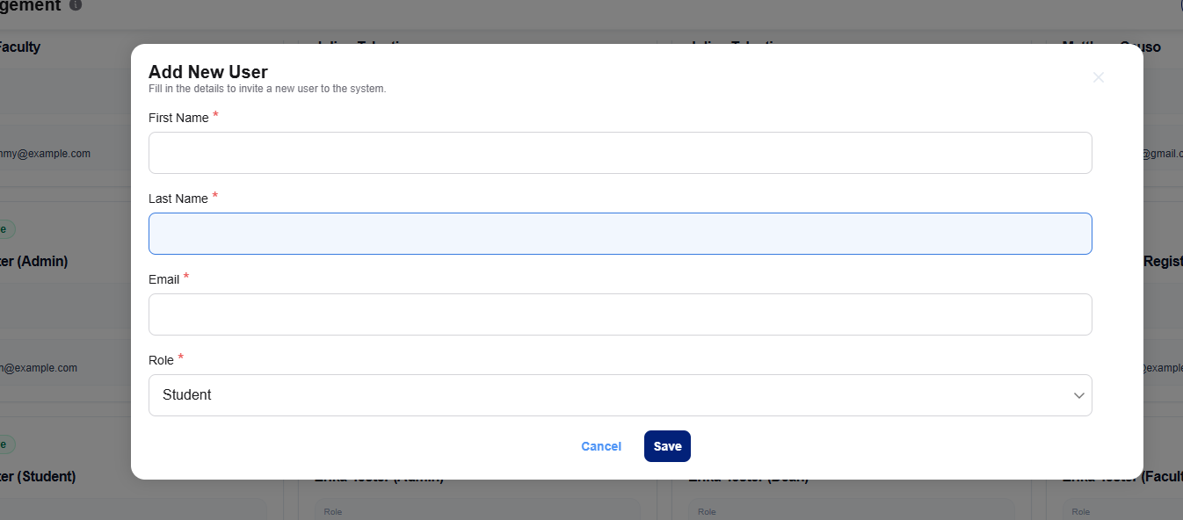
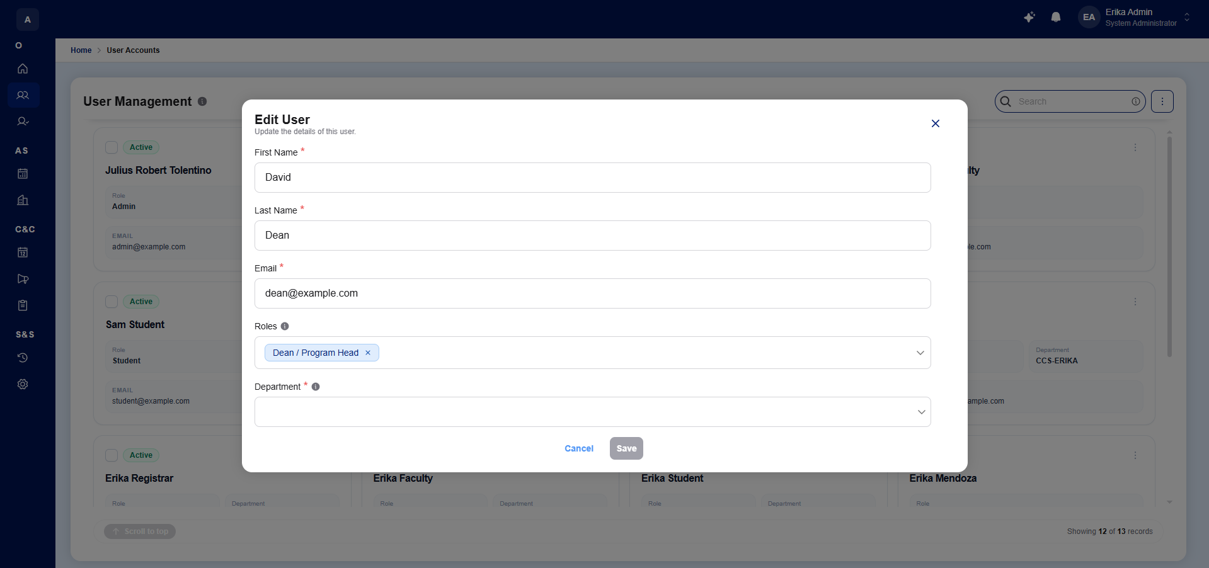
Figure 10. User Management (Admin)
The User Management module serves as the central directory for all registered LMS accounts across students, faculty members, registrars, deans, and administrators. Administrators can search and filter accounts in real time, provision individual users via the "Add New User" modal—which automatically dispatches a Supabase Auth email activation invite—or batch-create accounts using the Universal Bulk CSV Import pipeline.
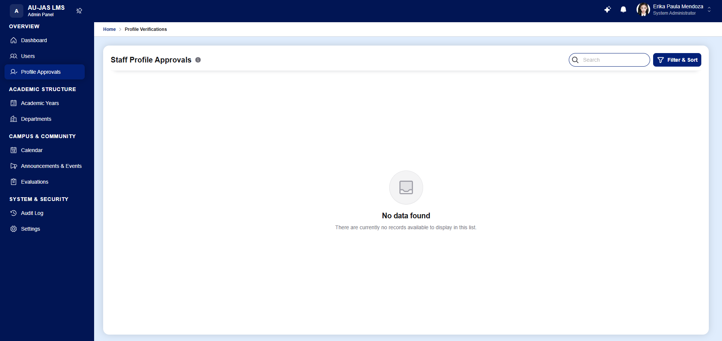
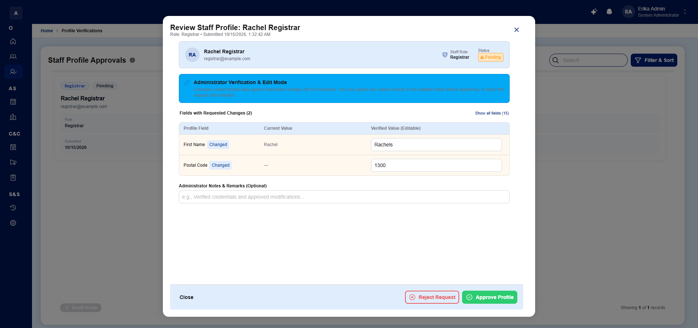
Figure 11. Profile Approval (Admin)
The Profile Approval queue in the Admin Portal functions as an administrative security control mechanism for reviewing personal and professional credential update requests submitted by staff personnel (Registrars, Academic Deans, and Faculty members). Administrators can inspect side-by-side field diffs showing previous and requested values before approving or rejecting the modification.
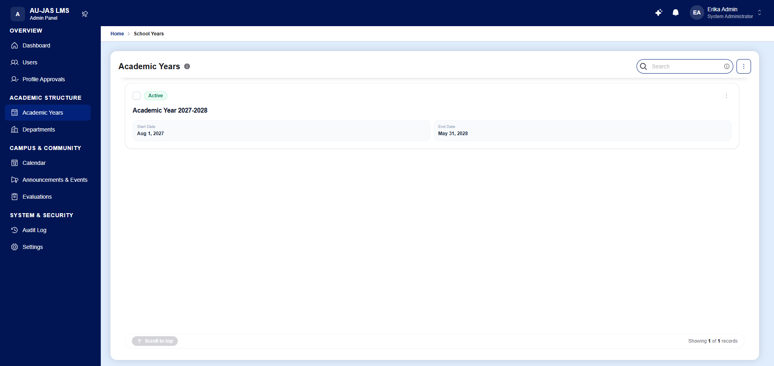
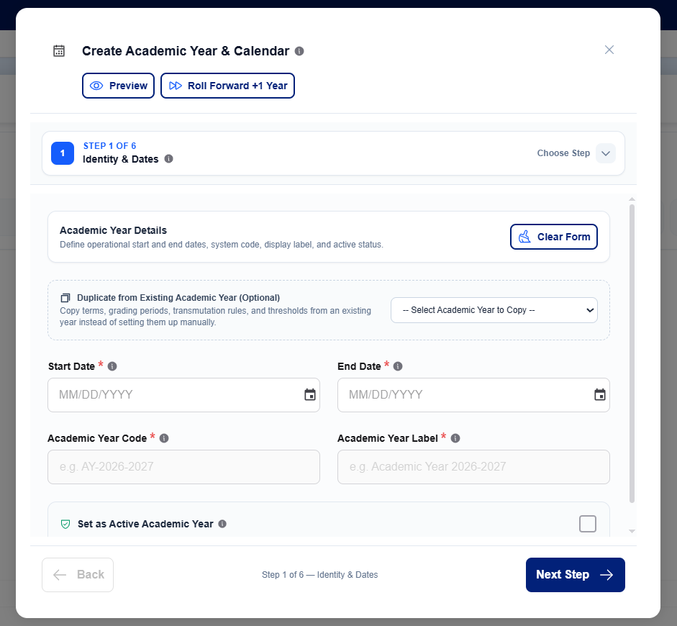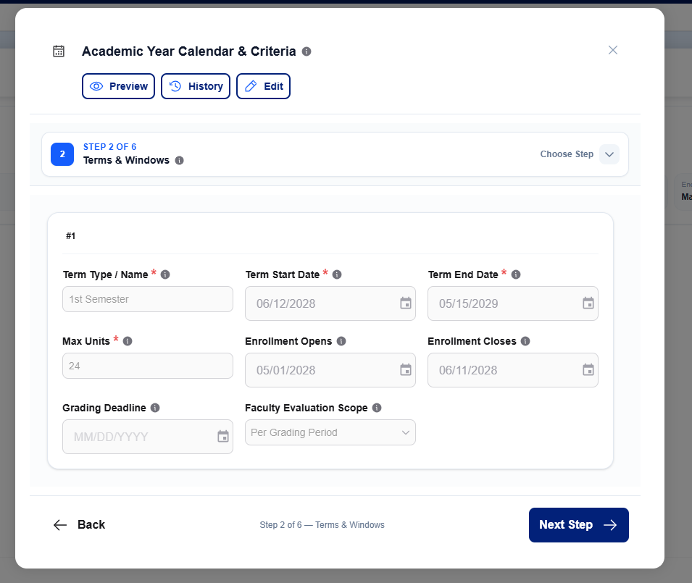
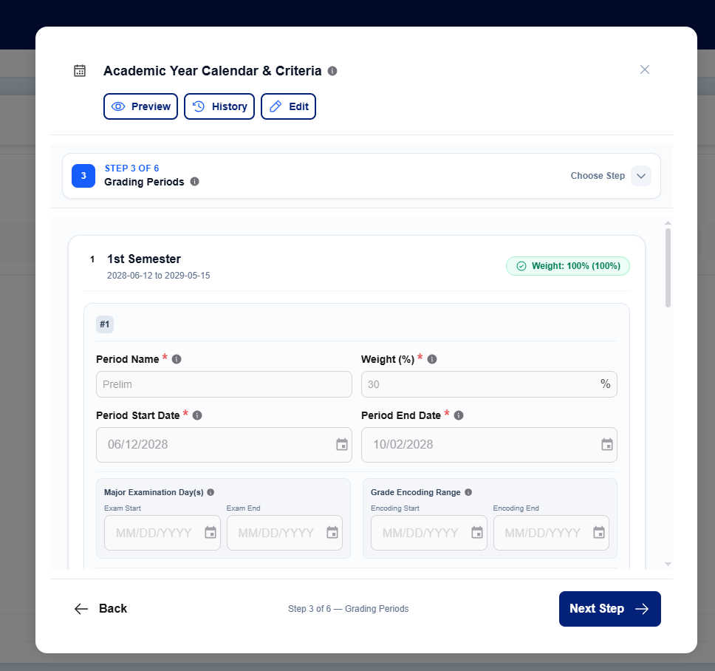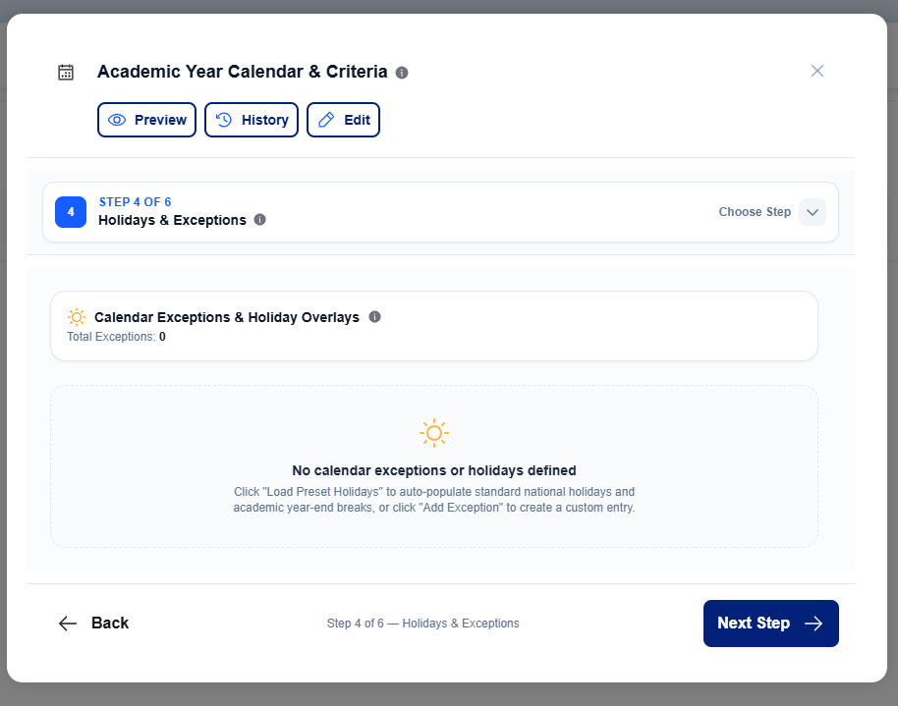
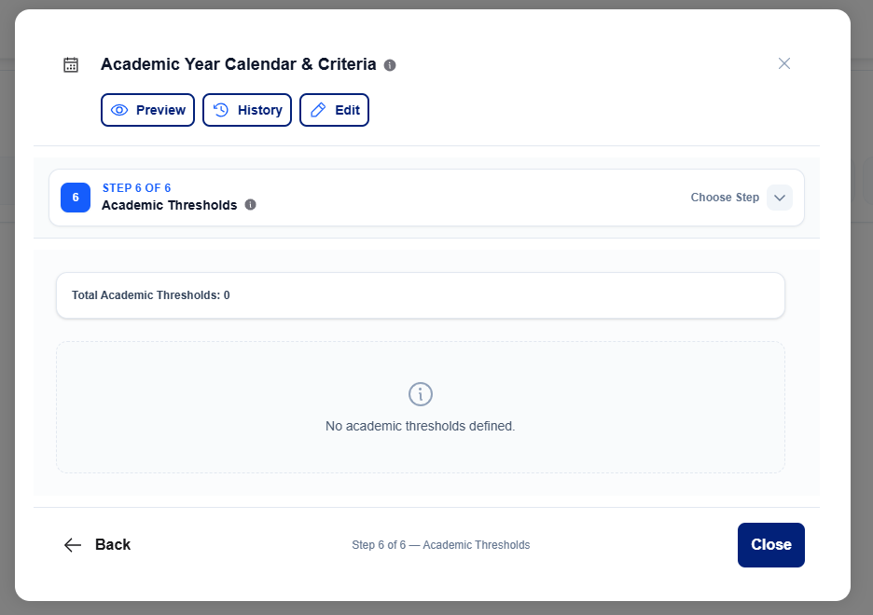
Figure 12. Academic Years Configuration Wizard
The Academic Years module serves as the core institutional calendar and grading configuration engine of the LMS. Through a guided multi-step wizard complete with version history snapshots and rollback capabilities, administrators configure school years, sequential term rails (1st Semester, 2nd Semester, Summer), enrollment windows, grading periods (Prelim, Midterm, Semi-Final, Finals), 100% component weight budgets, special grade rules (INC, DRP, FA) with a live dry-run sandbox, institutional grade transmutation tables, and academic honors/probation thresholds.
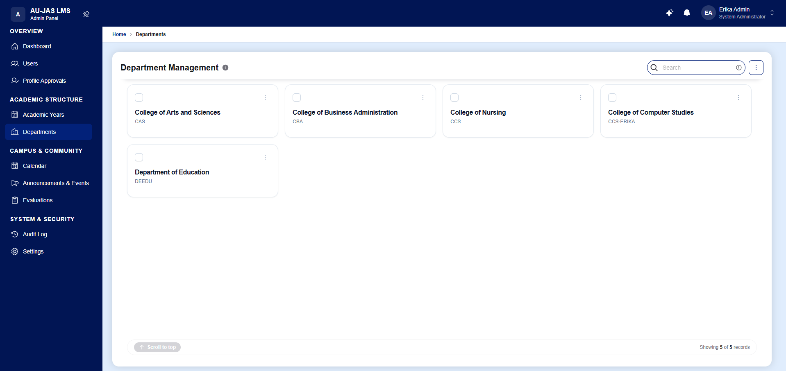
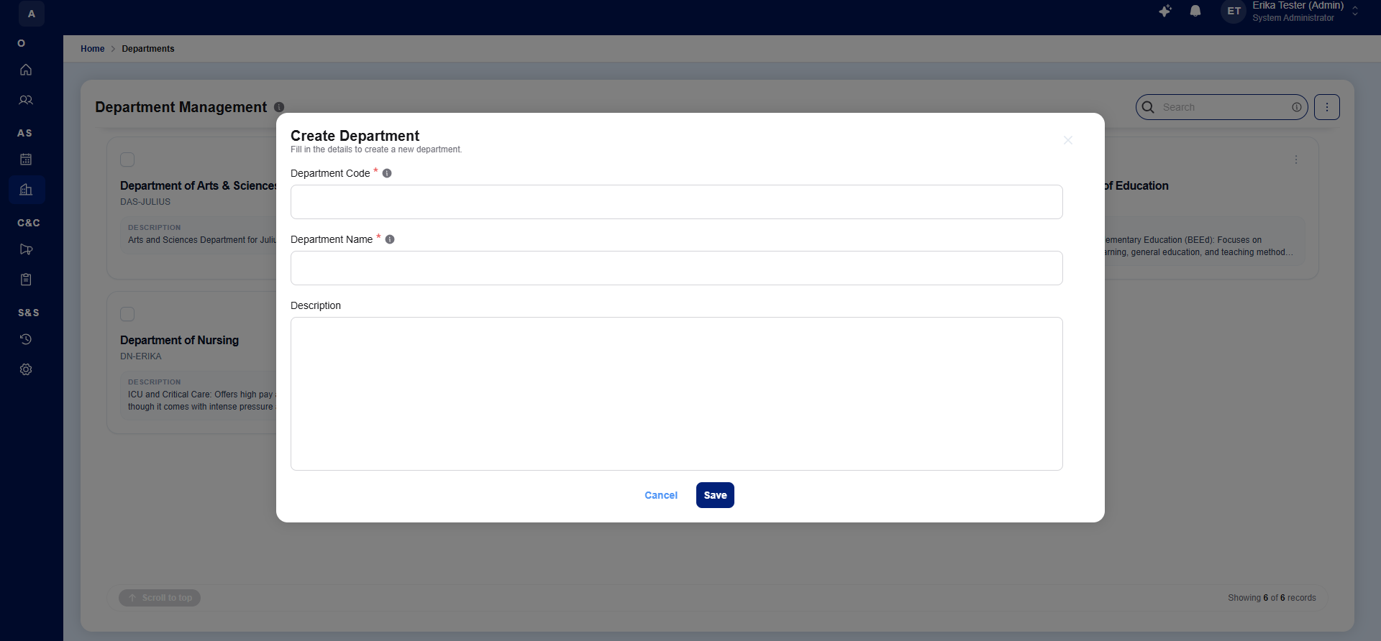
Figure 13. Department Management
The Department Management module enables administrators to establish, view, and organize academic colleges and departments (e.g., College of Computer Studies, College of Education) through a 3-step wizard that configures department identity, assigns an Academic Dean, and scopes the departmental faculty roster.
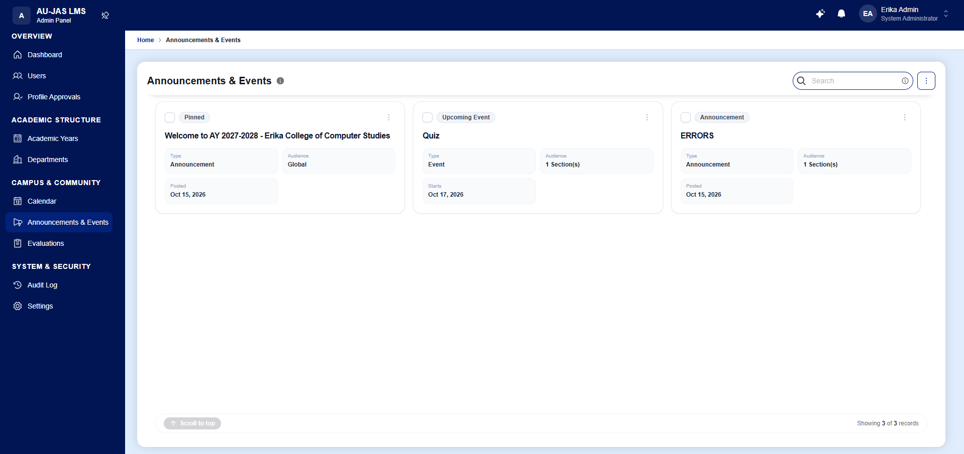
Figure 14. Announcements and Events
The Announcements and Events module allows administrators, deans, registrars, and faculty members to author and broadcast targeted communications using a rich Markdown editor. Notices and scheduled events can be published globally to the entire institution, targeted to specific roles or departments, or isolated strictly to individual class sections.
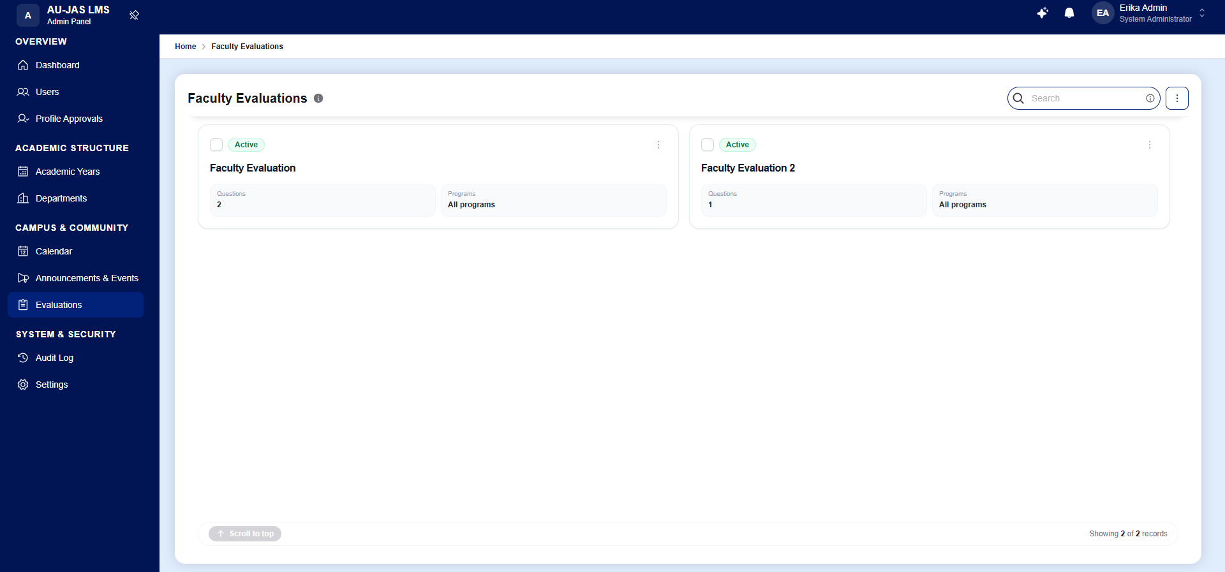
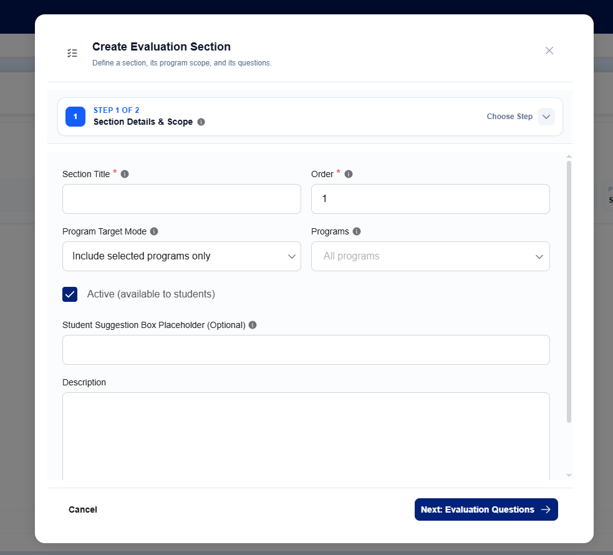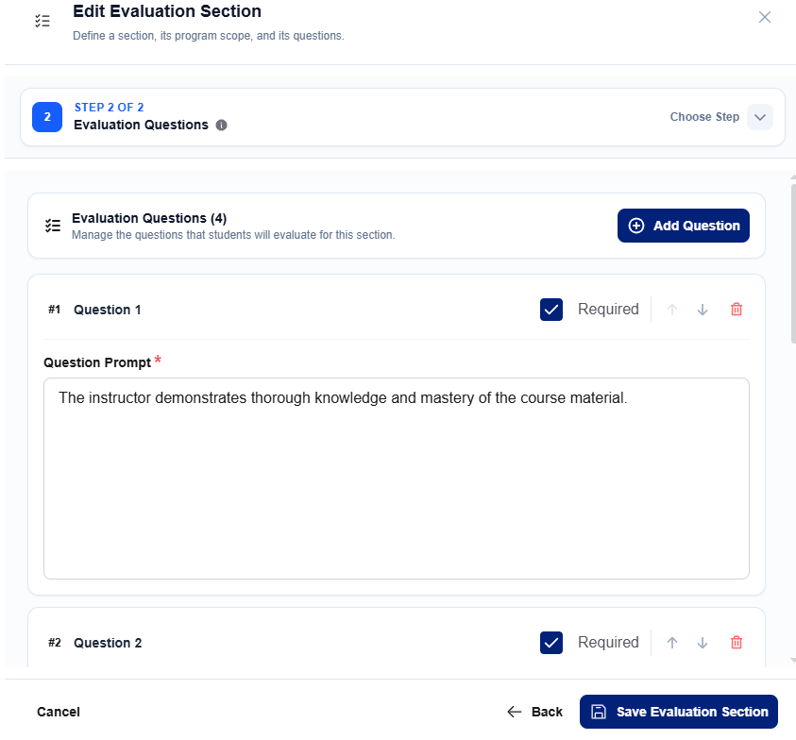
Figure 15. Faculty Evaluation Management
The Faculty Evaluation Management module enables administrators to configure evaluation periods and design standardized Likert-scale questionnaires Through a 2-step wizard and CSV template importer, administrators establish the evaluation criteria that students must complete at the close of each term before unlocking their official grade reports.
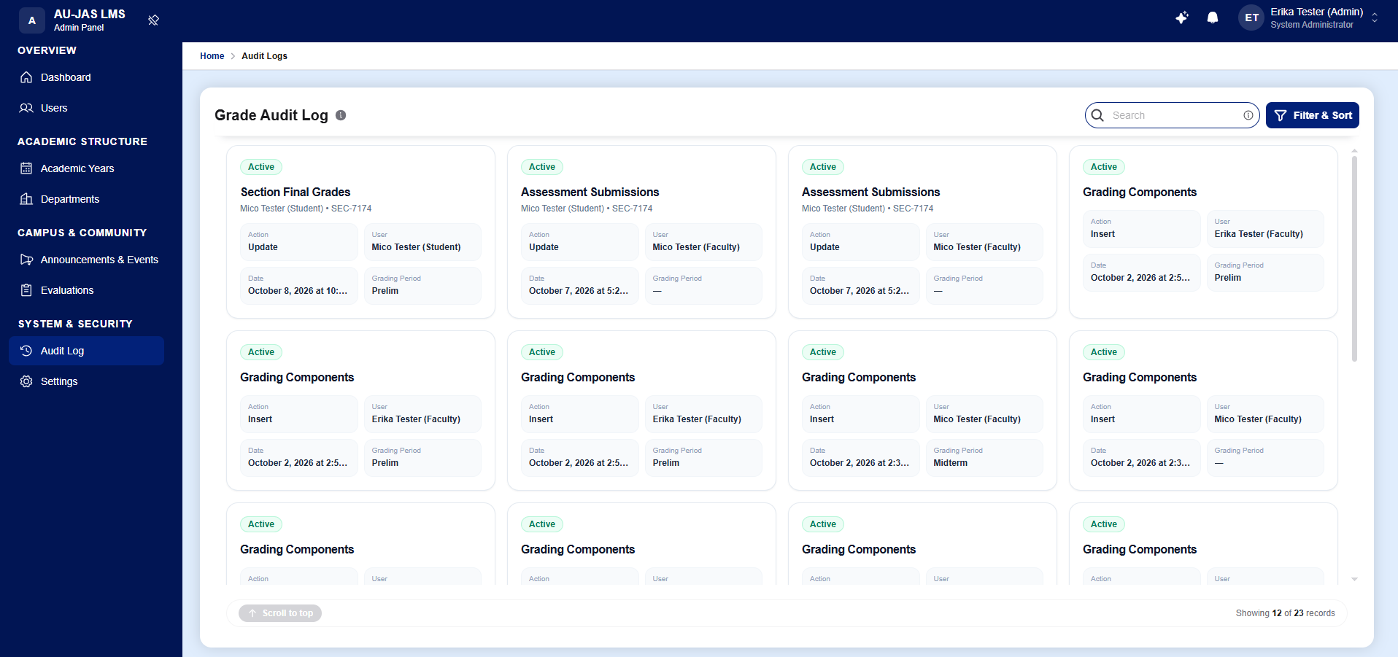
Figure 16. Audit Log (Admin)
The Forensic Audit Log provides administrators with complete operational transparency by recording immutable, timestamped logs of all critical system mutations—including academic year changes, grade schema updates, user role modifications, and grade releases—complete with a JSON payload inspector showing before-and-after state diffs.
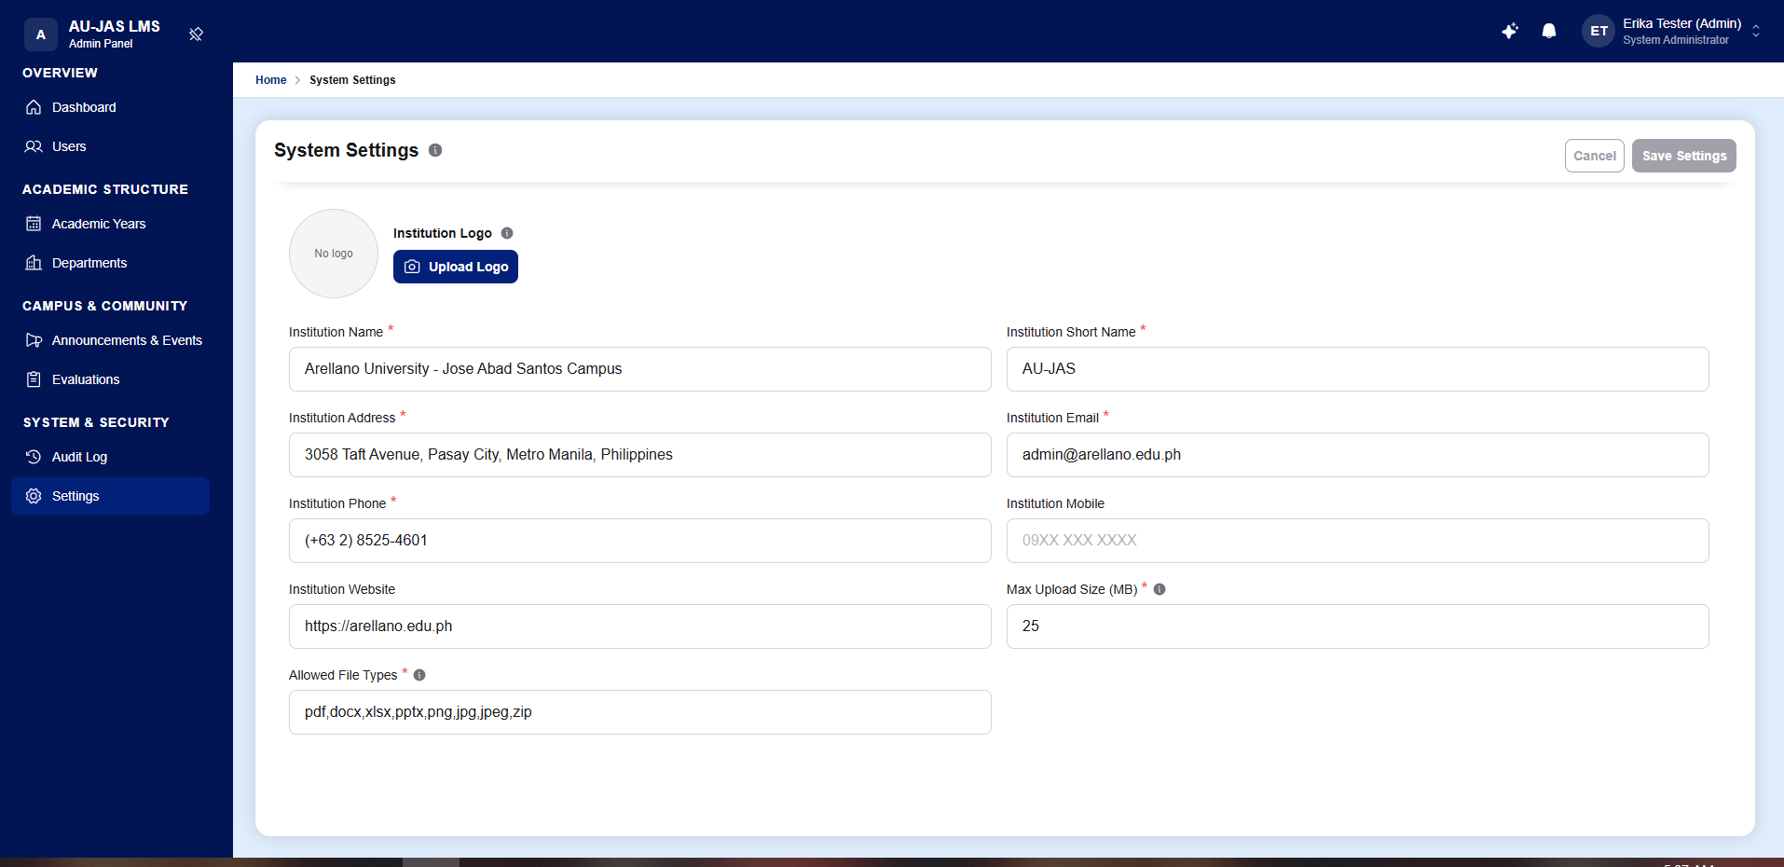
Figure 17. System Settings
The System Settings panel provides administrators with a centralized interface to configure global institutional parameters, including university name and branding logos, official contact information, session timeout durations, and file upload size and MIME-type restrictions across the platform.
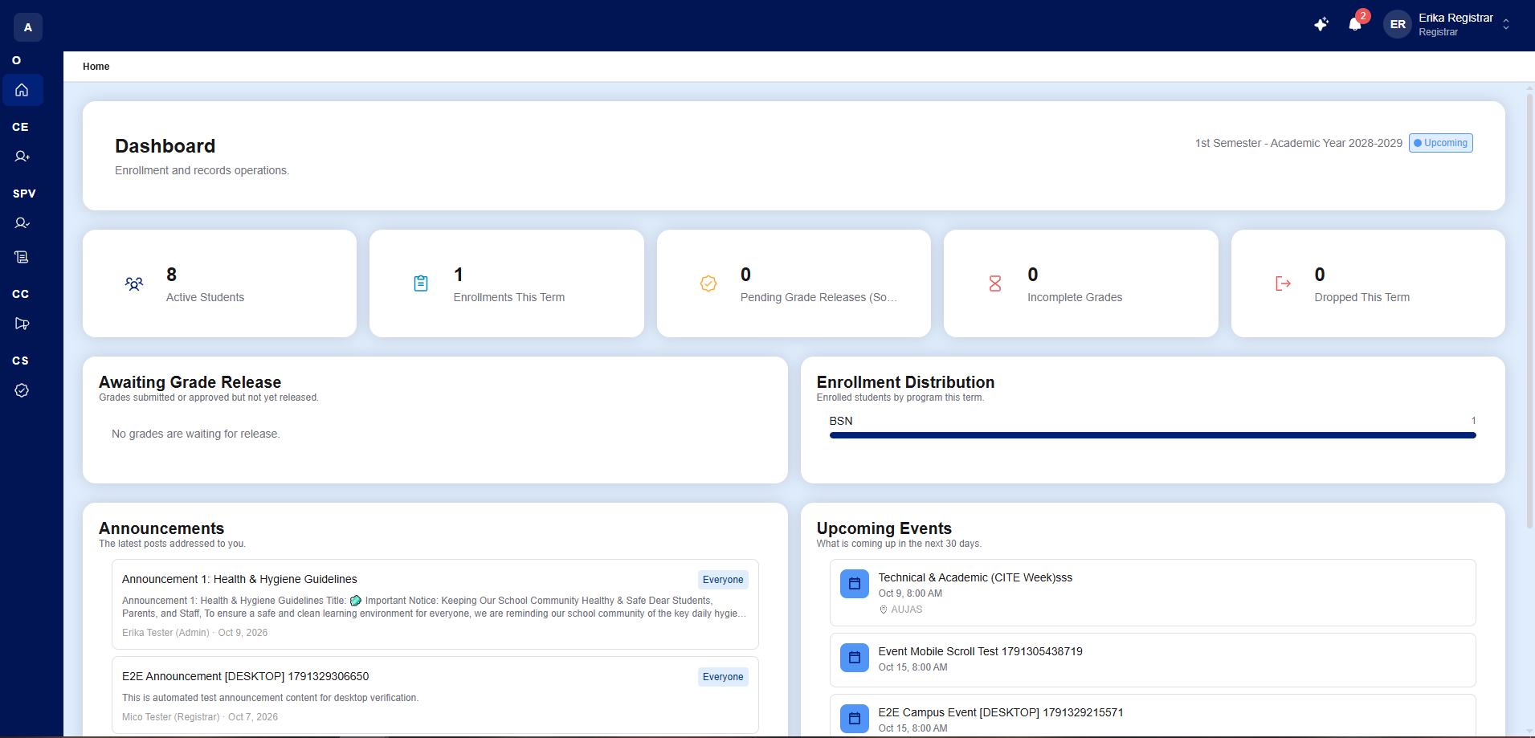
Figure 18. Registrar Dashboard
The Registrar Dashboard provides the Office of the University Registrar with an operational overview of term enrollment metrics, including Active Students, Enrollment This Term, Pending Grade Releases, Incomplete (INC) Grades, and Dropped (DRP) counts, alongside panels tracking sections awaiting grade release, program enrollment distributions, and campus announcements.
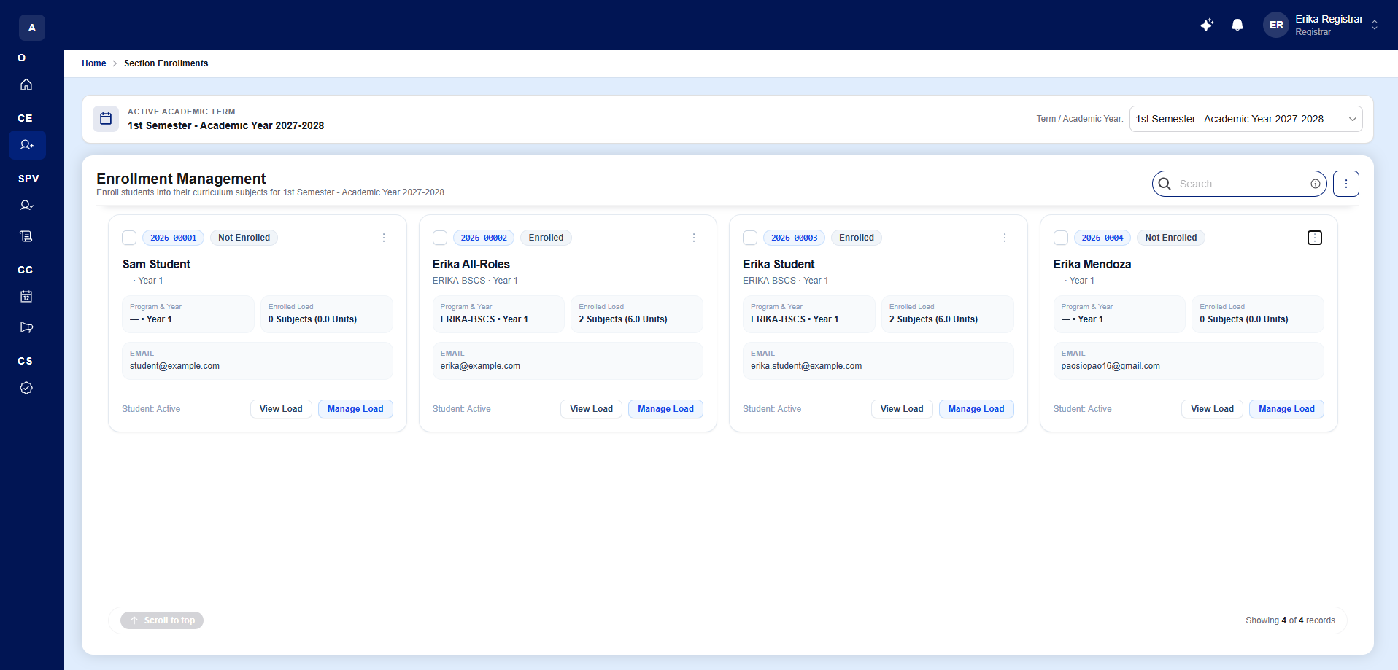
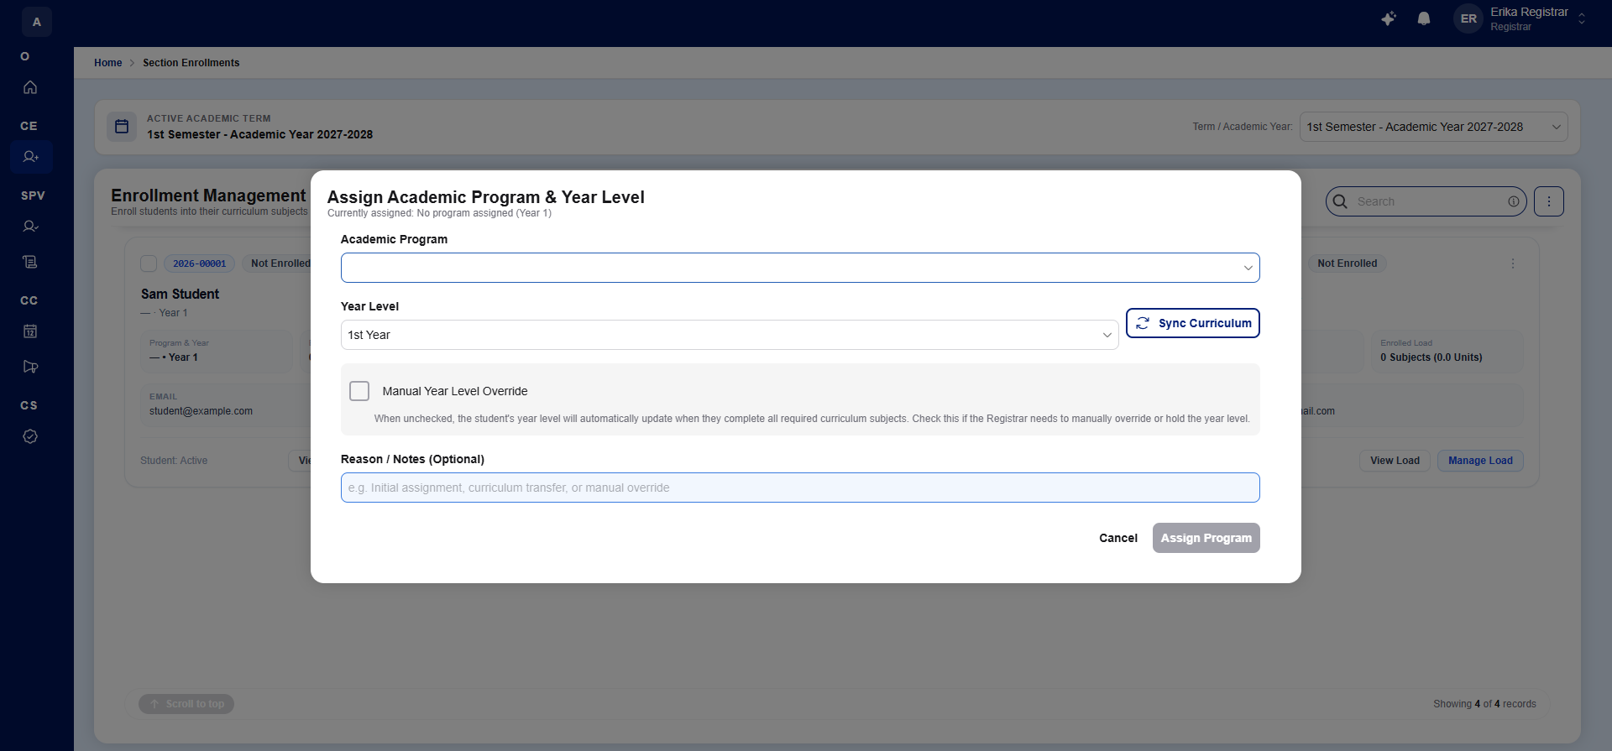
Figure 19. Enrollment Management (Registrar)
The Enrollment Management workspace enables the Registrar to manage student academic tracks, handle program shifting, and enroll students into active class sections for the current term. Supporting both an individual enrollment wizard and a Batch Bulk CSV Enrollment pipeline, the module automatically validates course prerequisites and section slot capacities before confirming enrollment.
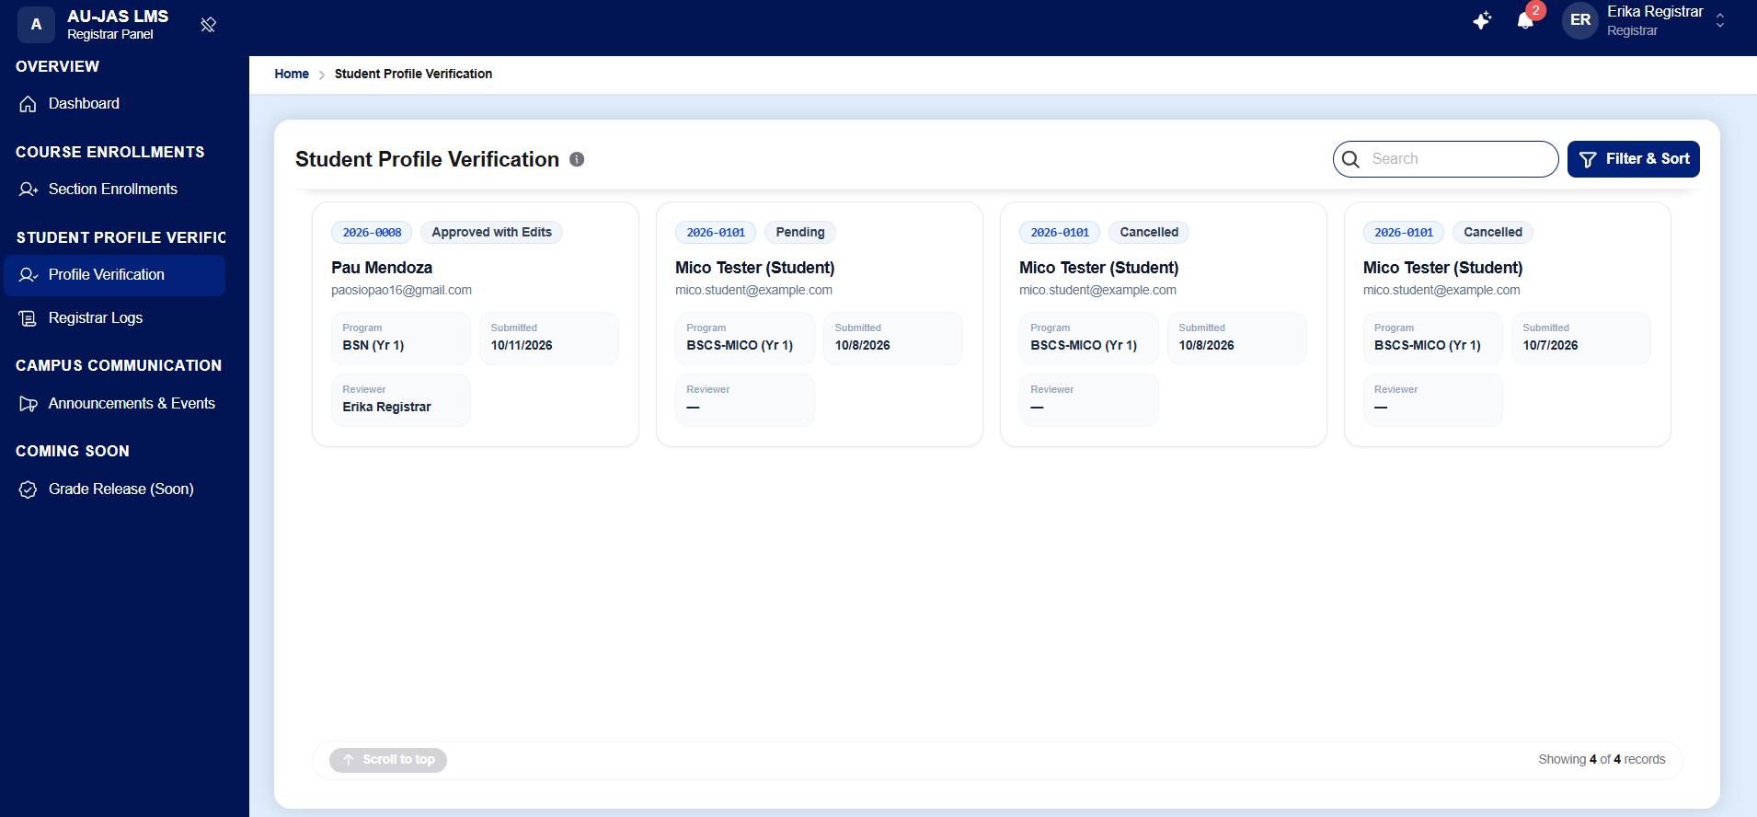
Figure 20. Profile Verification (Registrar)
The Student Profile Verification workspace allows the Registrar to audit and approve onboarding program selections and personal credential update requests submitted by students. To preserve the integrity of official academic records, student profile modifications remain pending until verified and approved by the Registrar.
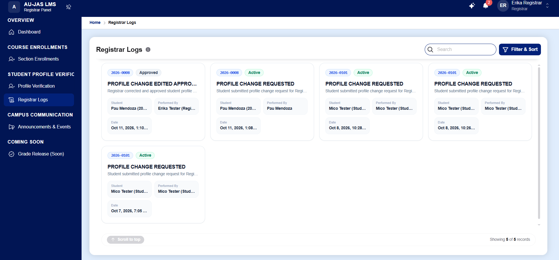
Figure 21. Registrar Logs
The Registrar Logs interface maintains a dedicated forensic audit trail of all registrar-specific operations, including approved student profile verifications, credential corrections, program shifts, batch enrollments, and official section grade releases, equipped with real-time search and multi-criteria sorting.
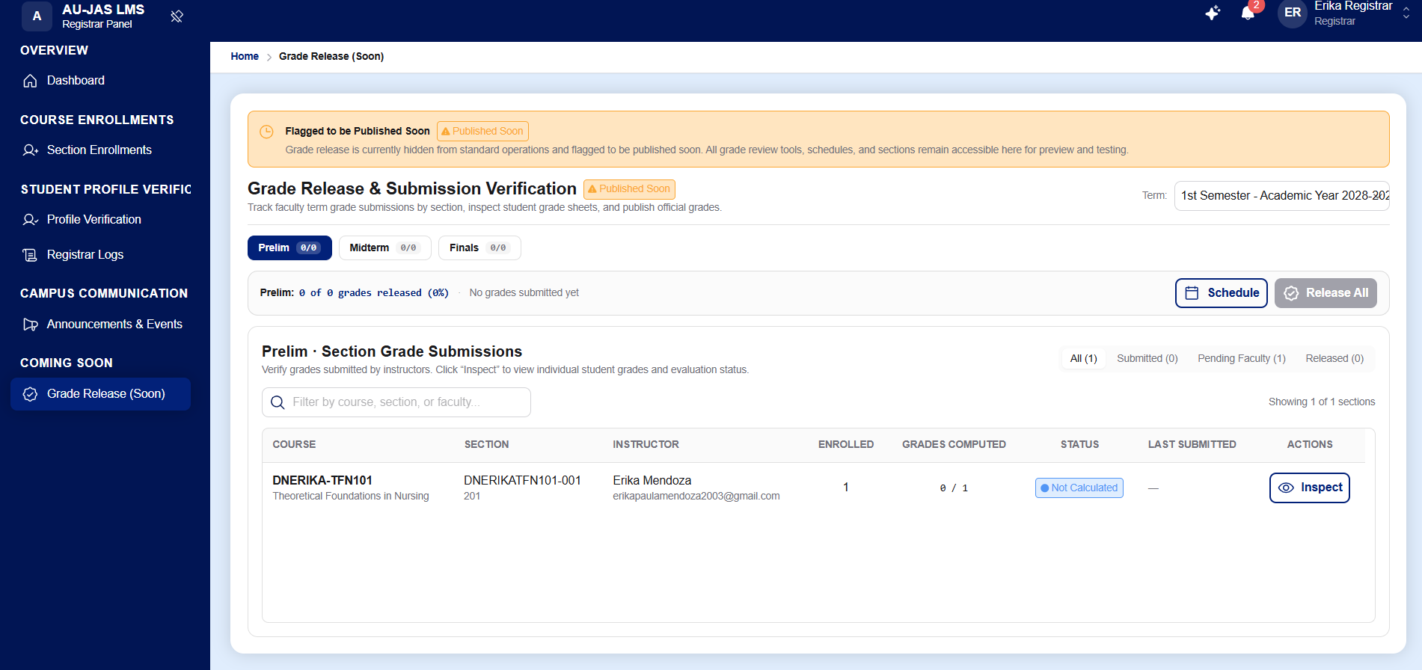
Figure 22. Grade Release and Submission Verification
The Grade Release and Submission Verification module implements the second half of the Dual-Key Grade Release pipeline. Registrars monitor section grade submissions across Prelim, Midterm, and Finals periods, inspect individual student computed grades and faculty evaluation clearance statuses, schedule publication windows, and officially release verified grades to student report cards.
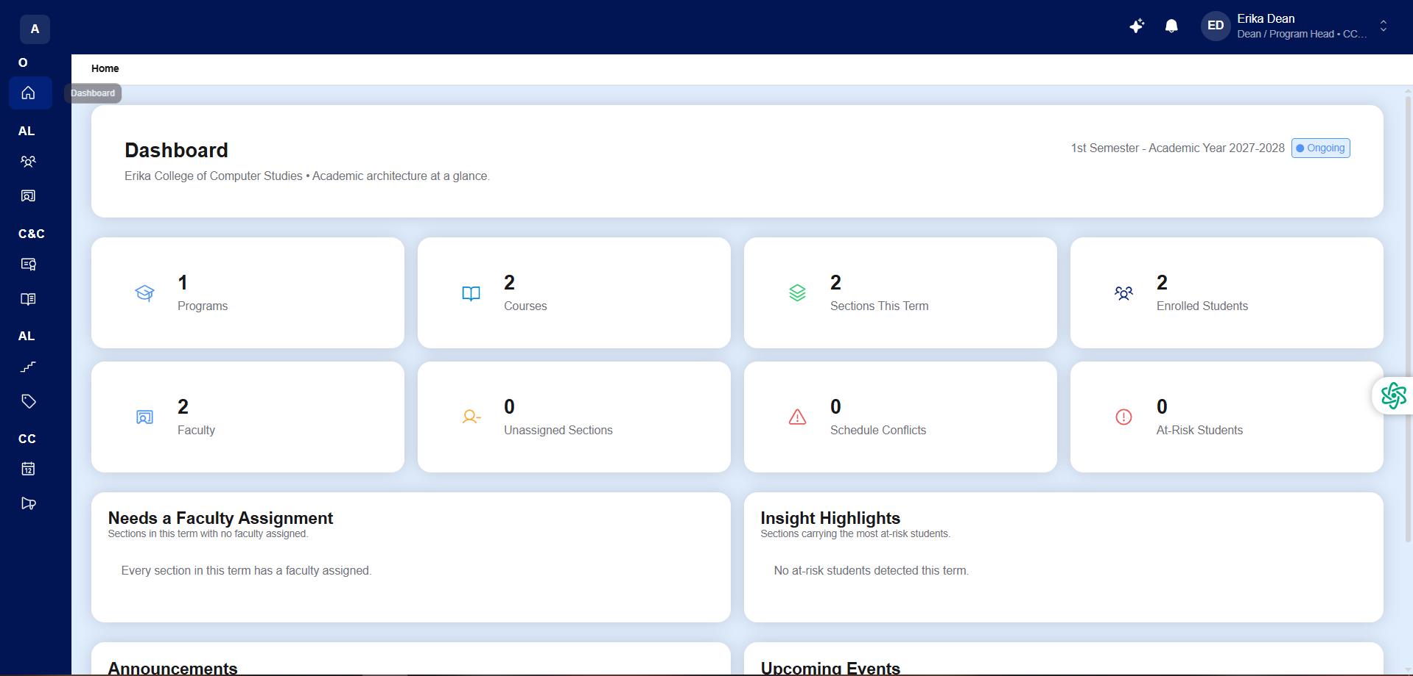
Figure 23. Dean Dashboard
The Academic Dean Dashboard presents a real-time executive summary of the college’s academic architecture for the active term, highlighting total Degree Programs, Courses, Active Sections, Enrolled Students, Departmental Faculty, Unassigned Sections, Schedule Conflicts, and At-Risk Students, together with actionable alerts for sections requiring faculty assignment.
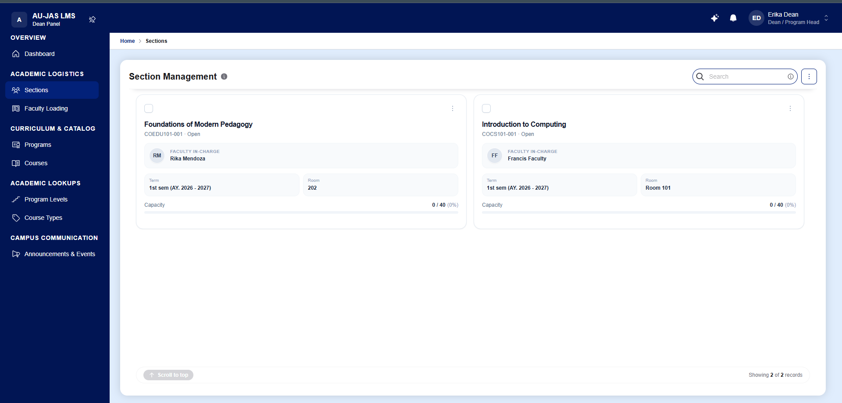
Figure 24. Section Management (Dean)
The Section Management module enables the Academic Dean to open and schedule class sections for each academic term via a 3-step wizard. Deans assign course blueprints, room allocations, weekly meeting days and time slots, enrollment capacity limits, and the faculty member in charge while the system automatically checks for room and schedule collisions.
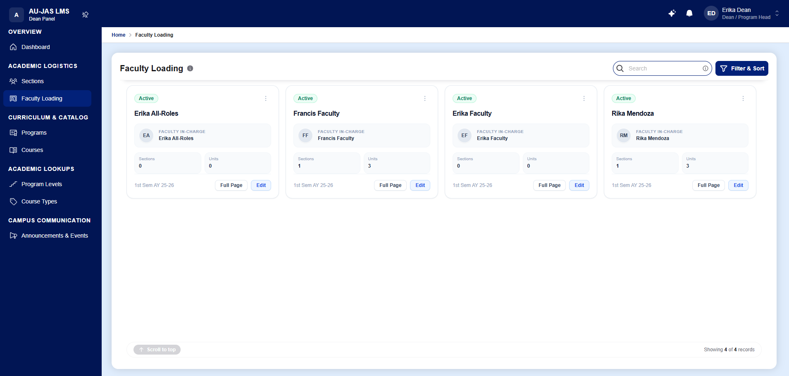
Figure 25. Faculty Loading (Dean)
The Faculty Loading workspace provides the Academic Dean with a comprehensive view of departmental instructors, displaying their active status, assigned class sections, and total teaching unit loads for the semester. Through the 3-step Faculty Load Assignment wizard, the system prevents unit overloads and detects overlapping teaching schedules in real time.
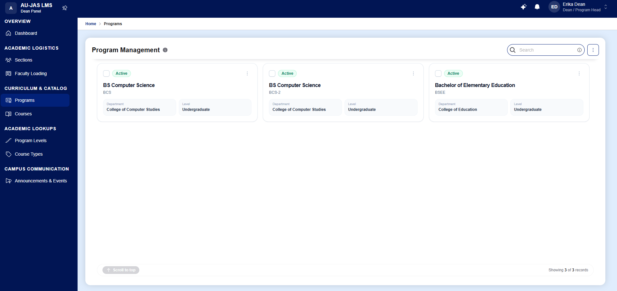
Figure 26. Program Management (Dean)
The Program Management module allows the Academic Dean to create and maintain degree programs (such as BS Computer Science, BS Information Technology, and Bachelor of Elementary Education), define total required curriculum units, map courses across year levels and semesters with prerequisite chains, and clone curriculum maps across academic years.
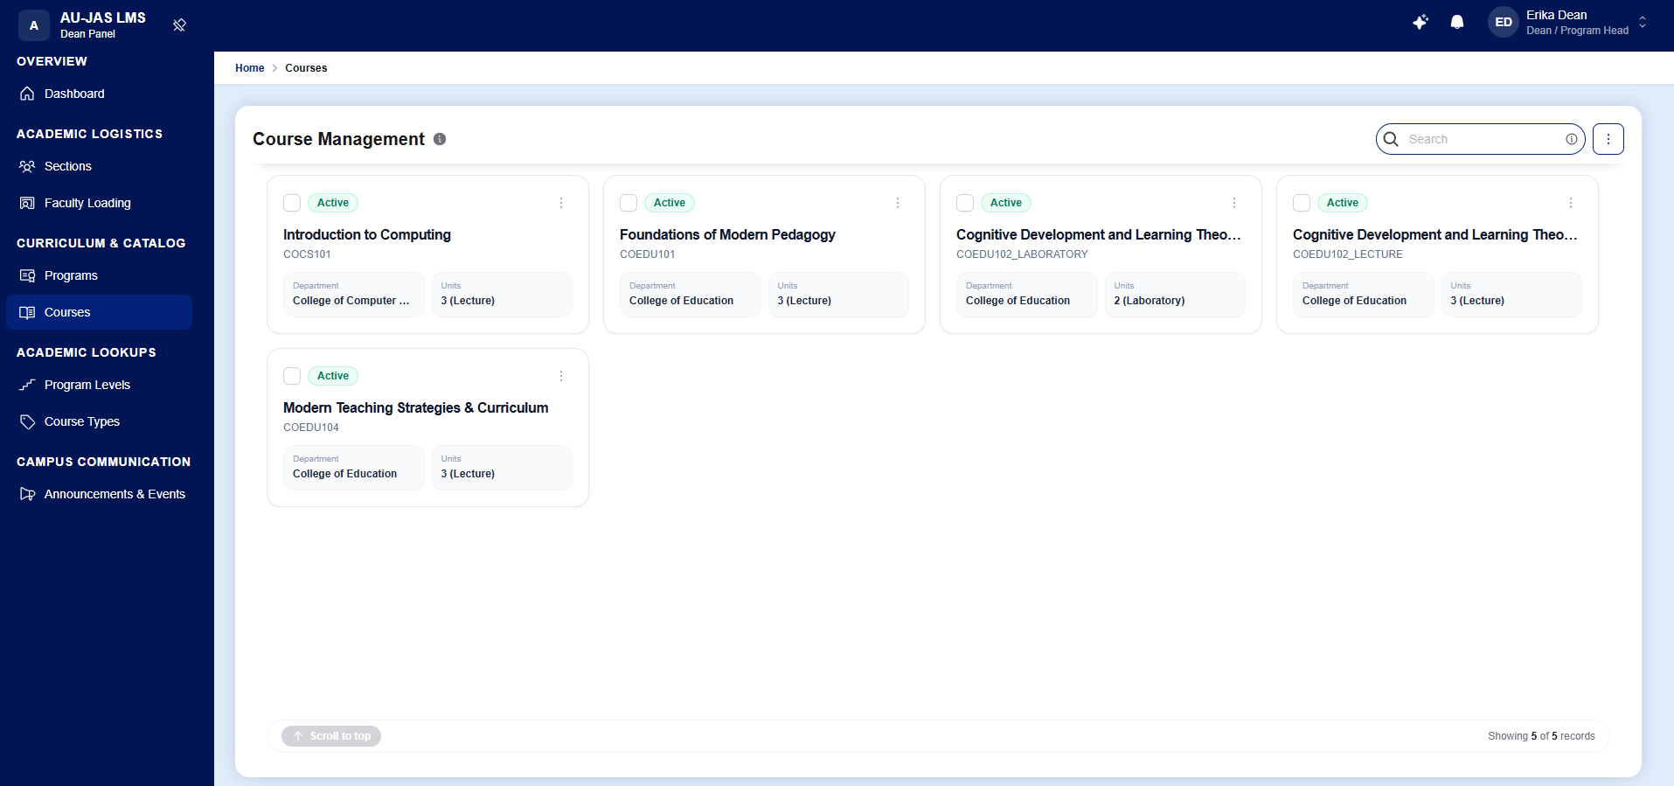
Figure 27. Course Catalog Management (Dean)
The Course Management interface serves as the college’s official subject blueprint catalog. Academic Deans define course codes, descriptive titles, credit units, departmental ownership, and lecture or laboratory classifications, supporting both manual creation and bulk CSV catalog imports.
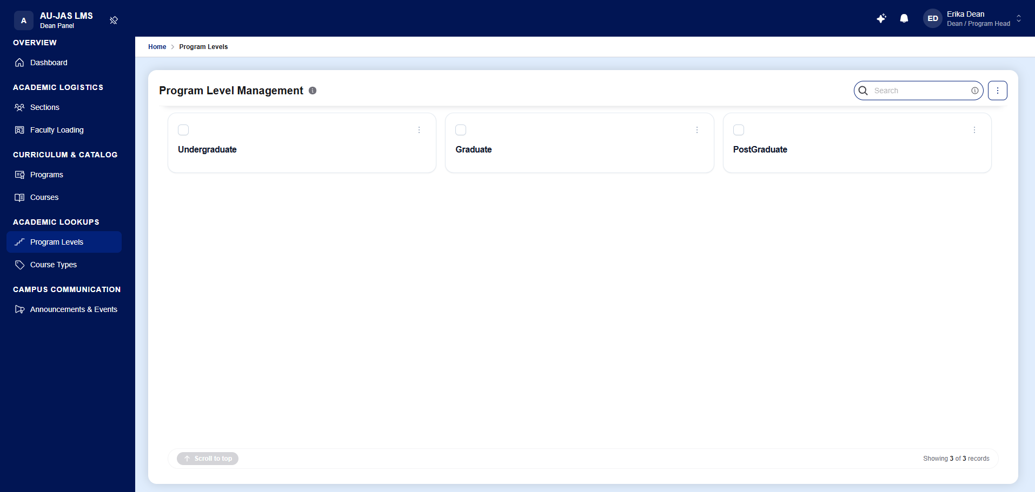
Figure 28. Program Level Management (Dean)
The Program Level Management module allows Academic Deans to define and categorize institutional degree hierarchy levels—such as Undergraduate, Graduate, and Post-Graduate/Doctorate—which govern degree program classification and academic policy scoping.
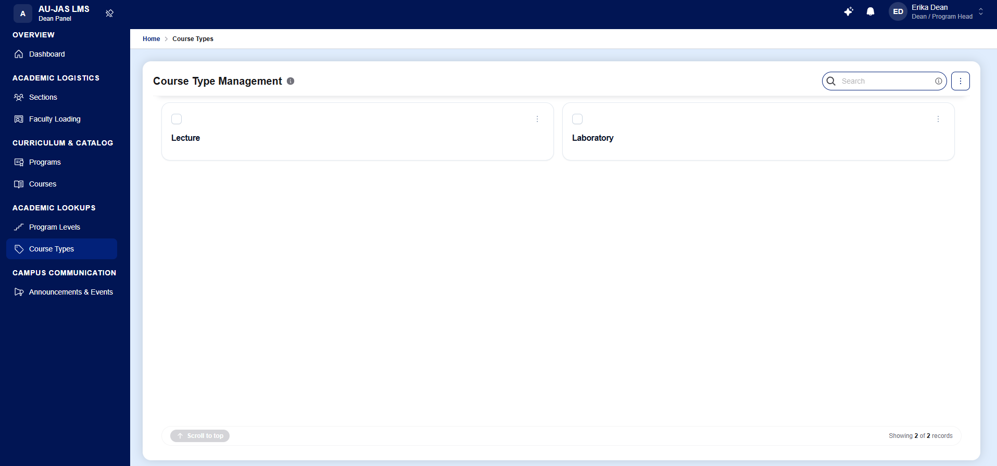
Figure 29. Course Type Management (Dean)
The Course Type Management module enables Academic Deans to configure instructional delivery classifications—such as Lecture, Laboratory, and Lecture-Lab—along with their corresponding contact-hour and unit multipliers used during course blueprint creation and faculty load calculation.
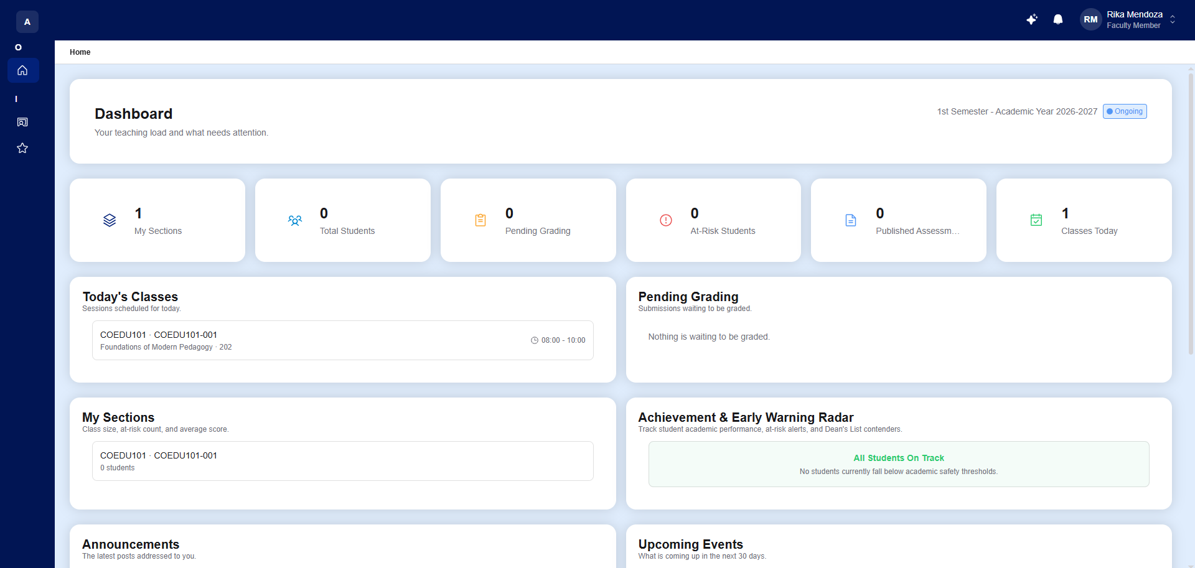
Figure 30. Faculty Dashboard
The Faculty Dashboard provides instructors with an immediate overview of their teaching responsibilities for the active term, featuring KPI cards for My Sections, Total Students, Pending Grading, At-Risk Students, Published Assessments, and Classes Today, alongside panels for Today’s Classes, the Achievement and Early Warning Radar, and campus announcements.
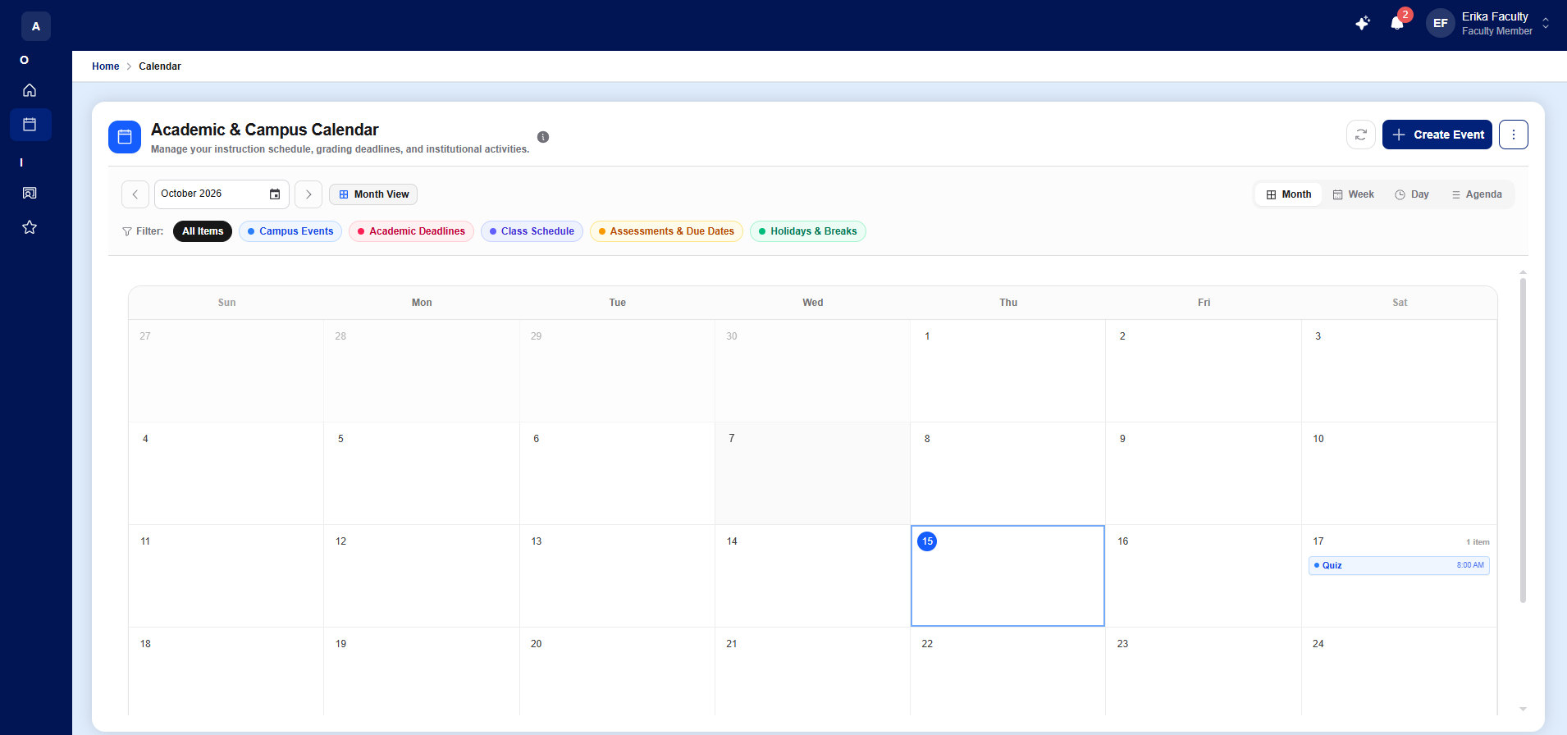
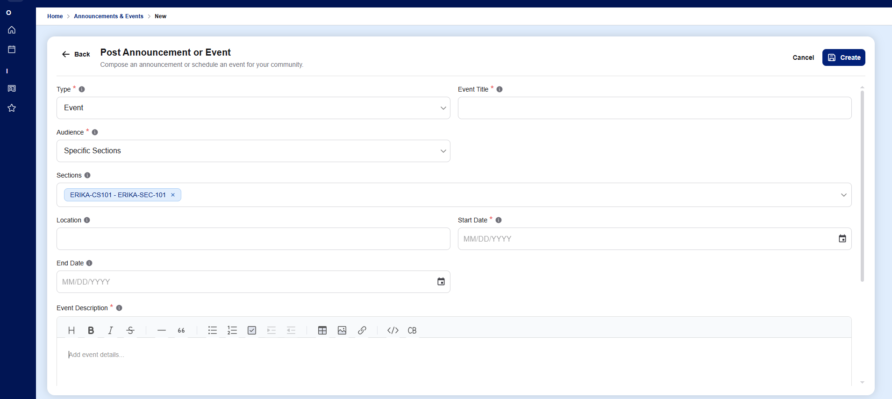
Figure 31. Academic and Campus Calendar
The Academic and Campus Calendar provides a universal, interactive scheduling interface across Month, Week, Day, and Agenda views. Users can filter calendar items by Campus Events, Academic Deadlines, Class Schedules, Assessments and Due Dates, and Holidays, while authorized roles can schedule new global or section-specific events.
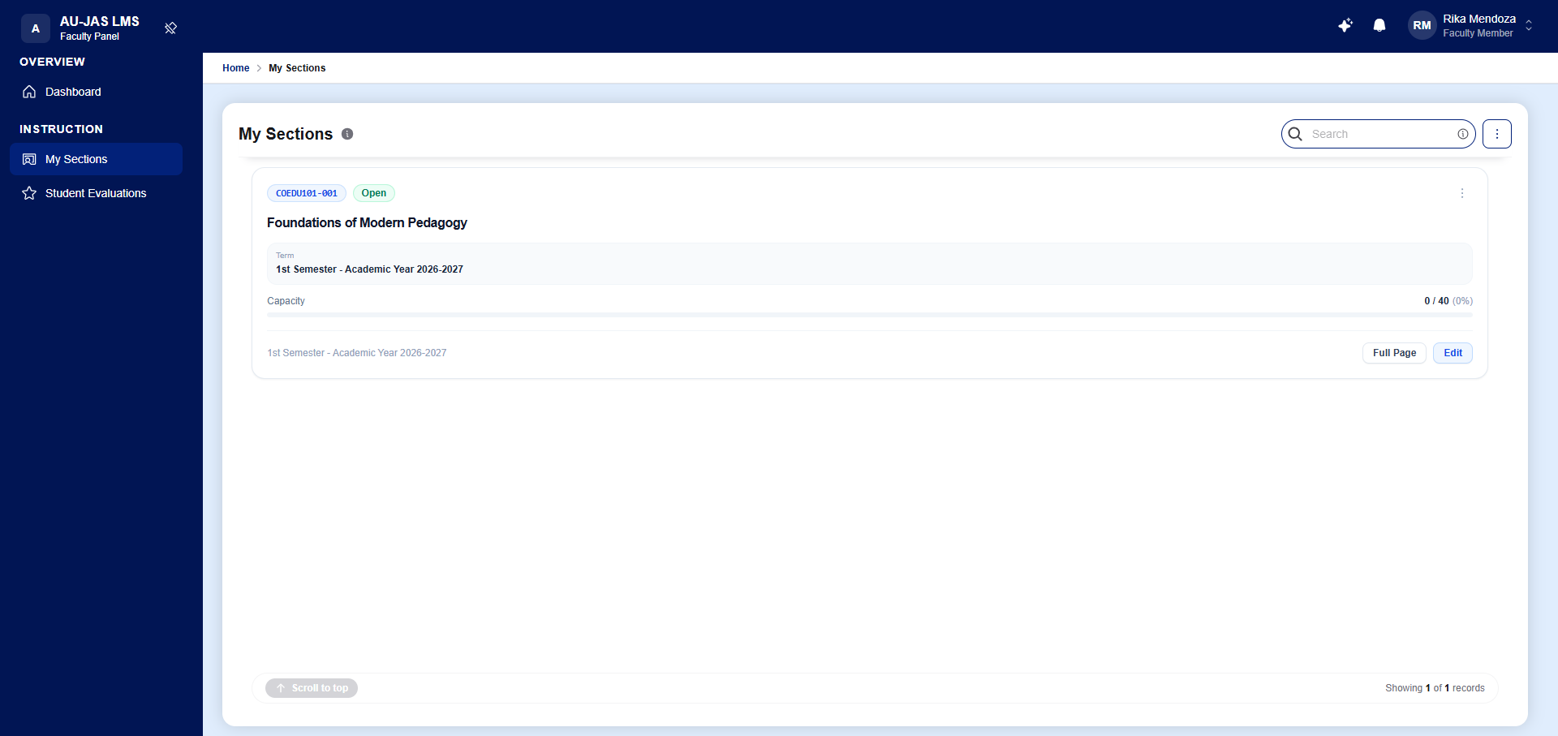
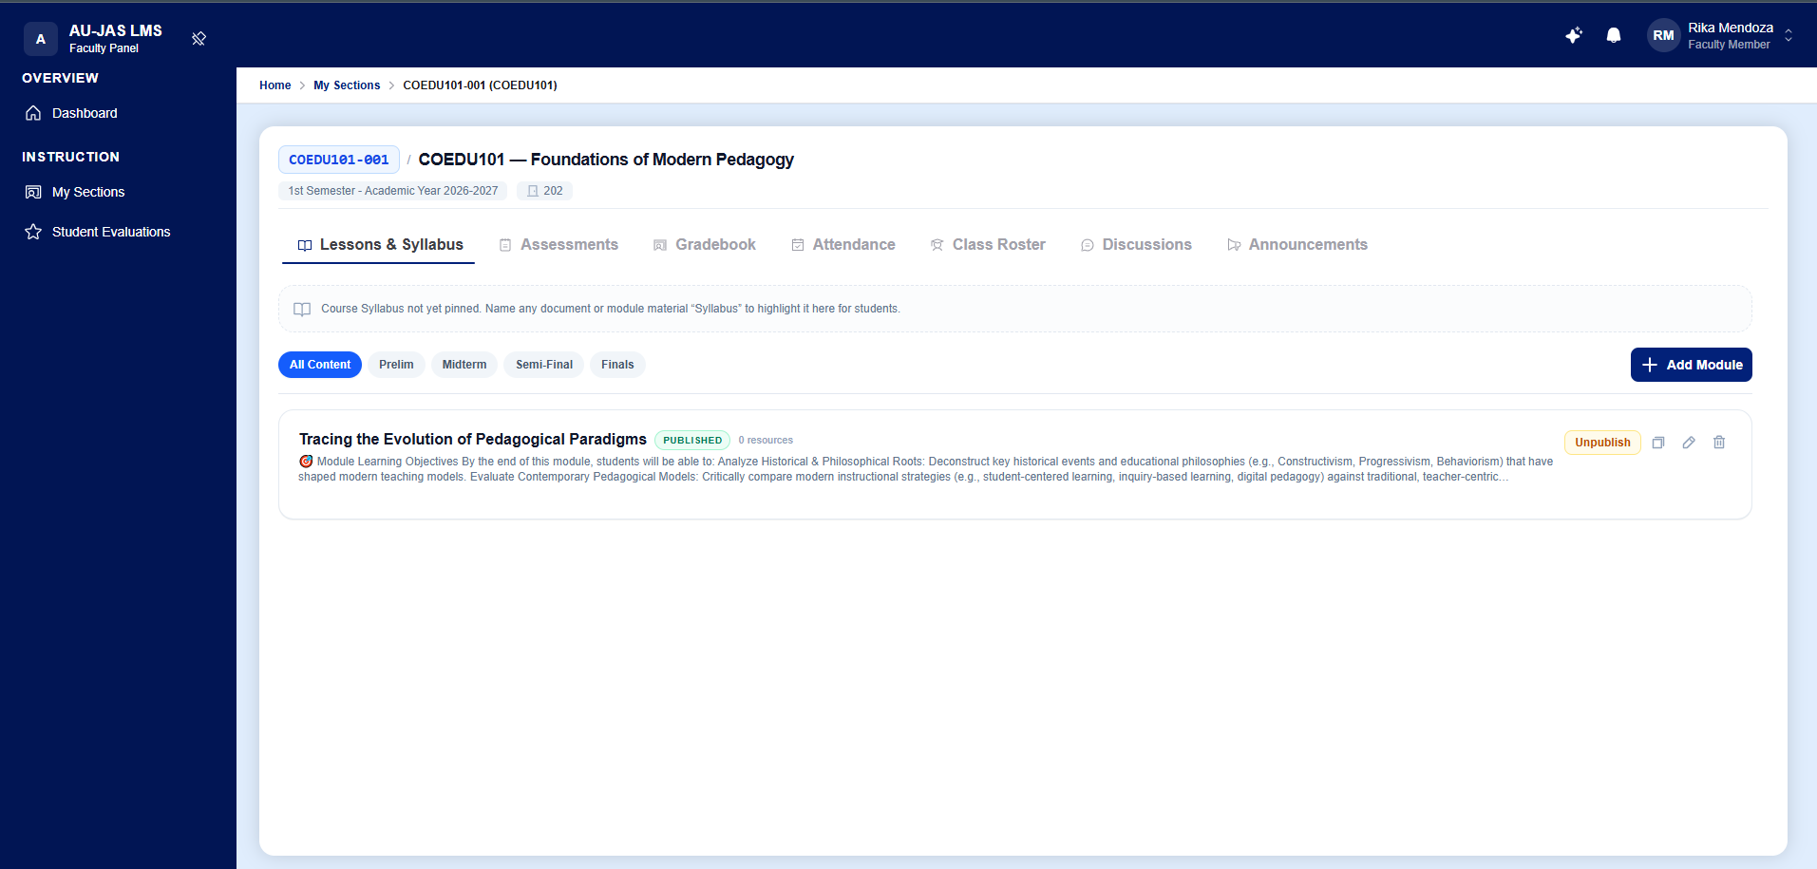
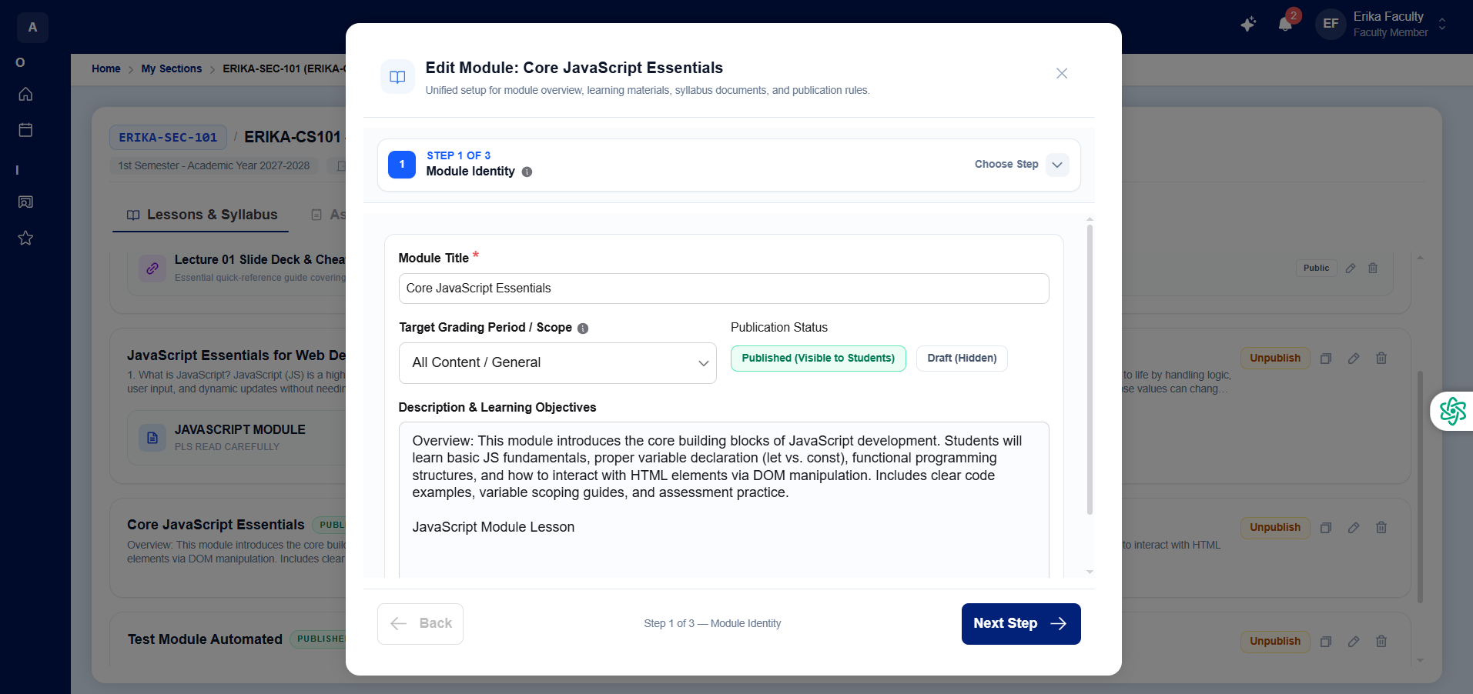
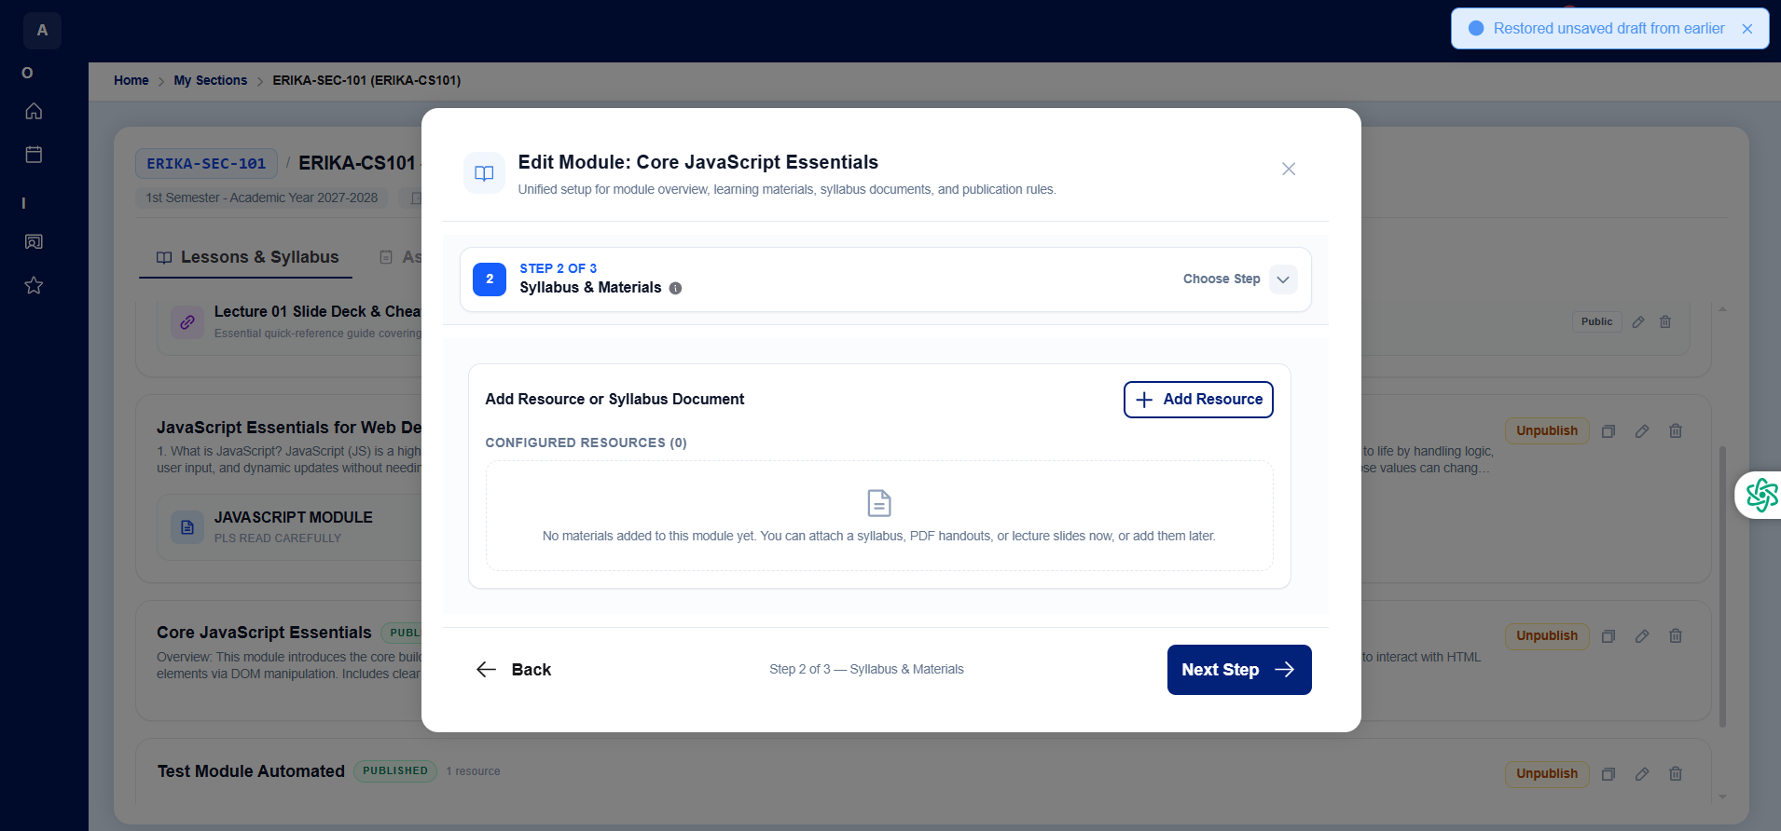
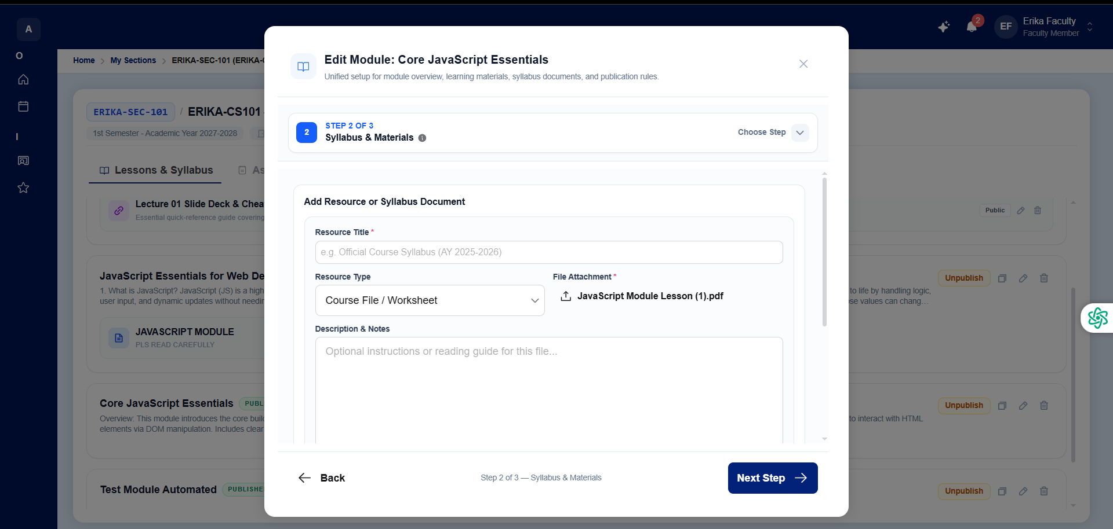
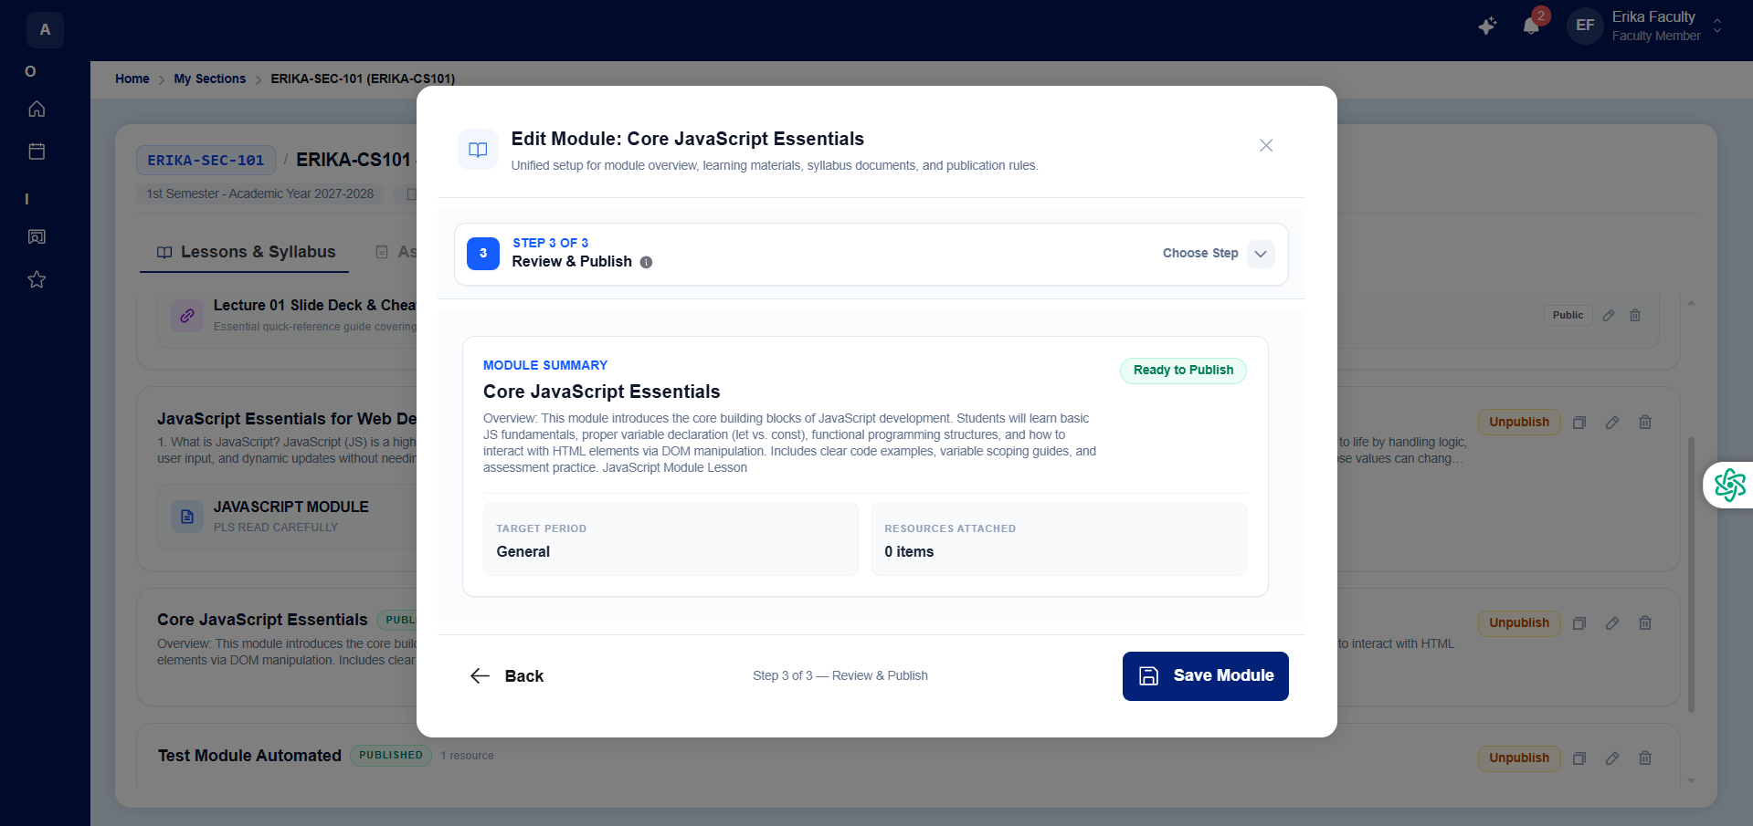
Figure 32. My Sections and Course Module Studio
The My Sections workspace and Course Module Studio serve as the primary instructional hub for Faculty members. Selecting an assigned section opens a multi-tab studio covering Lessons and Syllabus, Assessments, Gradebook, Attendance, Class Roster, Discussions, and Announcements. Through the 3-step Module Wizard—complete with automatic sessionStorage draft recovery—instructors define module learning objectives, attach syllabus documents and lecture files, filter materials by grading period, and duplicate modules across cohorts.
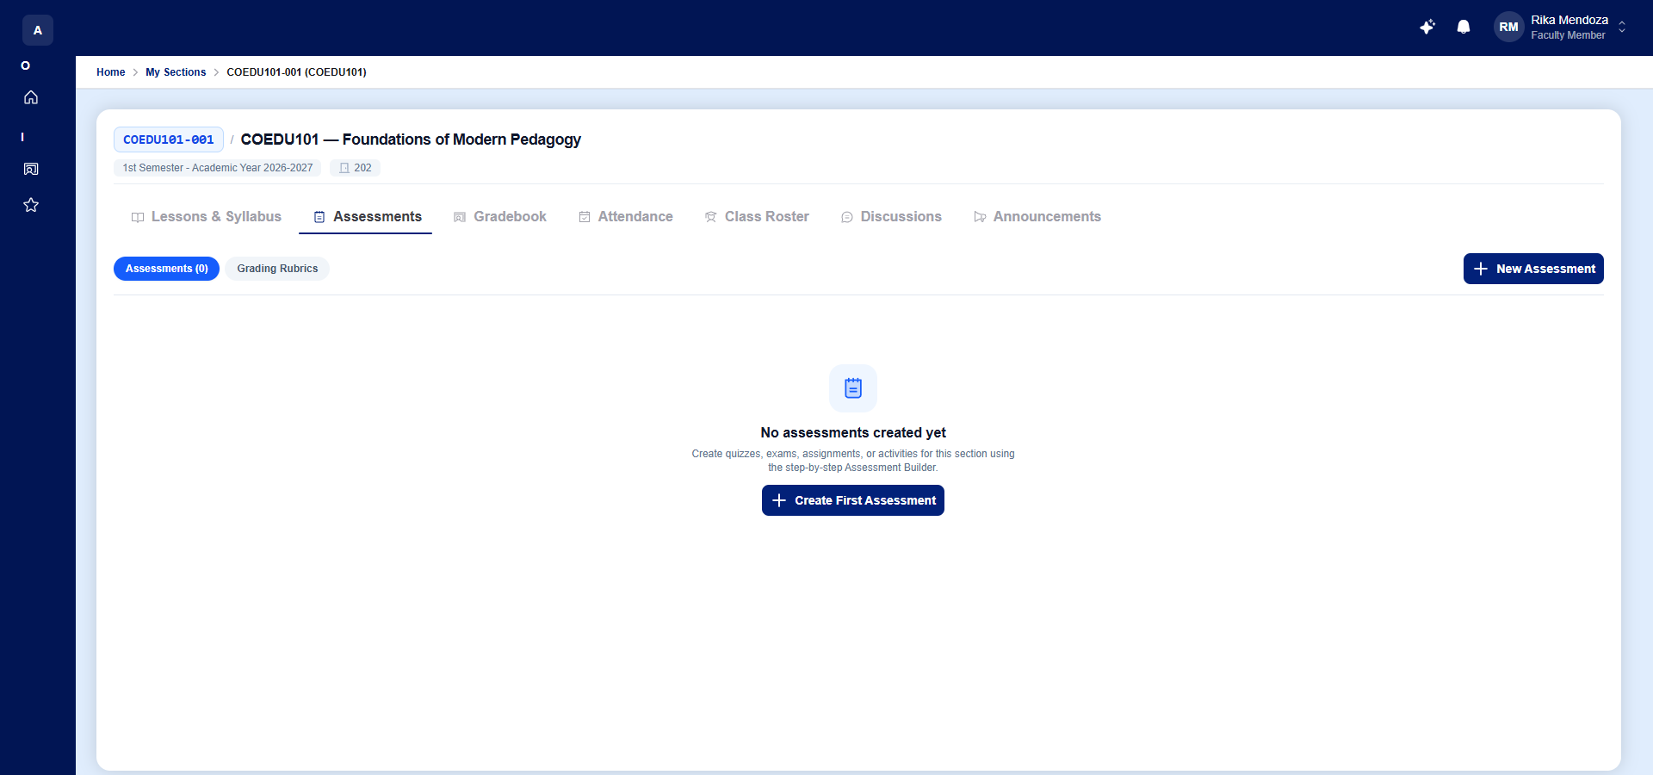
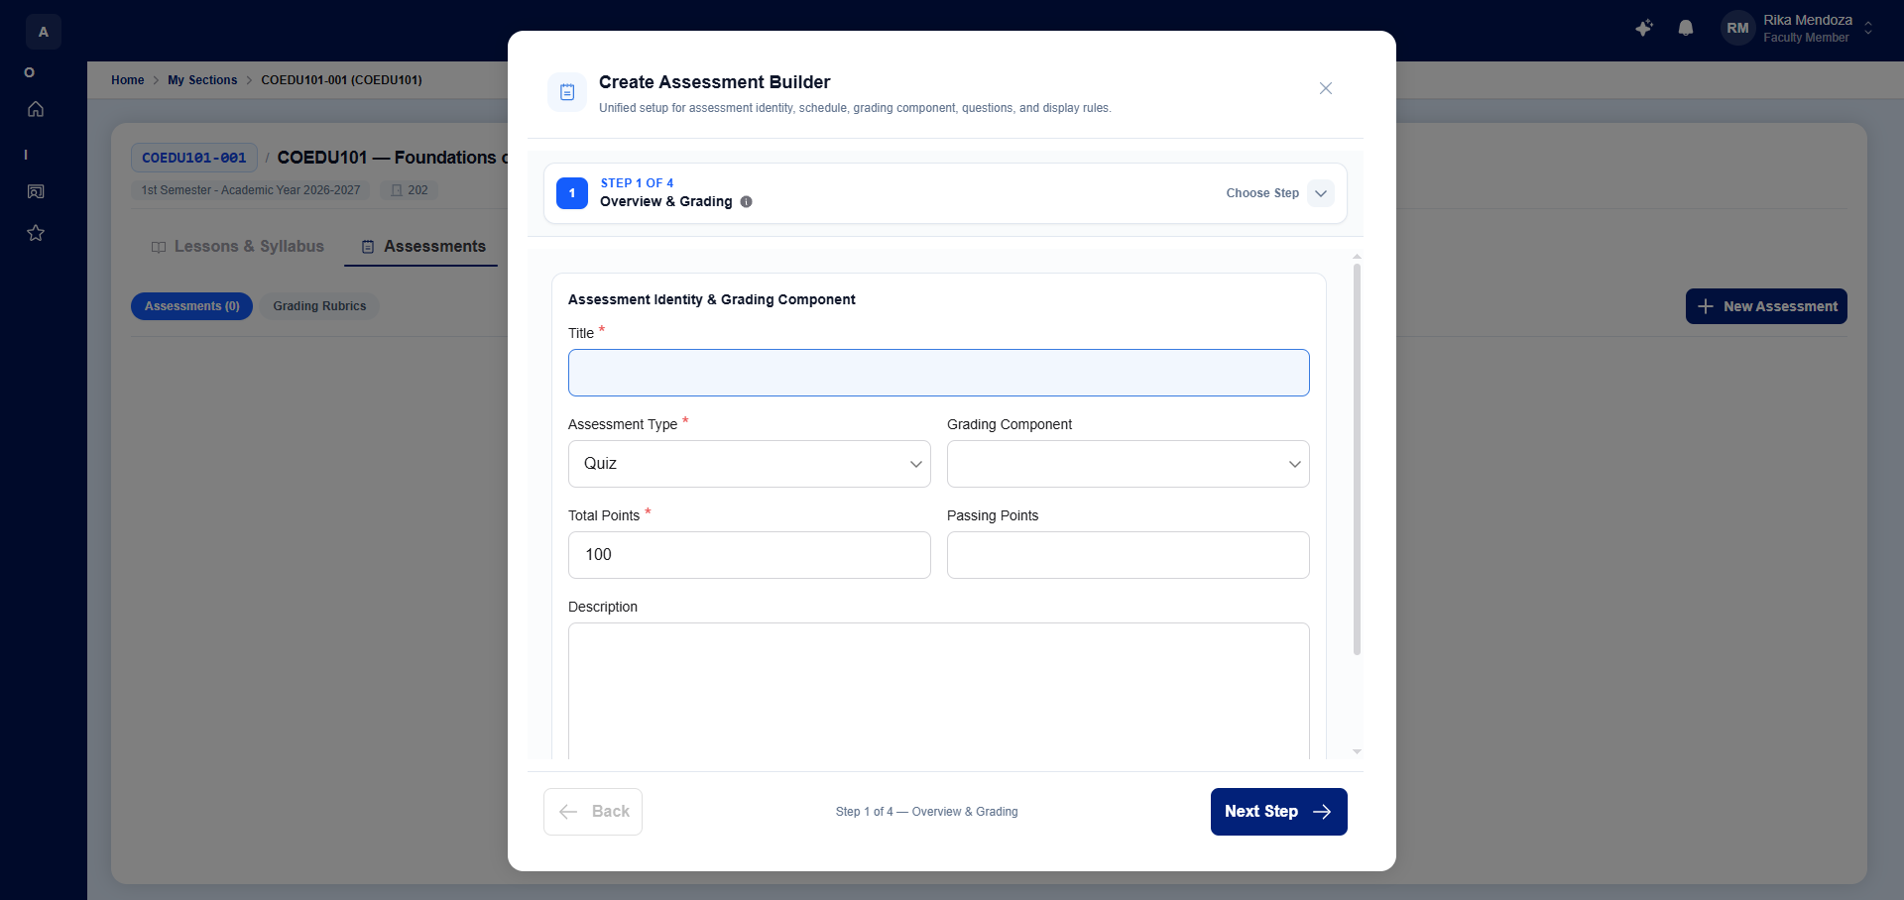
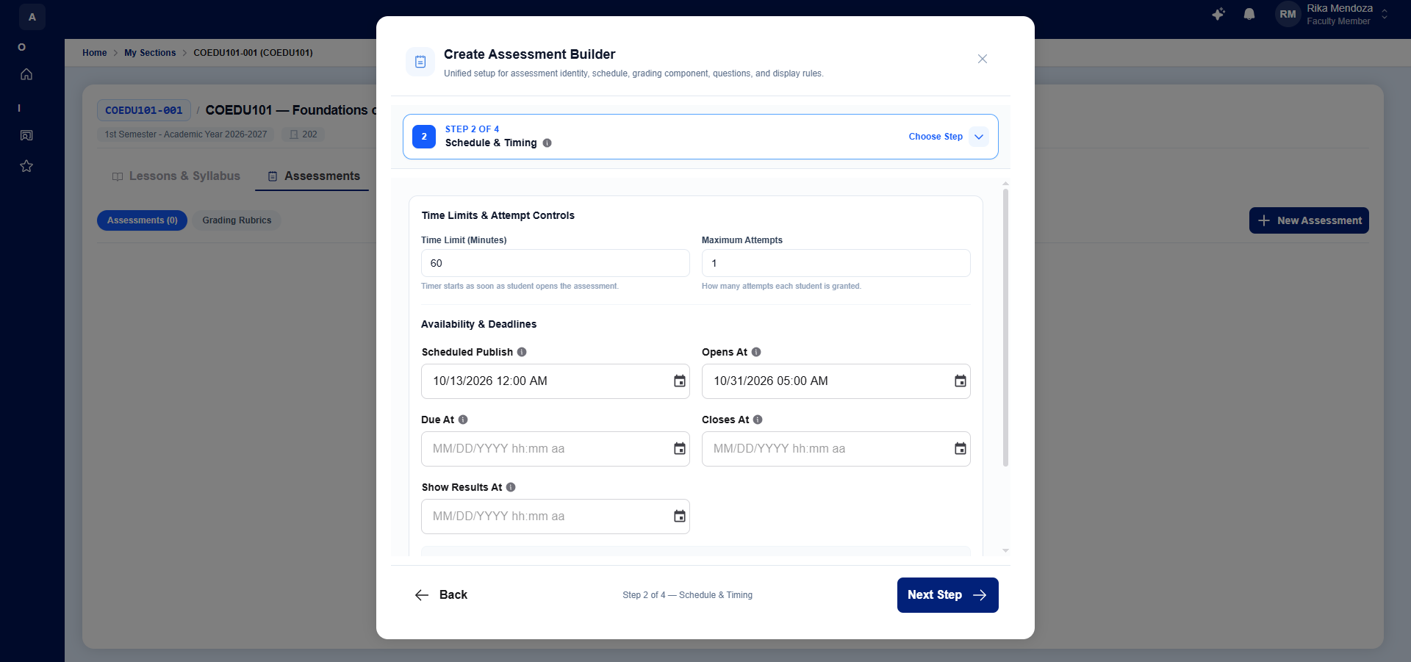
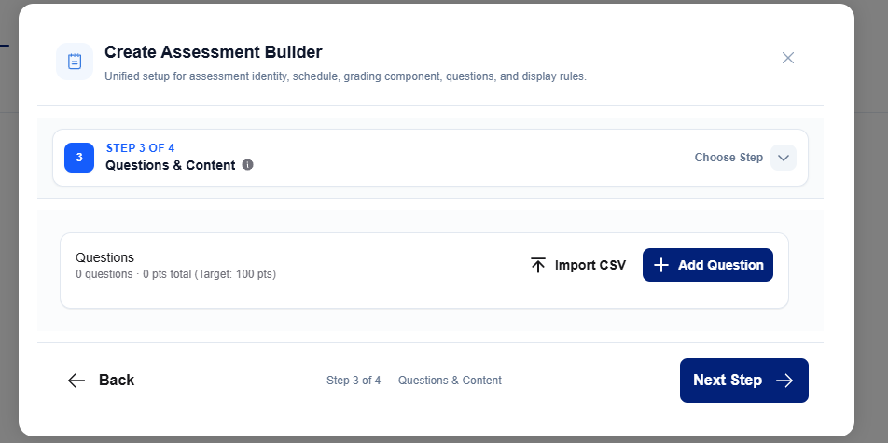
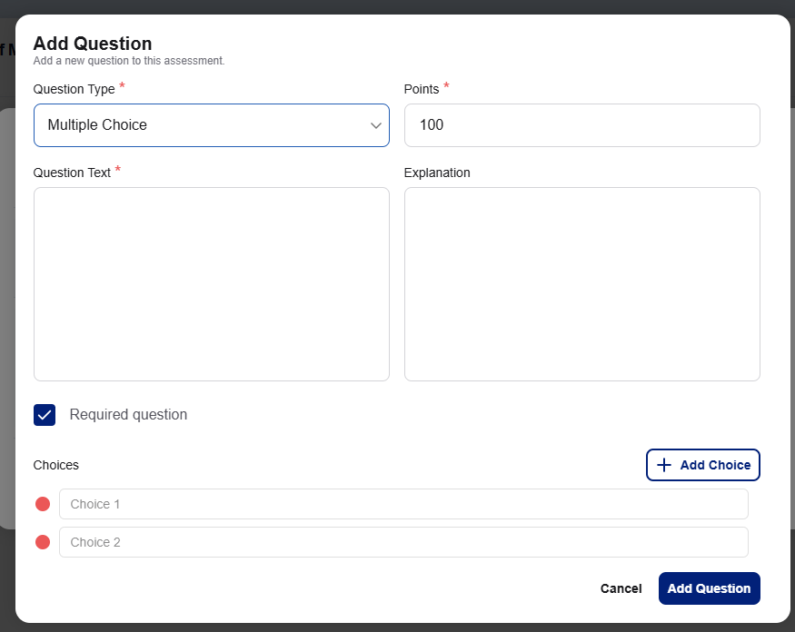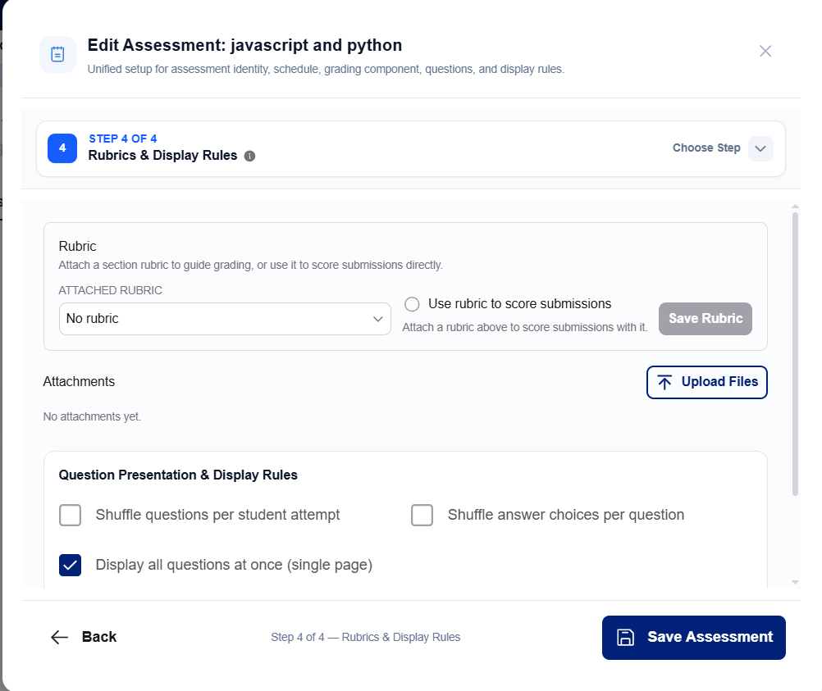
Figure 33. Create Assessment Builder
The Create Assessment Builder guides faculty members through a 4-step wizard to author Quizzes, Examinations, Activities, and Projects. Instructors configure assessment identity and grading component mapping (Step 1), time limits, maximum attempts, and availability windows (Step 2), question banks supporting Multiple Choice, Identification, Essay, and File Upload items via manual entry or bulk CSV import (Step 3), and multi-criterion grading rubrics and question/choice shuffling rules (Step 4).
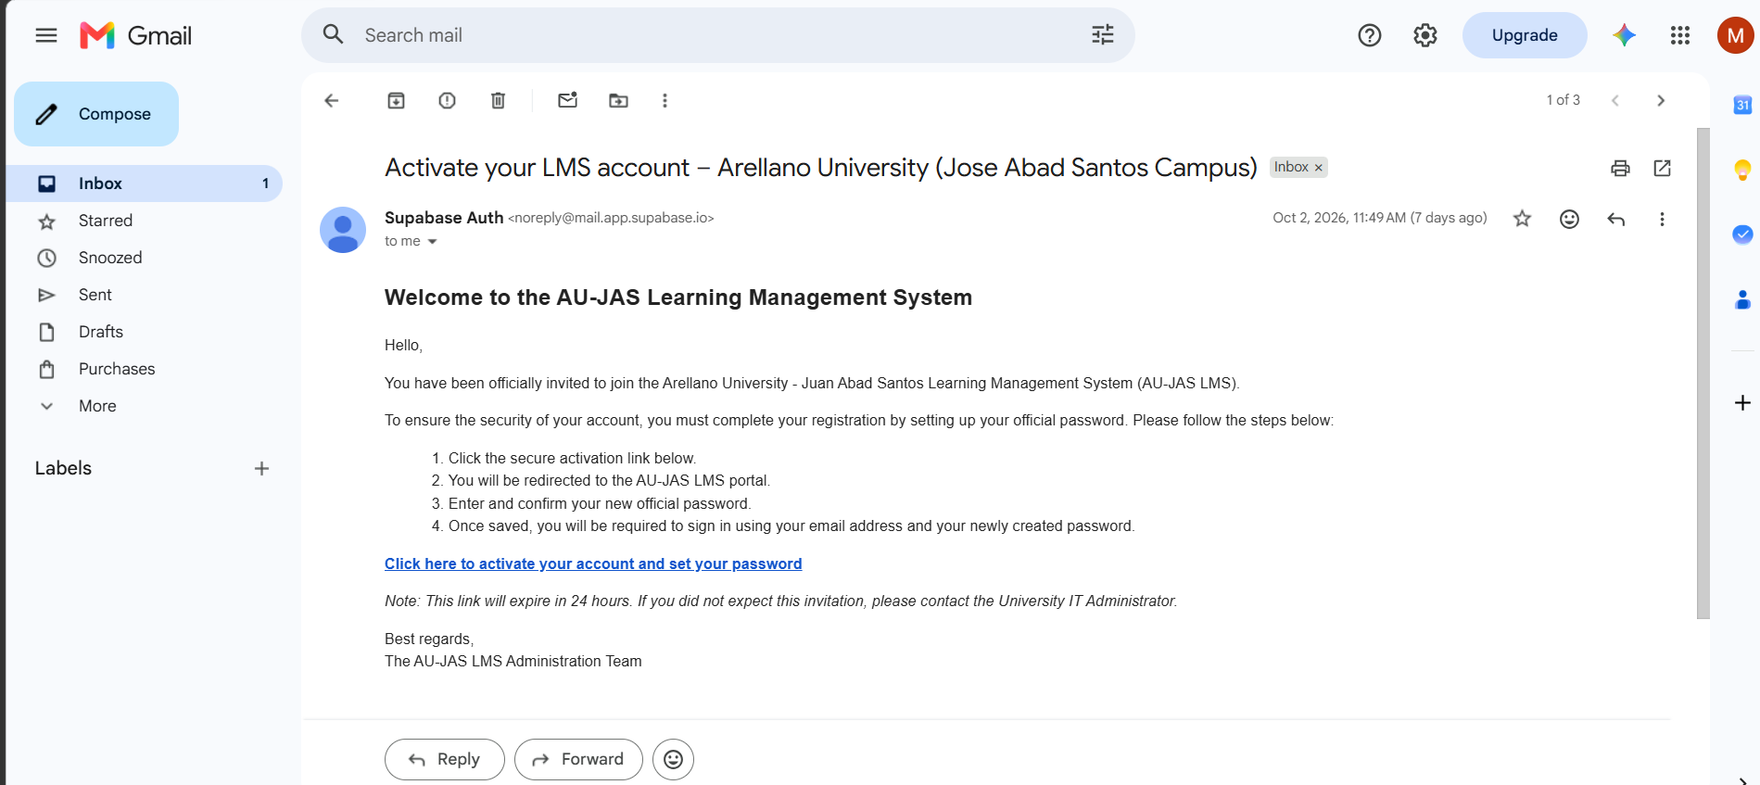
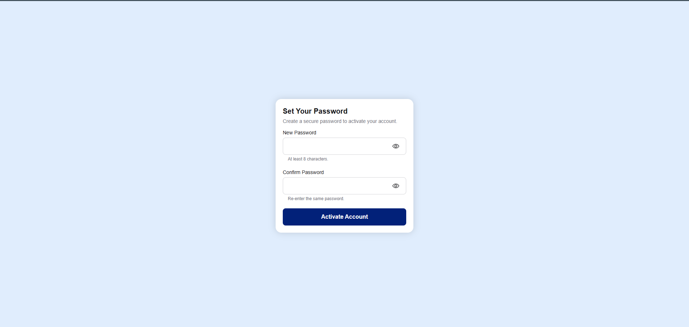
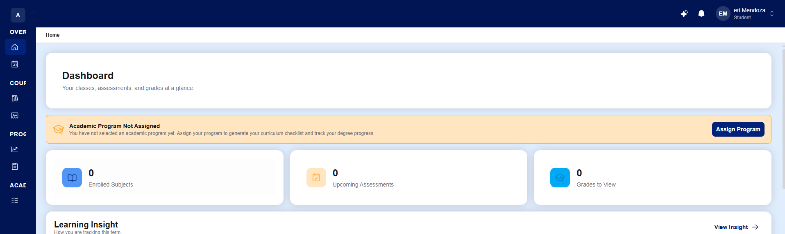
Figure 34. Account Activation and Student Onboarding
The Account Activation and Student Onboarding workflow illustrates the end-to-end onboarding experience for newly created users. When an administrator creates a user account, Supabase Auth dispatches an official "Activate your LMS account" email containing a secure 24-hour activation link. Clicking the link directs the user to the Set Your Password screen to establish their credentials, after which students land on the Student Dashboard where they are prompted to select their degree program for Registrar verification and curriculum checklist generation.
3.6 Implementation Plan
The Learning Management System for Arellano University – Jose Abad Santos Campus was deployed to a cloud production environment hosted on Vercel and backed by Supabase PostgreSQL, making the platform immediately accessible via standard web browsers on desktopcomputers, laptops, tablets, and smartphones without requiring local client installation. Data migration was supported through the system’s Universal Bulk CSV Import pipelines, allowing existing department rosters, degree programs, course catalogs, curriculum maps, class sections, user accounts, and student enrollments to be validated and imported cleanly while maintaining automated relational backups.
To ensure smooth institutional adoption, role-based orientation and training sessions were structured for System Administrators, Academic Deans, University Registrars, Faculty Members, and Students. Administrators were trained on school year wizard governance, transmutation configurations, and forensic audit monitoring; Deans and Registrars were guided through curriculum mapping, conflict-free section scheduling, bulk CSV enrollment, and dual-key grade release; and Faculty and Students were oriented on the Section Studio, 4-tier assessments, automated gradebooks, and the integrated AI Academic Assistant.
Continuous technical documentation, including an illustrated User’s Manual and pre-validated CSV templates, was prepared in coordination with the College of Information Technology Education (CITE) and the AU-JAS IT Department to support long-term system maintenance and institutional scalability.
3.7 Implementation Results
The implementation of the Learning Management System for Arellano University – JAS Campus yielded the following concrete outcomes:
• A fully functional, cloud-deployed, 5-role Learning Management System accessible across desktop (1440x900) and mobile (390x844) devices with zero horizontal overflow.
• Streamlined administrative governance, curriculum mapping, conflict-checked section scheduling, and batch CSV student enrollment with automated prerequisite validation.
• Automated periodic and final grade computation with anti-tamper Dual-Key Registrar Grade Release and mandatory student faculty evaluation gating.
• High user acceptance and software quality ratings ("Excellent" across all eight ISO/IEC 25010 characteristics) validated by 30 campus respondents, supported by real-time conversational assistance from the Google Gemini AI Academic Assistant.
CHAPTER 4: RESULTS AND DISCUSSION
This chapter presents the project description, comparative functional and technical evaluation, system module and viewport verification results, security architecture analysis, and the final user evaluation outcome of the Learning Management System for Arellano University – Jose Abad Santos Campus (AU-JAS LMS).
4.1 Results
The developed system is a cloud-native, role-based Learning Management System with an integrated AI Academic Assistant built specifically for Arellano University – Jose Abad Santos Campus. It is designed as a unified, multi-portal web application that streamlines institutional administration, curriculum engineering, enrollment validation, classroom instruction, and automated grade release across five institutional user roles.
• How the system runs: The application executes as a responsive Single-Page Application (SPA) served globally via Vercel edge infrastructure, communicating over TLS-encrypted channels with a managed Supabase backend comprising a PostgreSQL relational database with Row-Level Security (RLS), JWT-based Authentication, cloud object storage, and Deno Edge Functions powered by Google Gemini AI.
• Software used: The system was developed using React 18.3, TypeScript 5.9, Vite 7.1, Tailwind CSS 4.2, Material UI (MUI v7), AG-Grid React, Zustand, React Hook Form, and Toast UI Editor on the client side, paired with Supabase PostgreSQL, Supabase Auth, Supabase Storage, and Deno Edge Functions on the server side.
4.1.1 Testing Project Results
The following table presents a side-by-side technical and functional comparison of the developed AU-JAS Learning Management System against the existing legacy LMS platform (based on local institutional assessment) and standard generic commercial LMS platforms (based on secondary research benchmarks).
Table 1. Technical and Functional Comparison
Criteria | Existing Legacy LMS (Tested: AU-JAS) | Generic Commercial LMS (Secondary Data) | Proposed AU-JAS LMS (Tested: Production Build)
Frontend Architecture | Server-Rendered Multi-Page HTML | Monolithic / Hybrid Web UI | React 18 + TypeScript 5.9 SPA (Vite 7)
Database & Access Control | Centralized DB / App-Layer Filtering | Multi-Tenant Cloud Relational DB | Supabase PostgreSQL + Row-Level Security (RLS)
Role Portal Separation | 3 Basic Views (Admin, Teacher, Student) | Generic Configurable Roles | 5 Dedicated Portals (Admin, Dean, Registrar, Faculty, Student)
Curriculum & Prerequisite Check | Manual Spreadsheet Verification | Partial / Plugin-Dependent | Automated 3-Step Program Wizard + Prerequisite Enforcer
Grade Release Workflow | Direct Unverified Faculty Upload | Single-Tier Instructor Posting | Dual-Key Approval (Faculty Submit + Registrar Release + Eval Gate)
AI Academic Assistance | None | Paid External Add-on / None | Built-in Role-Aware AI Assistant (Supabase Edge + Gemini)
Mobile Responsiveness | Desktop-Centric / Non-Adaptive Tables | Separate Mobile App Required | Responsive Tailwind CSS + MUI Layout (Desktop & 390x844 Mobile)
Audit Trail & Forensics | Minimal System Logs | Admin-Level Activity Logs | Dual Immutable Audit Logs (Admin & Registrar Forensic Tracking)
Note: Generic commercial LMS data is derived from secondary research benchmarks across standard higher-education platforms.
Based on the objectives of the study and the technical evaluations conducted, the following findings were summarized:
• Architecture and Responsiveness: Unlike the legacy server-rendered architecture that required full-page reloads for every navigation action, the React 18 and TypeScript Single-Page Application architecture of the AU-JAS LMS delivers instantaneous view transitions, client-side state persistence via Zustand, and virtualized data rendering via AG-Grid.
• Institutional Role Alignment: Whereas the existing platform lacked specialized portals for academic governance and enrollment auditing, the developed system enforces strict separation of duties across five dedicated portals—empowering the Academic Dean to engineer curricula and faculty loads and the Registrar to govern student enrollments and official grade releases.
• Workflow Integrity and Automation: A critical limitation identified in the legacy workflow was the manual verification of prerequisites and direct unverified posting of grades. The AU-JAS LMS resolves this through automated prerequisite checking during enrollment and a Dual-Key Grade Release pipeline that requires Registrar approval and student completion of mandatory faculty evaluations before official grades are unlocked.
• Embedded AI Pedagogical Support: By integrating a role-aware AI Academic Assistant via Supabase Edge Functions and Google Gemini AI, the system provides real-time, context-sensitive support for platform navigation, syllabus comprehension, and study guidance without requiring external third-party subscriptions.
4.1.2 Application Performance and Verification Testing
To further evaluate the reliability, responsiveness, and functional completeness of the AU-JAS Learning Management System, comprehensive automated and interactive verification tests were conducted across all five user portals and core functional workflows. Testing was executed using Vitest unit and integration suites alongside Playwright browser automation across both Desktop (1440x900) and Mobile (390x844) viewports against the live cloud database environment [10].
Table 2. System Module and Viewport Verification Results
System Portal / Module | Test Scenario / Workflow | Desktop (1440x900) | Mobile (390x844) | Avg. Response | Verification Status
Authentication & Onboarding | Login, Role Routing & 3-Step Activation | 100% Pass | 100% Pass | 0.42 s | Verified Functional
Administrator Portal | AY Wizard, User Provisioning & Audit Logs | 100% Pass | 100% Pass | 0.55 s | Verified Functional
Academic Dean Portal | Program Wizard, Sections & Faculty Loading | 100% Pass | 100% Pass | 0.51 s | Verified Functional
University Registrar Portal | Single/Bulk CSV Enrollment & Grade Release | 100% Pass | 100% Pass | 0.58 s | Verified Functional
Faculty Portal & Studio | 8-Tab Section Studio, 4-Tier Quiz & Rubrics | 100% Pass | 100% Pass | 0.49 s | Verified Functional
Student Portal & Classroom | Lessons, Assessments, Eval Gate & Grades | 100% Pass | 100% Pass | 0.46 s | Verified Functional
AI Academic Assistant | Role-Aware Prompting & Edge Function Stream | 100% Pass | 100% Pass | 1.35 s | Verified Functional
The results indicate that the developed Learning Management System delivers rapid response times and consistent visual and functional fidelity across both desktop and mobile devices.
During verification of the core institutional lifecycle—spanning Academic Year initialization, Department and Program creation, Section scheduling, Faculty Loading, and Student Enrollment—all multi-step wizards executed without runtime exceptions, console errors, or layout overflow. Sub-second average response times (0.42s to 0.58s) were achieved across database-intensive operations by leveraging indexed PostgreSQL queries and optimistic UI updates.
Furthermore, viewport adaptability tests confirmed that complex data tables, calendar views, and the 8-tab Faculty Section Studio dynamically reflow into touch-friendly drawers, horizontal scroll containers, and stacked cards on 390x844 mobile screens, directly addressing the mobile accessibility gaps identified in earlier studies [3][4].
4.1.3 Security Evaluation
A central objective of the study was to implement robust security mechanisms that protect sensitive academic records, examination items, and personal information in compliance with institutional standards and the Philippine Data Privacy Act of 2012 (Republic Act No. 10173). The AU-JAS LMS achieves defense-in-depth security through database-level Row-Level Security (RLS), cryptographically signed JWT authentication, dual-stage profile verification, and immutable forensic audit logging [11][26].
Unlike traditional web applications that rely solely on client-side route guards or application-tier middleware, the AU-JAS LMS enforces fine-grained Row-Level Security (RLS) policies directly within the Supabase PostgreSQL database engine. Every query executed by the client is automatically scoped to the authenticated user’s cryptographic JSON Web Token (JWT) and verified institutional role. Consequently, a student cannot query another student’s grades or unpublished examination answers, and a faculty member can only modify course materials and gradebooks for sections explicitly assigned to them during Faculty Loading.
Additionally, account provisioning follows a closed-loop administrative invitation model. Public self-registration is disabled; instead, the Administrator provisions accounts with role-specific institutional identifiers, triggering automated email invitation tokens and a mandatory three-step Account Activation workflow requiring password hardening, identity verification, and government or school ID document upload.
Another critical security layer is the Dual-Key Grade Release and Forensic Audit architecture. Grades submitted by instructors remain locked in a pending state until verified and approved by the University Registrar, preventing unauthorized grade tampering. Every administrative, enrollment, and grade modification event is recorded in immutable Audit Logs capturing the actor identity, action category, affected entity, and timestamp [13][27].
4.1.4 Final Evaluation Outcome (User Review)
In addition to technical and functional verification, the developed AU-JAS Learning Management System was evaluated by 30 respondents—comprising 15 students, 8 faculty members, 4 administrative staff (Admin, Dean, and Registrar personnel), and 3 IT experts—to measure its compliance with the ISO/IEC 25010 Software Quality Model [22][25].
Table 3. Composite Mean
CRITERIA | COMPOSITE MEAN | VERBAL INTERPRETATION
A. Functional Suitability
1. Completeness | 4.93 | Excellent
2. Correctness | 4.90 | Excellent
3. Appropriateness | 4.90 | Excellent
B. Performance Efficiency
1. Time Behaviour | 4.83 | Excellent
2. Resource Utilization | 4.87 | Excellent
3. Capacity | 4.83 | Excellent
C. Compatibility
1. Co-existence | 4.83 | Excellent
2. Interoperability | 4.87 | Excellent
D. Usability
1. Appropriateness Recognizability | 4.90 | Excellent
2. Learnability | 4.87 | Excellent
3. Operability | 4.90 | Excellent
4. User Error Protection | 4.87 | Excellent
5. User Interface Aesthetics | 4.93 | Excellent
6. Accessibility | 4.87 | Excellent
E. Reliability
1. Maturity | 4.87 | Excellent
2. Availability | 4.90 | Excellent
3. Fault Tolerance | 4.80 | Excellent
4. Recoverability | 4.77 | Excellent
F. Security
1. Confidentiality | 4.93 | Excellent
2. Integrity | 4.90 | Excellent
3. Non-repudiation | 4.87 | Excellent
4. Accountability | 4.90 | Excellent
5. Authenticity | 4.90 | Excellent
G. Maintainability
1. Modularity | 4.90 | Excellent
2. Modifiability | 4.87 | Excellent
3. Testability | 4.87 | Excellent
H. Portability
1. Adaptability | 4.90 | Excellent
2. Installability / Deployability | 4.93 | Excellent
The evaluation of the developed Learning Management System for Arellano University – JAS Campus yielded a Composite Mean ranging from 4.77 to 4.93, which consistently falls under the "Excellent" verbal interpretation across all eight quality characteristics. With a total of 30 respondents representing students, faculty, academic administrators, and IT specialists, the results confirm that the platform meets rigorous standards of software quality, pedagogical utility, and institutional governance.
The system scored exceptionally well in Functional Suitability (4.90 – 4.93) and Performance Efficiency (4.83 – 4.87). These ratings validate that the five role-specific portals, guided academic configuration wizards, automated grading engine, and AI Academic Assistant accurately fulfill the operational requirements of the campus without lag or workflow bottlenecks.
Addressing the primary usability concerns identified in prior literature regarding cluttered interfaces in legacy LMS platforms, the respondents rated Usability highly:
• Learnability (4.87) and Operability (4.90): Indicates that the role-tailored navigation sidebars, step-by-step wizards, and contextual empty states enable both faculty and students to master the platform with minimal training.
• User Interface Aesthetics (4.93): Achieved one of the highest scores in the evaluation, reflecting strong user appreciation for the clean Arellano University-branded visual hierarchy, responsive Material UI components, and distraction-free classroom layout.
• Accessibility (4.87): Confirms that the platform is inclusive and seamless to operate across desktop workstations, laptops, tablets, and smartphones.
Security and data governance are critical pillars for an academic information system. The survey demonstrates strong stakeholder confidence in the platform’s protective architecture:
• Confidentiality (4.93), Integrity (4.90), and Accountability (4.90): Respondents expressed high confidence in the system’s Row-Level Security (RLS) enforcement, Dual-Key Grade Release workflow, and immutable audit trails in preventing unauthorized access and grade tampering.
• Recoverability (4.77): While representing the lowest specific sub-characteristic mean in the dataset, it still falls solidly within the "Excellent" tier, suggesting that while cloud database persistence is highly dependable, future iterations could introduce offline draft caching for assessments during intermittent student internet connectivity.
Finally, the high ratings in Modularity (4.90), Adaptability (4.90), and Deployability (4.93) reflect the strengths of the TypeScript component architecture and zero-install cloud deployment model. Updates to individual portals or Edge Functions can be deployed seamlessly without disrupting active academic sessions. The uniformity of the "Excellent" ratings across all 30 respondents substantiates the technical and institutional viability of the developed system.
4.2 Conclusions
Based on the findings obtained from functional verification, multi-viewport performance testing, security auditing, and ISO/IEC 25010 user evaluations, it is concluded that the developed Learning Management System for Arellano University – Jose Abad Santos Campus successfully achieved all objectives of the study. The system eliminated the fragmented, manual, and error-prone processes of the legacy academic workflow by unifying institutional setup, curriculum management, conflict-checked scheduling, bulk student enrollment, interactive instruction, and verified grade release within a single cloud-native platform.
The observed improvements in operational efficiency and user satisfaction are directly attributable to the system’s five-role architectural separation (Administrator, Academic Dean, University Registrar, Faculty, and Student), its guided multi-step configuration wizards, and its 8-tab Faculty Section Studio equipped with a 4-tier Assessment Builder and Rubric Studio. Furthermore, integrating the role-aware AI Academic Assistant via Supabase Edge Functions and Google Gemini AI provided immediate, context-sensitive academic and administrative guidance, while the Dual-Key Grade Release pipeline and PostgreSQL Row-Level Security (RLS) guaranteed strict data privacy and academic integrity.
Moreover, evaluation results from 30 respondents across all stakeholder groups yielded "Excellent" composite mean ratings (4.77 to 4.93) across all eight ISO/IEC 25010 quality characteristics. Overall, this study demonstrates that a modern, institutionally tailored Learning Management System significantly enhances instructional delivery, administrative transparency, and student engagement at Arellano University – Jose Abad Santos Campus.
4.3 Recommendation
Based on the results and observations of the study, several recommendations are proposed for future system enhancements and further research.
First, future researchers and developers may integrate Progressive Web App (PWA) service workers with local IndexedDB synchronization. This enhancement would allow students to cache downloaded learning modules and automatically preserve in-progress quiz responses locally during temporary internet disconnections, further strengthening the system’s recoverability in low-bandwidth environments.
Second, the platform may be expanded to include native real-time video conferencing and synchronous virtual classroom rooms via WebRTC, alongside automated plagiarism and AI-authorship detection within the essay and file-upload grading studio. Integrating these capabilities directly into the Section Studio would further consolidate synchronous and asynchronous learning tools.
Lastly, future institutional deployment may incorporate automated API bridges with the university’s centralized accounting and cashier systems, as well as a dedicated Parent/Guardian observer portal. Expanding the ecosystem across all Arellano University campuses would maximize institutional return on investment and standardize digital education quality university-wide.
CHAPTER 5: ACKNOWLEDGEMENT
The researchers wish to express their deepest gratitude to all those who contributed to the successful completion of this thesis project.
First and foremost, the researchers thank Almighty God for His unwavering love, grace, wisdom, and guidance, which served as the foundation of strength, perseverance, and inspiration throughout this study.
Special thanks are extended to the families and friends of the researchers—Hubilla, Mendoza, Carillanes, and Tolentino—for their unfailing moral, emotional, and financial support, which sustained the team throughout the development of this project.
The researchers would also like to sincerely thank Dr. Leonard L. Alejandro, our Technical and Class Adviser in Thesis 1 and Thesis 2, for his invaluable mentorship, insightful feedback, and scholarly guidance, which greatly assisted in shaping the architecture, documentation, and completion of this project.
Gratitude is likewise extended to the College of Information Technology Education (CITE) faculty, the Academic Dean, the University Registrar, and the administration of Arellano University – Jose Abad Santos Campus for providing the institutional context and domain expertise essential to building the AU-JAS Learning Management System.
Finally, the researchers express sincere appreciation to the defense panelists, faculty members, administrative staff, IT experts, and student respondents whose time, thorough evaluation, and constructive suggestions contributed significantly to the refinement and success of this study.
References:
[1] J. Santiago, R.izon, and M. Villanueva. 2021. Transitioning to Online Learning Management Systems in Philippine Higher Education During the COVID-19 Pandemic. Philippine Journal of Educational Technology 14, 2 (2021), 18–32.
[2] R. B. Dela Cruz. 2022. Evaluating the Effectiveness of Learning Management Systems in Metro Manila Universities: A Mixed-Methods Study. Asian Journal of Distance Education 17, 1 (2022), 45–60.
[3] M. A. Santos and L. P. Reyes. 2023. Mobile Accessibility and User Interface Challenges in University Learning Management Systems in the Philippines. Journal of Information Technology Education: Research 22 (2023), 105–122.
[4] K. L. Mendoza. 2020. Digital Divide and Device Constraints Among Filipino College Students in Blended Learning Environments. Philippine Social Science Review 72, 1 (2020), 89–104.
[5] C. P. Villanueva and D. S. Bautista. 2022. Faculty Workload, Pedagogical Readiness, and LMS Adoption in Philippine Private Universities. International Journal of Educational Management 36, 4 (2022), 512–528.
[6] A. G. Garcia. 2021. Factors Influencing Sustained Engagement with E-Learning Platforms in Higher Education Institutions. Journal of Computing in Higher Education 33, 3 (2021), 601–619.
[7] E. T. Ramos and J. M. Aquino. 2023. Designing Culturally and Institutionally Aligned E-Learning Portals for Philippine Universities. Philippine Computing Journal 18, 1 (2023), 12–25.
[8] P. D. Navarro. 2022. Automating Academic Advising, Prerequisite Tracking, and Enrollment Workflows in Local Colleges. Proceedings of the Computing Society of the Philippines Annual Conference (2022), 74–83.
[9] L. S. Mercado and R. V. Chua. 2023. Comparative Analysis of Open-Source and Custom-Built Learning Management Systems in Philippine State and Private Universities. International Journal of Advanced Computer Science and Applications 14, 5 (2023), 210–219.
[10] T. H. Nguyen, M. K. Lee, and S. R. Patel. 2023. Cloud-Native Single-Page Application Architectures for Scalable Educational Platforms Using React and TypeScript. IEEE Access 11 (2023), 44120–44135.
[11] D. K. Osei and H. B. Mensah. 2024. Implementing Row-Level Security and Serverless Edge Functions in Multi-Tenant Academic Information Systems. Journal of Cloud Computing 13, 1 (2024), 1–16.
[12] R. Ferguson and S. Buckingham Shum. 2022. Learning Analytics and Real-Time Academic Dashboards for Early Student Intervention in Higher Education. British Journal of Educational Technology 53, 4 (2022), 890–907.
[13] W. Al-Rahmi, N. Yahaya, and M. M. Alamri. 2021. Role-Based Access Control and Workflow Automation in University Academic Management Systems. Education and Information Technologies 26, 5 (2021), 5611–5629.
[14] S. L. Wang and C. Y. Wu. 2020. The Impact of Immediate Automated Feedback and Rubric-Based Grading on Student Self-Regulated Learning. Computers & Education 151 (2020), 103852.
[15] M. Chatti, V. Lukarov, and H. Thüs. 2021. Human-Centered Design and Usability Engineering in Next-Generation Learning Management Systems. ACM Transactions on Computing Education 21, 3 (2021), 1–24.
[16] J. Nielsen and R. Budiu. 2021. Mobile Usability and Responsive Web Design Principles for Complex Information Systems. Nielsen Norman Group Press, Fremont, CA.
[17] K. Holstein, B. M. McLaren, and V. Aleven. 2022. Co-Designing Real-Time Classroom Analytics and Grading Studios with Instructors. Proceedings of the ACM Conference on Human Factors in Computing Systems (CHI) (2022), 1–15.
[18] E. Kasneci, K. Sessler, S. Küchemann, et al. 2023. ChatGPT for Good? On Opportunities and Challenges of Large Language Models for Education. Learning and Individual Differences 103 (2023), 102274.
[19] H. Crompton and D. Burke. 2023. Artificial Intelligence in Higher Education: The State of the Field and Conversational Tutoring Systems. International Journal of Educational Technology in Higher Education 20, 1 (2023), 22.
[20] W. Holmes, M. Bialik, and C. Fadel. 2022. Artificial Intelligence in Education: Promises and Implications for Teaching and Learning. Center for Curriculum Redesign, Boston, MA.
[21] R. S. Pressman and B. R. Maxim. 2020. Software Engineering: A Practitioner’s Approach (9th ed.). McGraw-Hill Education, New York, NY.
[22] International Organization for Standardization. 2011. ISO/IEC 25010:2011 Systems and Software Engineering — Systems and Software Quality Requirements and Evaluation (SQuaRE) — System and Software Quality Models. ISO, Geneva, Switzerland.
[23] J. W. Creswell and J. D. Creswell. 2018. Research Design: Qualitative, Quantitative, and Mixed Methods Approaches (5th ed.). SAGE Publications, Thousand Oaks, CA.
[24] S. Kvale and S. Brinkmann. 2015. InterViews: Learning the Craft of Qualitative Research Interviewing (3rd ed.). SAGE Publications, Thousand Oaks, CA.
[25] A. Fink. 2017. How to Conduct Surveys: A Step-by-Step Guide (6th ed.). SAGE Publications, Thousand Oaks, CA.
[26] National Privacy Commission. 2012. Republic Act No. 10173: Data Privacy Act of 2012 and Its Implementing Rules and Regulations. Official Gazette of the Republic of the Philippines, Manila.
[27] I. Sommerville. 2016. Software Engineering (10th ed.). Pearson Education, Boston, MA.

List of Appendices
APPENDIX A
Certificate of Implementation
Arellano University – Jose Abad Santos Campus
College of Information Technology Education
This is to certify that the capstone/thesis project entitled “Development of a Learning Management System for Arellano University – JAS Campus” has been successfully implemented by the undersigned researchers. The project was meticulously designed, developed, and executed in alignment with the objectives outlined in the approved research proposal. It has undergone comprehensive functional, viewport, and security testing and evaluation to ensure that its core features—including the five role-based portals (Administrator, Academic Dean, University Registrar, Faculty, and Student), guided Academic Year and Curriculum configuration wizards, conflict-checked Section Scheduling and Faculty Loading, 8-tab Faculty Section Studio with 4-tier Assessment Builder, Dual-Key Grade Release pipeline, and integrated AI Academic Assistant—are fully functional and effectively support its intended goal to modernize academic governance and digital learning delivery.
Furthermore, this certification affirms the researchers’ commitment, technical proficiency, and collaboration in bringing this project to fruition. As fourth-year Bachelor of Science in Computer Science students, their successful implementation of the cloud-native Learning Management System demonstrates high competence in full-stack software engineering, database security, and artificial intelligence integration. The project reflects not only their academic growth but also their dedication to providing a meaningful technological solution for Arellano University – Jose Abad Santos Campus.
Beneficiary:
Name & Signature: ________________________________________
Researchers:
Name & Signature: HUBILLA, ERROL JAMES
Name & Signature: MENDOZA, ERIKA PAULA
Name & Signature: CARILLANES, MICO ANGELO
Name & Signature: TOLENTINO, JULIUS ROBERT T.
Date Signed: ________________________

APPENDIX B
Sample Input/ Output/ Report
Figure 1: Input-Process-Output-Benefits (IPOB) Diagram
Screen Output:
- Role-Based Interactive Dashboards (Admin, Dean, Registrar, Faculty, Student)
- Real-Time Enrollment Rosters, Gradebooks, and Audit Logs
- Conversational AI Academic Assistant Responses
Hard Copy / Exportable Output:
- Official Released Term Grade Reports & Section Gradebooks
- CSV Enrollment Rosters & Forensic Audit Trail Exports
- System Documentation & User Manual
Data Inputs:
- Academic Year, Semester, and Grading Period Configurations
- Degree Programs, Curriculum Courses, and Section Schedules
- Learning Modules, 4-Tier Assessments, Rubrics, and Student Submissions
Users:
- System Administrators, Academic Deans, and University Registrars
- Faculty / Instructors and Enrolled Students
Figure 2. Administrator Dashboard Output
Figure 3. Registrar Grade Release and Submission Verification Output
Figure 4. Academic Dean Dashboard Output
Figure 5. Faculty Portal Dashboard Output

APPENDIX C
Presentation of Findings
Figure 1: Detailed Presentation of Findings by ISO/IEC 25010 Quality Characteristic
ISO/IEC 25010 Characteristic | Students (n=15) | Faculty (n=8) | Admin/Staff (n=4) | IT Experts (n=3) | Composite Mean | Verbal Interpretation
A. Functional Suitability | 4.91 | 4.92 | 4.92 | 4.89 | 4.91 | Excellent
B. Performance Efficiency | 4.84 | 4.83 | 4.88 | 4.83 | 4.84 | Excellent
C. Compatibility | 4.85 | 4.84 | 4.88 | 4.83 | 4.85 | Excellent
D. Usability | 4.90 | 4.88 | 4.90 | 4.87 | 4.89 | Excellent
E. Reliability | 4.84 | 4.83 | 4.85 | 4.81 | 4.84 | Excellent
F. Security | 4.90 | 4.89 | 4.93 | 4.90 | 4.90 | Excellent
G. Maintainability | 4.88 | 4.88 | 4.88 | 4.89 | 4.88 | Excellent
H. Portability | 4.92 | 4.91 | 4.92 | 4.90 | 4.92 | Excellent
OVERALL GRAND MEAN | 4.88 | 4.87 | 4.90 | 4.87 | 4.88 | Excellent
Figure 2: Concluded Presentation of Findings Summary
Across all 30 evaluators at Arellano University – Jose Abad Santos Campus, the developed Learning Management System achieved an Overall Grand Mean of 4.88 ("Excellent"). Functional Suitability (4.91), Portability/Deployability (4.92), Security (4.90), and Usability (4.89) emerged as the highest-rated dimensions, confirming that the multi-role architecture, responsive design, Row-Level Security enforcement, and AI Academic Assistant directly satisfied stakeholder requirements.

APPENDIX D
Evaluation Tool/ Test Documents (ISO/IEC 25010 Instrument)
Project Title: Development of a Learning Management System for Arellano University – JAS Campus
Rating Scale: 5 – Excellent (4.51–5.00) | 4 – Very Good (3.51–4.50) | 3 – Good (2.51–3.50) | 2 – Fair (1.51–2.50) | 1 – Poor (1.00–1.50)
Evaluation Dimension & Indicator Statement | 5 | 4 | 3 | 2 | 1
A. Functional Suitability: The LMS provides complete role portals, curriculum wizards, assessment builders, and AI assistance. | ✓
B. Performance Efficiency: Pages, data tables, and AI responses load rapidly without freezing on desktop and mobile. | ✓
C. Compatibility: The system operates consistently across modern web browsers (Chrome, Edge, Safari, Firefox) and CSV imports. | ✓
D. Usability: The interface is intuitive, visually clear, and prevents user errors through step-by-step validation. | ✓
E. Reliability: Academic data, submissions, and gradebook computations are consistently accurate and available 24/7. | ✓
F. Security: Row-Level Security (RLS), Dual-Key Grade Release, and Audit Logs protect sensitive academic records. | ✓
G. Maintainability: The modular React/TypeScript and Supabase architecture supports seamless updates and verification. | ✓
H. Portability: The cloud-deployed web application adapts smoothly to both desktop monitors and mobile smartphones. | ✓

APPENDIX E
Certificate of Initial and Final Testing
Initial Testing Approval Sheet
In partial fulfilment of the requirements for the degree of BACHELOR OF SCIENCE IN COMPUTER SCIENCE, this thesis project in Thesis 2 entitled “Development of a Learning Management System for Arellano University – JAS Campus” has been prepared by: Errol James Hubilla, Erika Paula Mendoza, Mico Angelo Carillanes, and Julius Robert T. Tolentino, who are hereby recommended for initial testing of the system to the beneficiary.
________________________________________
Dr. Leonard L. Alejandro
Technical Adviser
Final Testing Approval Sheet
In partial fulfilment of the requirements for the degree of BACHELOR OF SCIENCE IN COMPUTER SCIENCE, this thesis project in Thesis 2 entitled “Development of a Learning Management System for Arellano University – JAS Campus” has been prepared by: Errol James Hubilla, Erika Paula Mendoza, Mico Angelo Carillanes, and Julius Robert T. Tolentino, who are hereby recommended for final testing and deployment of the system to the beneficiary.
________________________________________
Dr. Leonard L. Alejandro
Technical Adviser

APPENDIX F
Gantt Chart of Developmental Schedule
SDLC Phase / Milestone Activity | Jul–Aug | Sep–Oct | Nov–Dec | Jan | Feb | Mar
1. Requirements Analysis & Stakeholder Interviews | ████ | ██
2. System Architecture, DFD & Database Schema Design |  | ████ | ██
3. UI/UX Prototyping & Multi-Portal Wireframing |  | ██ | ████
4. Core Frontend (React/TS) & Supabase RLS Implementation |  |  | ████ | ████
5. Section Studio, 4-Tier Assessment & AI Assistant Build |  |  |  | ████ | ██
6. Initial & Final Testing (Desktop/Mobile & ISO 25010 Survey) |  |  |  |  | ████ | ██
7. Final Deployment, Documentation Alignment & Oral Defense |  |  |  |  | ██ | ████
Figure 1: Gantt Chart of Developmental Schedule.
The project schedule was structured to transition systematically from requirements analysis and architectural modeling to full-stack cloud implementation and verification over an eight-month period covering Thesis 1 and Thesis 2. The first semester, spanning July to October, focused on stakeholder consultations at Arellano University – Jose Abad Santos Campus, establishing the five-role governance model, and designing the IPOB conceptual framework, Data Flow Diagrams, and Supabase PostgreSQL schema.
The second semester shifted into intensive development and two-phase verification, beginning with the implementation of the Administrator, Academic Dean, and University Registrar portals, followed by the 8-tab Faculty Section Studio, 4-tier Assessment Builder, Dual-Key Grade Release pipeline, and Google Gemini AI Academic Assistant Edge Function. Comprehensive automated testing across desktop and mobile viewports and the 30-respondent ISO/IEC 25010 survey were completed in February and March, culminating in the production release and final thesis defense.
This progression was supported by a collaborative division of labor among Errol James Hubilla, Erika Paula Mendoza, Mico Angelo Carillanes, and Julius Robert T. Tolentino under the guidance of Dr. Leonard L. Alejandro, ensuring that all technical milestones and documentation standards were met on schedule.

APPENDIX G
USER'S MANUAL
INTRODUCTION
This section provides a step-by-step operational guide for authenticating, configuring, and utilizing the Learning Management System for Arellano University – Jose Abad Santos Campus across its five institutional portals.
GETTING STARTED
Welcome to the AU-JAS Learning Management System developed for the study “Development of a Learning Management System for Arellano University – JAS Campus.” The platform is accessible via any modern desktop or mobile web browser and automatically routes authenticated users to their designated role portal.
Step 1: Authentication and Role-Based Sign-In (User Login)
Navigate to the AU-JAS LMS web portal. Enter your institutional email address and password in the sign-in form and click "Sign In." The system verifies your credentials via Supabase Auth and redirects you to your assigned portal.
Step 2: First-Time Account Activation and Identity Verification
Newly provisioned users complete the three-step Account Activation wizard: (1) set a strong personal password, (2) verify personal and academic profile details, and (3) upload a clear image of a valid school or government ID for Registrar/Admin verification.
Step 3: Academic Year and Grading Period Initialization (Administrator)
In the Administrator Portal, open the Academic Years module and launch the 4-step configuration wizard to define the school year, active semester, and Preliminary, Midterm, and Finals grading period windows.
Step 4: Curriculum Engineering and Program Setup (Academic Dean)
In the Academic Dean Portal, use the Program Management 3-step wizard and Course Catalog to establish degree programs, year levels, credit units, and course prerequisites.
Step 5: Class Section Scheduling and Faculty Loading (Academic Dean)
Create class sections with room capacities and schedules in Section Management, then assign qualified instructors to each course offering in the Faculty Loading module with automatic schedule conflict detection.
Step 6: Student Enrollment and Profile Verification (University Registrar)
In the Registrar Portal, approve pending student ID verifications and enroll eligible students into active class sections individually or in bulk using the CSV batch uploader.
Step 7: Course Module Authoring and Assessment Creation (Faculty)
In the Faculty Portal, open My Sections to access the 8-tab Section Studio. Publish rich-text lessons and PDF materials, and use the 4-tier Assessment Builder and Rubric Studio to create exams, quizzes, and assignments.
Step 8: Dual-Key Grade Release and Student Grade Viewing
Once the instructor submits computed term grades in the Section Gradebook, the University Registrar audits and approves the batch in the Grade Release module. Students who have completed their mandatory Faculty Evaluation can then view their official term grades.

